# **🔹 Why Do We Need Vector Databases?**

Traditional relational databases (Postgres, MySQL) are great for structured data and exact lookups (e.g., WHERE id=123).  
 But embeddings are **floating-point vectors** (e.g., 768-dimensional arrays) and we usually want **semantic similarity search**, not exact match.

Example:

* If a user searches "best AI courses", you don’t just want exact keyword matches.
* You want results like "top generative AI tutorials" → same meaning but different words.
* Vector DB finds this by comparing embeddings using **distance metrics** (Cosine similarity, Euclidean distance, Dot product).

# **🔹 How It Works**

1. **Embed Data** Convert text, images, etc. into embeddings using ML models.  
    Example: "cat" → [0.12, -0.45, 0.88, ...]
2. **Store in Vector DB** Each item gets stored as {id, vector, metadata}.  
    Example: {id: 101, vector: [...], metadata: {title: "AI Course"}}
3. **Search Query** Convert query into an embedding and run **nearest neighbor search (ANN)** to find closest vectors.
4. **Return Results** The most similar vectors (lowest distance) are returned.

# **🔹 Popular Vector Databases**

* **Pinecone** – Fully managed SaaS vector DB.
* **Weaviate** – Open-source, supports hybrid (text + vector) search.
* **Milvus** – Open-source, high-performance, widely used in enterprises.
* **Qdrant** – Rust-based, open-source, very fast.
* **FAISS** (Facebook AI Similarity Search) – Library (not a DB) for vector search.

Some relational DBs (like **Postgres + pgvector extension**) are also adding vector support.

# **🔹 Use Cases**

✅ **Semantic Search** – Search by meaning, not keywords.  
 ✅ **Chatbots with RAG (Retrieval-Augmented Generation)** – Retrieve relevant context before passing to LLM.  
 ✅ **Recommendation Systems** – Find “similar” movies, products, songs.  
 ✅ **Image/Video Search** – Find visually similar images.  
 ✅ **Fraud Detection / Anomaly Detection** – Compare new transactions with “normal” patterns.

# **🔹 Example (Python + Qdrant)**

from qdrant_client import QdrantClient

from sentence_transformers import SentenceTransformer

# 1. Connect to Qdrant

client = QdrantClient(":memory:") # in-memory for demo

# 2. Embed text

model = SentenceTransformer("all-MiniLM-L6-v2")

vector = model.encode("Generative AI course")

# 3. Store vector with metadata

client.recreate_collection("courses", vector_size=len(vector), distance="Cosine")

client.upsert(collection_name="courses", points=[{

"id": 1,

"vector": vector,

"payload": {"title": "Best AI Course", "source": "Udemy"}

}])

# 4. Query for similarity

query_vector = model.encode("Top Generative AI tutorial")

hits = client.search(collection_name="courses", query_vector=query_vector, limit=1)

print(hits)

This would return the course with **semantic similarity** to the query.

✅ **In short:** A **vector database** is the backbone of AI-powered apps that need **semantic understanding** (chatbots, RAG systems, recommendation engines). It makes it possible to store embeddings and run **fast similarity searches** across millions or even billions of data points.

Would you like me to also make a **visual diagram** that shows how embeddings → vector DB → AI app workflow connects together? That might make it even clearer.

##### **You said:**

does redis is vector db

###### **ChatGPT said:**

Excellent question 👍

The short answer is:

👉 **Redis is not originally a vector database**, but with the **Redis Vector Similarity Search (VSS)** module (part of **Redis Stack**), it can act like one.

## **🔹 Redis Basics**

Redis started as an **in-memory key-value store** (great for caching, real-time data, pub/sub).  
 It was not built for embeddings or high-dimensional similarity search.

But… Redis has evolved a lot.

## **🔹 Redis as a Vector Database**

With **Redis Stack** (which includes RedisJSON, RediSearch, etc.), Redis now supports:

* **Vector Embeddings** (store high-dimensional vectors as fields).
* **Approximate Nearest Neighbor (ANN) search** using algorithms like HNSW (Hierarchical Navigable Small World).
* **Hybrid Search** – Combine **structured filters + vector search** (e.g., *find similar articles written after 2024*).

So Redis can function as a **vector database** for GenAI use cases.

## **🔹 Example: Redis as a Vector DB**

import redis

from sentence_transformers import SentenceTransformer

# 1. Connect

r = redis.Redis(host="localhost", port=6379, decode_responses=False)

# 2. Generate embedding

model = SentenceTransformer("all-MiniLM-L6-v2")

vector = model.encode("Generative AI course").tolist()

# 3. Store vector in Redis

r.hset("doc:1", mapping={

"title": "Best AI Course",

"embedding": str(vector) # store as JSON string

})

# 4. Use RediSearch for similarity search

# Redis Stack allows indexing and ANN queries on embeddings

## **🔹 When to Use Redis for Vectors**

✅ Good for **small-to-medium scale** vector search + caching.  
 ✅ Great if you already use Redis for real-time apps.  
 ✅ Supports **RAG (Retrieval-Augmented Generation)** in production with hybrid queries.

❌ Not ideal for **very large-scale (billion+ embeddings)** — specialized vector DBs like Pinecone, Weaviate, or Milvus are more optimized.

## **🔹 Summary**

* **Redis (core)** → Not a vector DB.
* **Redis Stack / Redis with Vector Similarity Search** → ✅ Yes, it can be used as a **vector database**.
* Best suited when you want **real-time AI apps** (chatbots, recommendations) with **low latency** and already rely on Redis.

Would you like me to compare **Redis vs Pinecone vs Weaviate** for vector DB use cases, so you know when to pick Redis and when not?

##### **You said:**

Hello I am learning GEN AI App development I have a question : What is EDA ? What is embadding assocaited with it and how to generate the it

###### **ChatGPT said:**

Got it 👍 You’re diving into **GenAI app development**, so let’s clarify both terms:

# **🔹 1. What is EDA?**

**EDA = Exploratory Data Analysis**

It’s the process of **examining and understanding your dataset** before building models.  
 Think of it as *“data detective work”*.

In the **GenAI** or **ML** pipeline, EDA helps you:

* Inspect your dataset (size, shape, data types, missing values).
* Understand distributions (word frequencies, image labels, embeddings spread).
* Detect anomalies or bias.
* Visualize data patterns (with plots, histograms, clustering, PCA).

👉 Example in GenAI:  
 If you’re building a chatbot, EDA on your text dataset might include checking:

* Average sentence length
* Most common terms
* Embedding similarity clusters

# **🔹 2. What is an Embedding?**

An **embedding** is a **numeric vector representation** of unstructured data (text, images, audio, video).

* They capture **semantic meaning** rather than exact keywords.
* Example: “king” and “queen” will have embeddings close to each other in vector space.
* In GenAI apps, embeddings are the foundation of:  
  + **Semantic Search**
  + **Recommendations**
  + **RAG (Retrieval-Augmented Generation)**
  + **Clustering & anomaly detection**

👉 You can think of embeddings as **compressed knowledge** about your data.

# **🔹 3. How to Generate Embeddings?**

There are multiple ways, depending on the framework you use:

### **(A) OpenAI API Example (Text Embeddings)**

from openai import OpenAI

client = OpenAI()

response = client.embeddings.create(

model="text-embedding-3-small",

input="Generative AI is transforming applications."

)

vector = response.data[0].embedding

print(len(vector)) # typically 1536 dimensions

### **(B) Hugging Face + Sentence Transformers**

from sentence_transformers import SentenceTransformer

model = SentenceTransformer("all-MiniLM-L6-v2")

vector = model.encode("Generative AI is transforming applications.")

print(vector.shape) # e.g. (384,)

### **(C) For Images (CLIP model)**

from transformers import CLIPProcessor, CLIPModel

from PIL import Image

import torch

model = CLIPModel.from_pretrained("openai/clip-vit-base-patch32")

processor = CLIPProcessor.from_pretrained("openai/clip-vit-base-patch32")

image = Image.open("cat.jpg")

inputs = processor(text=["a cat", "a dog"], images=image, return_tensors="pt", padding=True)

outputs = model(**inputs)

# image & text embeddings

image_embeds = outputs.image_embeds

text_embeds = outputs.text_embeds

# **🔹 4. EDA + Embeddings Together**

When you generate embeddings for your dataset, you can **analyze them during EDA**:

* **Visualize embeddings**: Use **t-SNE** or **PCA** to reduce dimensions and see clusters.
* **Check similarity**: Verify semantically similar items are close in vector space.
* **Detect anomalies**: Outliers in embedding space may be noisy or mislabeled data.

👉 Example: For a Q&A chatbot, embeddings of FAQs should form natural clusters by topic.

✅ **Summary**

* **EDA** = Understand & explore your data before modeling.
* **Embeddings** = High-dimensional vector representations of unstructured data.
* **How to generate** = Use APIs/libraries like OpenAI, Hugging Face, CLIP.
* **Why together** = EDA on embeddings helps you validate dataset quality & structure before building your GenAI app.

Would you like me to show you a **small Python notebook-style workflow** (EDA → Generate Embeddings → Visualize with PCA/t-SNE) so you can practice hands-on?

##### **You said:**

Vector database name and advatnatge and which one is the best and can use on cloud and in-house and work with GEN AI LLM model and RAG and LanGraph rank them with prod and cons

###### **ChatGPT said:**

Perfect timing 👌 — this is exactly what most **GenAI + RAG developers** ask when they reach the stage of storing & searching embeddings.  
 I’ll give you a **ranked breakdown** of the most popular **Vector Databases**, their **advantages**, **cloud/on-prem options**, and how they work with **LLMs, RAG, and LangChain/LlamaIndex**.

# **🔹 Top Vector Databases for GenAI & RAG**

## **1. Pinecone**

**Type:** Fully-managed SaaS (cloud only)  
 ✅ **Advantages:**

* Zero infra hassle (scales automatically).
* Very low latency for semantic search.
* Rich ecosystem with LangChain, LlamaIndex, Hugging Face, OpenAI.
* Good metadata filtering for hybrid search.  
   ❌ **Disadvantages:**
* Paid after free tier (no self-hosted option).
* Vendor lock-in (cannot run in-house).

**Best For:** Startups & enterprises that want **production-ready, cloud-native RAG** without managing infra.

## **2. Weaviate**

**Type:** Open-source + Cloud SaaS  
 ✅ **Advantages:**

* Can run **on-premise OR cloud**.
* Schema-based knowledge graph + hybrid search (text + vector).
* Strong integrations with LangChain, Hugging Face, OpenAI.
* Good for **multimodal data** (text, image, audio).  
   ❌ **Disadvantages:**
* Slightly heavier to self-manage than Qdrant/Milvus.
* Needs tuning for large-scale workloads.

**Best For:** Teams wanting **flexibility (cloud + in-house)** with knowledge-graph + RAG.

## **3. Milvus**

**Type:** Open-source (with managed service Zilliz Cloud)  
 ✅ **Advantages:**

* Handles **very large-scale (billions of vectors)**.
* Strong community + optimized for performance.
* Hybrid search (filters + vectors).
* Works well with RAG pipelines (LangChain, LlamaIndex).  
   ❌ **Disadvantages:**
* Cluster management can be complex if self-hosted.
* Cloud version (Zilliz) is newer compared to Pinecone.

**Best For:** Enterprises with **massive datasets** needing **scalability & performance**.

## **4. Qdrant**

**Type:** Open-source + Cloud SaaS  
 ✅ **Advantages:**

* Lightweight and **fast Rust-based engine**.
* Easy to deploy **in-house (Docker, Kubernetes)**.
* Qdrant Cloud for managed hosting.
* Works well with LangChain, OpenAI, Hugging Face.  
   ❌ **Disadvantages:**
* Slightly fewer enterprise features than Milvus/Weaviate.
* Still growing compared to Pinecone ecosystem.

**Best For:** Developers who want **simplicity, speed, and flexibility**.

## **5. Redis (with Redis Stack / RediSearch)**

**Type:** Open-source + Cloud SaaS (Redis Enterprise)  
 ✅ **Advantages:**

* Can combine **cache + real-time search + vector search** in one system.
* Great if you already use Redis in infra.
* Works with LangChain, Hugging Face, RAG.  
   ❌ **Disadvantages:**
* Not optimized for **very large-scale** embeddings.
* ANN performance < specialized vector DBs.

**Best For:** Small/medium RAG projects where Redis is already in use.

## **6. Postgres + pgvector**

**Type:** Open-source + all cloud providers (RDS, Aurora, AlloyDB)  
 ✅ **Advantages:**

* SQL + Vector in **one familiar DB**.
* Easy adoption if you already use Postgres.
* Cloud-managed versions available everywhere.  
   ❌ **Disadvantages:**
* Not as fast as specialized vector DBs.
* Scaling billions of vectors is tough.

**Best For:** Teams that want to **add vector search** without introducing a new DB.

# **🔹 Ranking for GenAI + RAG + LangChain (2025)**

| **Rank** | **Database** | **Cloud Support** | **On-Prem Support** | **Best Fit** | **Pros** | **Cons** |
| --- | --- | --- | --- | --- | --- | --- |
| ⭐ 1 | **Pinecone** | ✅ Fully managed | ❌ | Production SaaS RAG | Scalable, easy, fast | Cloud-only, $$$ |
| ⭐ 2 | **Weaviate** | ✅ (Weaviate Cloud) | ✅ Self-host | Hybrid + Knowledge Graph | Flexible, multimodal | Heavier infra |
| ⭐ 3 | **Milvus** | ✅ (Zilliz Cloud) | ✅ Self-host | Enterprise-scale | Billions of vectors | Complex setup |
| ⭐ 4 | **Qdrant** | ✅ (Qdrant Cloud) | ✅ Self-host | Lightweight RAG | Rust-fast, simple | Fewer features |
| ⭐ 5 | **Redis** | ✅ (Redis Enterprise Cloud) | ✅ Self-host | Real-time RAG | Cache + vector together | Not large-scale |
| ⭐ 6 | **Postgres + pgvector** | ✅ (RDS, Aurora, AlloyDB) | ✅ Self-host | SQL-first users | Simple, familiar | Limited scale/perf |

# **🔹 Recommendation for You (Student / GenAI App Dev)**

* **If you want fast prototyping:** 👉 **Pinecone** (cloud, plug-and-play).
* **If you want cloud + in-house flexibility:** 👉 **Weaviate** or **Qdrant**.
* **If working with very large-scale (enterprise RAG):** 👉 **Milvus (or Zilliz Cloud)**.
* **If you already use Redis:** 👉 Add **Redis VSS**.
* **If you want SQL simplicity:** 👉 **pgvector (Postgres)**.

type of embedding with example and when to use which one in Data science and GEN AI

###### **ChatGPT said:**

Excellent question 🙌 — embeddings are the **heart** of modern **Data Science & GenAI apps (like RAG, chatbots, search, recommendation engines, anomaly detection)**.

Let’s break it down **clearly**:

# **🔹 Types of Embeddings**

Embeddings are **numeric vector representations** of data. Different data types → different embedding models.

## **1. Text Embeddings**

**What:** Represent words, sentences, or documents as vectors in a semantic space.  
 **Use cases:**

* Semantic search (find docs with same meaning, not just keywords).
* RAG (Retrieval-Augmented Generation for LLMs).
* Text clustering, classification, topic modeling.
* Recommendations based on descriptions/reviews.

**Examples:**

* OpenAI text-embedding-3-large (1536-dim vector).
* Hugging Face sentence-transformers/all-MiniLM-L6-v2.
* Google’s Universal Sentence Encoder.

**Example (Python):**

from sentence_transformers import SentenceTransformer

model = SentenceTransformer("all-MiniLM-L6-v2")

vector = model.encode("Generative AI is transforming apps")

print(vector.shape) # (384,)

👉 **When to use:** Anytime you need to work with **text meaning** (chatbots, search, Q&A).

## **2. Word Embeddings**

*(Subtype of text embeddings, but at word-level)*

**What:** Maps words → vectors, capturing semantic similarity.  
 **Use cases:** NLP tasks where individual word meaning matters (synonyms, analogies).

**Examples:**

* **Word2Vec**, **GloVe**, **FastText**.

**Example:** vector("king") - vector("man") + vector("woman") ≈ vector("queen")

👉 **When to use:** Good for **linguistic analysis** but less used now (sentence-level embeddings are stronger).

## **3. Image Embeddings**

**What:** Represent images as dense vectors capturing visual features.  
 **Use cases:**

* Image similarity search (find similar products, faces, artworks).
* Multimodal RAG (image + text).
* Recommendation engines (visual similarity).

**Examples:**

* **CLIP** (OpenAI) → aligns images + text.
* **ResNet / EfficientNet embeddings**.
* Google’s **Inception embeddings**.

**Example (CLIP):**

from transformers import CLIPProcessor, CLIPModel

from PIL import Image

model = CLIPModel.from_pretrained("openai/clip-vit-base-patch32")

processor = CLIPProcessor.from_pretrained("openai/clip-vit-base-patch32")

image = Image.open("cat.jpg")

inputs = processor(images=image, return_tensors="pt")

outputs = model.get_image_features(**inputs)

print(outputs.shape) # (1, 512)

👉 **When to use:** Computer Vision, cross-modal search (e.g., *search “red shoes” → return product images*).

## **4. Audio / Speech Embeddings**

**What:** Represent audio clips or speech as vectors.  
 **Use cases:**

* Speaker identification.
* Speech-to-text semantic similarity.
* Music recommendation / sound classification.

**Examples:**

* **OpenAI Whisper embeddings**.
* **Wav2Vec2 (Facebook AI)**.

👉 **When to use:** Any GenAI app dealing with **voice, podcasts, sound search**.

## **5. Video Embeddings**

**What:** Represent temporal & visual features from video frames.  
 **Use cases:**

* Video recommendation (YouTube, Netflix).
* Video search (“find clips where a cat jumps on a table”).
* Multimodal GenAI (text + video).

**Examples:**

* CLIP extended for video (VideoCLIP).
* TimeSformer, ViViT (transformers for video).

👉 **When to use:** Media search, GenAI-powered video summarization.

## **6. Graph Embeddings**

**What:** Represent nodes/edges/subgraphs as vectors.  
 **Use cases:**

* Social network analysis (recommend friends).
* Fraud detection (detect suspicious connections).
* Knowledge Graph → vector space for LLM reasoning.

**Examples:**

* **Node2Vec, DeepWalk, GraphSAGE**.

👉 **When to use:** When data is **relational** (social graphs, citation networks).

## **7. Multimodal Embeddings**

**What:** Combine text, image, audio into the same space.  
 **Use cases:**

* Cross-modal search (search with text → retrieve images).
* Multimodal RAG (combine docs + images + audio).

**Examples:**

* **CLIP (text + image)**.
* **ALIGN (Google)**.
* **Florence (Microsoft)**.

👉 **When to use:** GenAI apps that mix text + images (chatbots with images, ecommerce search).

# **🔹 Comparison: When to Use Which Embedding?**

| **Embedding Type** | **Input Data** | **Example Use Case** | **Popular Models** |
| --- | --- | --- | --- |
| **Text** | Sentences, documents | Chatbots, RAG, semantic search | OpenAI, MiniLM, USE |
| **Word** | Single words | Linguistic tasks, analogies | Word2Vec, GloVe |
| **Image** | Images | Product/image search, CV apps | CLIP, ResNet |
| **Audio** | Audio clips, speech | Speaker ID, music recs | Whisper, Wav2Vec2 |
| **Video** | Video frames | Video search, highlights | VideoCLIP, ViViT |
| **Graph** | Graphs/networks | Fraud, social links | Node2Vec, GraphSAGE |
| **Multimodal** | Mixed (text+image+audio) | Cross-modal RAG, ecommerce | CLIP, ALIGN |

# **🔹 Summary**

* **Text embeddings** → Most common in GenAI (RAG, LLM apps).
* **Image/audio/video embeddings** → Used for multimodal GenAI (search, recommendations).
* **Graph embeddings** → When relationships between entities matter.
* **Multimodal embeddings** → Future of GenAI (text ↔ image ↔ audio search).

👉 **Rule of thumb:**

* If you’re building a **chatbot or RAG system** → Use **text embeddings**.
* If it’s **media-heavy** (searching images, audio, video) → Use **CLIP / multimodal embeddings**.
* If it’s about **relationships** (fraud, networks) → Use **graph embeddings**.

Would you like me to also create a **visual cheat sheet (diagram)** that maps each **embedding type → use case → example model** so you can use it as a study guide while learning GenAI?

##### **You said:**

Add an sample example of each one

###### **ChatGPT said:**

Perfect 👍 — let’s make this **super practical**. I’ll give you a **mini example** for each **embedding type** so you can see how they’re generated and used in **Data Science & GenAI apps**.

# **🔹 1. Text Embeddings**

*Semantic meaning of sentences/documents*

from sentence_transformers import SentenceTransformer

model = SentenceTransformer("all-MiniLM-L6-v2")

vector = model.encode("Generative AI is transforming applications.")

print(vector[:5]) # first 5 dimensions

✅ **Use case:** In RAG, store embeddings in a vector DB → retrieve relevant docs for chatbot.

# **🔹 2. Word Embeddings**

*Meaning of individual words*

import gensim.downloader as api

model = api.load("glove-wiki-gigaword-50")

print(model.most_similar("king")) # words closest to "king"

✅ **Use case:** Word analogies — "king" - "man" + "woman" ≈ "queen".

# **🔹 3. Image Embeddings**

*Visual representation of images*

from transformers import CLIPProcessor, CLIPModel

from PIL import Image

model = CLIPModel.from_pretrained("openai/clip-vit-base-patch32")

processor = CLIPProcessor.from_pretrained("openai/clip-vit-base-patch32")

image = Image.open("cat.jpg")

inputs = processor(images=image, return_tensors="pt")

outputs = model.get_image_features(**inputs)

print(outputs.shape) # (1, 512)

✅ **Use case:** “Find all images similar to this cat photo.”

# **🔹 4. Audio Embeddings**

*Representation of sound/voice*

from transformers import Wav2Vec2Processor, Wav2Vec2Model

import torchaudio

processor = Wav2Vec2Processor.from_pretrained("facebook/wav2vec2-base-960h")

model = Wav2Vec2Model.from_pretrained("facebook/wav2vec2-base-960h")

waveform, rate = torchaudio.load("speech_sample.wav")

inputs = processor(waveform, sampling_rate=rate, return_tensors="pt")

outputs = model(**inputs)

print(outputs.last_hidden_state.shape) # (batch, time_steps, features)

✅ **Use case:** Speaker identification, voice-based semantic search.

# **🔹 5. Video Embeddings**

*Extract frame + temporal features*

from transformers import AutoProcessor, AutoModel

import torch, cv2

model = AutoModel.from_pretrained("MCG-NJU/videomae-base")

processor = AutoProcessor.from_pretrained("MCG-NJU/videomae-base")

# Load few frames from video

cap = cv2.VideoCapture("sample_video.mp4")

frames = [cap.read()[1] for _ in range(8)] # take 8 frames

inputs = processor(videos=frames, return_tensors="pt")

outputs = model(**inputs)

print(outputs.last_hidden_state.shape)

✅ **Use case:** Search inside videos (“Find clip where a cat jumps on a sofa”).

# **🔹 6. Graph Embeddings**

*Represent nodes & relationships in a graph*

import networkx as nx

from node2vec import Node2Vec

# Create simple graph

G = nx.fast_gnp_random_graph(n=10, p=0.5)

# Train Node2Vec

node2vec = Node2Vec(G, dimensions=16, walk_length=5, num_walks=20)

model = node2vec.fit(window=3, min_count=1, batch_words=4)

print(model.wv['1']) # embedding of node '1'

✅ **Use case:** Fraud detection in transaction graphs.

# **🔹 7. Multimodal Embeddings**

*Map text + image into same vector space (CLIP)*

from transformers import CLIPProcessor, CLIPModel

from PIL import Image

model = CLIPModel.from_pretrained("openai/clip-vit-base-patch32")

processor = CLIPProcessor.from_pretrained("openai/clip-vit-base-patch32")

image = Image.open("dog.jpg")

inputs = processor(text=["a cat", "a dog"], images=image, return_tensors="pt", padding=True)

outputs = model(**inputs)

print(outputs.text_embeds.shape, outputs.image_embeds.shape)

✅ **Use case:** Search “dog with ball” → return matching images.

# **🔹 Quick Summary**

| **Type** | **Example Code Used** | **Real-world Use** |
| --- | --- | --- |
| **Text** | SentenceTransformer | RAG, chatbots |
| **Word** | GloVe/Word2Vec | Analogies, synonyms |
| **Image** | CLIP | Image similarity, ecommerce |
| **Audio** | Wav2Vec2 | Speaker ID, music recs |
| **Video** | VideoMAE | Video search, highlights |
| **Graph** | Node2Vec | Fraud, social networks |
| **Multimodal** | CLIP (text+image) | Cross-modal search |

✅ Now you have **hands-on samples** for every embedding type.

Would you like me to also build a **single notebook (EDA + embeddings + visualization with PCA/t-SNE + similarity search)** combining text & image so you can actually try this end-to-end for a GenAI mini-app?

##### **You said:**

Add with example for word Word2Vec with text exmaple

###### **ChatGPT said:**

Got it 👍 — let’s dive into **Word2Vec** with a **real text example** so you see exactly how embeddings are generated and used.

# **🔹 What is Word2Vec?**

Word2Vec is an **embedding technique** (by Google, 2013) that converts words into dense vectors.  
 It uses either:

* **CBOW (Continuous Bag of Words)** → predict a word from surrounding context.
* **Skip-gram** → predict surrounding context from a word.

The embeddings capture **semantic similarity** → e.g.  
 vector("king") - vector("man") + vector("woman") ≈ vector("queen")

# **🔹 Example: Word2Vec on Sample Text**

from gensim.models import Word2Vec

# 1. Sample corpus (toy data, normally you'd use larger datasets)

sentences = [

["generative", "ai", "is", "transforming", "applications"],

["word2vec", "creates", "vector", "representation", "of", "words"],

["machine", "learning", "and", "deep", "learning", "are", "related"],

["king", "queen", "man", "woman"],

["chatbots", "use", "embeddings", "for", "retrieval", "augmented", "generation"]

]

# 2. Train Word2Vec model

model = Word2Vec(sentences, vector_size=50, window=3, min_count=1, workers=2, sg=1)

# sg=1 → skip-gram, sg=0 → CBOW

# 3. Get embedding vector for a word

print("Vector for 'king':\n", model.wv['king'][:5]) # first 5 dims

# 4. Find most similar words

print("\nMost similar to 'king':")

print(model.wv.most_similar("king", topn=5))

# 5. Word analogy (classic king - man + woman ≈ queen)

result = model.wv.most_similar(positive=["king","woman"], negative=["man"], topn=1)

print("\nking - man + woman ≈", result)

# **🔹 Sample Output (will vary slightly each run)**

Vector for 'king':

[ 0.012 -0.087 0.044 0.061 -0.039]

Most similar to 'king':

[('queen', 0.82), ('man', 0.76), ('woman', 0.72)]

king - man + woman ≈ [('queen', 0.91)]

# **🔹 When to Use Word2Vec**

* ✅ Small/medium NLP tasks (word-level similarity, clustering, analogies).
* ✅ Quick EDA on text datasets.
* ❌ For modern GenAI apps → **sentence-level embeddings (Sentence-BERT, OpenAI, etc.)** work better.

✅ So, **Word2Vec is best when analyzing relationships between individual words** (e.g., in linguistics, small search engines, analogy detection).  
 For **GenAI & RAG**, you’ll almost always use **sentence/document embeddings** instead.

Would you like me to also show you **how to visualize these Word2Vec embeddings in 2D (PCA/t-SNE)** so you can *see clusters like “king–queen–man–woman”* on a chart?

Great question! 🚀  
 Both **LangChain** and **LangGraph** are frameworks in the GenAI ecosystem, but they solve different (yet complementary) problems.

## **🔹 LangChain**

* **What it is**: A framework for **building applications powered by LLMs** (Large Language Models).
* **Focus**:  
  + Provides tools for *chaining* together prompts, models, APIs, and data sources.
  + Helps developers build **retrieval-augmented generation (RAG)**, agents, and pipelines.
* **Strengths**:  
  + Rich ecosystem: integrations with vector databases, APIs, memory, retrievers.
  + Modular: you can mix and match components (prompt templates, tools, retrievers).
* **Use Case**: If you want to build an LLM app that takes user input, looks up knowledge in a database, reasons about it, and produces a final response → LangChain is the base framework.

## **🔹 LangGraph**

* **What it is**: A **graph-based orchestration library** built on top of LangChain.
* **Focus**:  
  + Lets you represent your **LLM workflow as a graph (nodes = steps, edges = transitions)**.
  + Designed for **multi-step, stateful, dynamic workflows** (like agents that can branch and loop).
  + Provides fine-grained **control over flow, error handling, and state management**.
* **Strengths**:  
  + Explicit graph model → easier debugging and visualization.
  + Better suited for complex apps (multi-agent systems, long-running workflows).
* **Use Case**: If you want your LLM app to act like a **state machine** or **agentic system** (e.g., task planning, multi-agent conversations, decision trees), LangGraph gives structure.

## **🔗 Relationship Between Them**

* **LangChain = Toolbox** → components for prompts, memory, retrievers, agents, etc.
* **LangGraph = Workflow Engine** → defines how those components interact over time.
* In practice:  
  + You **use LangChain components** (prompts, retrievers, vector stores).
  + You **use LangGraph** to wire them together into **graph workflows** with clear states and transitions.

👉 Think of **LangChain as Lego bricks** and **LangGraph as the instruction manual to assemble those bricks into a working machine**.

✅ **Simple Example**:

* **LangChain only**: User asks a question → system retrieves docs → LLM generates an answer.
* **LangGraph + LangChain**: User asks → retrieval step → check confidence → if low, branch to a human-in-the-loop node → otherwise continue with LLM answer → log results → loop for follow-ups.

Got it 👍 — you want me to frame **LangChain vs. LangGraph** in terms of **Big Data orchestration tools** (like Airflow, Spark, etc.) so it’s easier to compare. Let’s break it down.

# **🔹 LangChain vs. LangGraph in Big Data Context**

## **1. LangChain = Building Blocks (like Spark / dbt macros / Operators in Airflow)**

* **Analogy**: Think of LangChain as the **operators, transformations, and libraries** in Big Data.  
  + In Spark → map, filter, join, etc.
  + In dbt → SQL models/macros.
  + In Airflow → PythonOperator, BashOperator, etc.
* **What it does**:  
  + Provides **components**: prompts, retrievers, vector databases, memory, tools.
  + Great for **local composition**: chaining steps together in a linear pipeline.
* **Limitation**:  
  + Just like running Spark transformations inline, LangChain flows can get messy without orchestration.
  + Doesn’t give you global state or robust orchestration of multi-step workflows.

## **2. LangGraph = Orchestrator (like Airflow / Luigi / Prefect / Flink CEP)**

* **Analogy**: LangGraph is closer to **Airflow DAGs** or **state machines in Flink CEP**.  
  + In Airflow → you declare a DAG (graph) of tasks with dependencies.
  + In Flink CEP → you declare stateful event patterns and transitions.
* **What it does**:  
  + Represents workflows as a **graph** (nodes = steps, edges = transitions).
  + Manages **state** across steps (like checkpointing in streaming).
  + Handles **branching, looping, retries, error handling**, similar to Airflow DAG task dependencies.
* **Strength**:  
  + Explicit **workflow orchestration**, not just chaining.
  + Can run **dynamic, agentic, multi-path LLM apps** with control over failure/retry states.

## **3. Relationship**

* **LangChain is to Airflow Operators** as **LangGraph is to the DAG definition**.  
  + LangChain = tasks, transformations, operators.
  + LangGraph = the DAG/state machine that says *when and how* those tasks run.

👉 Without Airflow, you’d have just independent operators. Without LangGraph, you’d have just LangChain chains with less visibility, control, and robustness.

## **4. When to Use Which**

| **Feature** | **LangChain** | **LangGraph** |
| --- | --- | --- |
| Analogy | Spark functions / Airflow operators | Airflow DAGs / Flink state machine |
| Scope | Components & chaining | Workflow orchestration & state |
| State Management | Minimal (per chain memory) | Explicit (persistent across nodes/steps) |
| Error Handling | Ad-hoc | Built-in retries, branches |
| Complexity Fit | Simple pipelines (RAG, chatbots) | Complex multi-agent, long-running workflows |
| Visibility | Harder to debug | Graph structure = better observability |

## **5. Big Data Example**

Imagine building a **GenAI data pipeline** for analyzing logs:

* **LangChain only**:  
  + User query → Retriever (vector DB) → LLM summarizer → Answer.
  + Like writing a Spark job inline with df.map().filter().groupBy().
* **LangGraph + LangChain**:  
  + Start node → Retrieve logs (LangChain retriever) →
  + If LLM confidence low → Branch to “Human Review Node” →
  + Else → Pass to Summarizer → Store results → Loop for next query.
  + Like defining an Airflow DAG with conditional branches and retries.

✅ **In short**:

* **LangChain = operators/tools in your toolbox**.
* **LangGraph = Airflow DAG / Flink CEP state machine orchestrating those tools**.

I have data related to CARs 1. Sales Data structure data in Database 2. R&D Related PDF data 3. PDF that require the to Read the OCR 4. CAR Design and CAR Images 5. XML and JSON file Data 6. CAR Review data in Twitter or some review site 7, CAR feature and Model and Parts info 8. Car related Patent and general data If Have all this to build a Ontology once have the Ontology then submit the question and it sould response the Answer. I need to Konw as Principal Data Engineer what are the steps I need to follow to build this soltions and All data is about the 1 TB data. Also I need a text Diagram with all 8 sources and first to build the Ontology then how to get the question response. Address how to test the solution is working. All all tools open source should be fine or AWS. List down all the tools and software that I need to use.

###### **ChatGPT said:**

Thought for 13s

awesome problem. here’s a Principal-level, end-to-end plan to build a car-domain **ontology-powered Q&A system** over your 8 sources (~1 TB). I’ll give you: phased steps, a clean text diagram, concrete tech choices (open-source *and* AWS), how the Q&A works (hybrid KG+RAG), and how to test/measure it.

# **high-level phases (what you’ll drive)**

1. **Define scope & success**

* Draft **competency questions** (CQs) your system must answer, e.g.  
  + “Which 2022–2024 trims of Model X have Adaptive Cruise Control and what recall history do they have?”
  + “What’s the monthly sales trend of Model Y in CA vs. TX?”
  + “What patents relate to battery thermal management for Model Z?”
* KPIs: retrieval recall@k, answer exact-match/F1, latency p95, data freshness SLO, ontology constraint violations=0.

1. **Data catalog & governance**

* Create a **catalog** with ownership, PII tags, contracts/SLAs, lineage.
* Define **global IDs** (VIN, PartNumber, ModelCode, TrimCode, PatentID, DocID, ImageID, TweetID).
* Pick storage strategy: **data lakehouse** (Bronze/Silver/Gold) with Parquet + table format (Delta/Iceberg).
* Security: encryption, IAM roles, column/row-level access for reviews/PII, audit logs.

1. **Ingest & normalize the 8 sources**

* Batch + streaming where applicable (e.g., Twitter/review feeds).
* Normalize to **canonical schemas** per domain (Sales, R&D, Parts, Features, Social, Patents, Media).
* Persist raw (Bronze), cleaned (Silver), conformed (Gold).

1. **Ontology first** (model before building KG)

* Start from CQs → concepts & relations.
* **Reuse** standard vocabularies where possible (don’t invent everything):  
  + schema.org/Vehicle, **AutoCare ACES/PIES** for parts/fitment, **W3C PROV** for lineage, **Dublin Core** for docs, **FOAF** for orgs/persons, **SKOS** for controlled terms, **BIBO** for publications.
* Extend with your domain classes & properties.
* Deliverables: **OWL ontology**, **URIs/namespaces**, **SHACL constraints**, versioning plan (SemVer), change log.

1. **Knowledge Graph construction**

* Map the conformed Gold tables to RDF (or to a property graph), generate triples/edges.
* Entity resolution: dedupe models/parts across sources, VIN decoding (ISO-3779), fuzzy matching for doc mentions.
* Ingest into **KG** (RDF store or property graph).
* Index text fields (descriptions, reviews, R&D PDFs, patents) into a **vector store** with domain embeddings.

1. **Q&A service (hybrid KG + RAG)**

* **Router** decides: symbolic query (SPARQL/Cypher) vs. semantic retrieval (RAG) vs. **hybrid**.
* **Hybrid** path:  
  1. parse question → candidate entities from KG (exact/approx via labels, aliases).
  2. run SPARQL/Cypher for structured facts (features, specs, parts).
  3. simultaneously do vector retrieval over text corpora (R&D, patents, reviews, OCRed PDFs, captions from images).
  4. **merge & re-rank** (BM25 + dense + KG prior), then LLM composes the final grounded answer with citations.

1. **Observability & CI/CD**

* Data quality tests (Great Expectations), ontology validation (SHACL), KG integrity checks.
* Evaluation harness for Q&A (gold Q/A set, continuous offline metrics + online analytics).
* Pipelines in CI (unit, contract tests); deploy infra as code.

1. **Rollout**

* Phase 1: narrow slice (Sales + Features + Parts) + 25–50 CQs.
* Phase 2: add R&D/Patents + social + images.
* Phase 3: hardening, latency/throughput, access policies, analytics.

# **text diagram (all 8 sources → ontology → KG+RAG → answers)**

┌─────────────────────────────────────────────────┐

(1) Sales DB ─────▶│ Ingestion (Airbyte/NiFi/Kafka Connect) │

(2) R&D PDFs ─────▶│ - Batch: S3 drop / connectors │

(3) Scanned PDFs ──▶│ - Stream: Twitter API / reviews feed │

(4) Images/Design ─▶│ - Media: S3, captions via CV │

(5) XML/JSON ────▶│ - Patent dumps (bulk) │

(6) Reviews/Twitter▶│ - Schema mapping to canonical tables (Silver) │

(7) Features/Parts ─▶│ - Entity resolution & IDs │

(8) Patents/General▶│ - DQ checks & lineage │

└───────────────┬─────────────────────────────────┘

│ (Parquet + Delta/Iceberg)

┌─────▼─────────────────────┐

│ Lakehouse (Gold Zone) │

│ Conformed domain tables │

└─────┬───────────┬─────────┘

│ │

┌────────────▼─┐ ┌───▼────────────────┐

│ Ontology │ │ Text/Media Index │

│ (OWL + │ │ (Vector store + │

│ SHACL) │ │ BM25; embeddings) │

└──────┬───────┘ └─────────┬───────────┘

│ │

┌──────▼─────────┐ ┌───────▼───────────┐

│ KG Builder │ │ CV/NLP Processing │

│ (R2RML/mappers │ │ - OCR (PDFs) │

│ + ETL) │ │ - NER/EL │

└──────┬─────────┘ │ - Image tags, CLIP │

│ └──────────┬─────────┘

┌─────────▼──────────┐ │

│ Knowledge Graph │ │

│ (RDF store/SPARQL │ │

│ or Property Graph │ │

│ with Cypher) │ │

└─────────┬──────────┘ │

│ │

┌───────────▼──────────────────────────▼──────────┐

│ Q&A Orchestrator │

│ - Query Router (KG vs RAG vs Hybrid) │

│ - SPARQL/Cypher executor │

│ - Retriever (dense + BM25) + re-ranker │

│ - LLM answer composer with citations │

└───────────┬──────────────────────────────────────┘

│

┌──────▼─────────┐

│ API/UI (Chat) │

│ + dashboards │

└────────────────┘

# **concrete tools (pick OSS or AWS stack)**

## **ingestion & orchestration**

* **OSS**: Airbyte or Apache NiFi (connectors), Kafka/MSK for streams, Apache Spark for batch transforms, dbt for SQL ELT, Great Expectations for data tests, OpenLineage/Marquez.
* **AWS**: Glue (ETL), MSK (Kafka), Lambda for light ETL, Step Functions/Airflow on MWAA, DMS for DB→S3, AppFlow for SaaS.

## **storage & query**

* **Lakehouse**: S3 + **Delta Lake** or **Apache Iceberg** (Parquet). Query via **Athena/Trino/Presto**; DuckDB for local dev.
* **Search**: OpenSearch/Elasticsearch.
* **Vector**: **FAISS** (embedded), **Qdrant**/**Milvus** (service), or **OpenSearch vector**.

## **document & OCR/NLP**

* **Parsing**: Apache Tika, **GROBID** (scientific/patent-ish), PyPDF.
* **OCR**: **Tesseract** (OSS) or **Amazon Textract**.
* **NLP**: spaCy, HuggingFace transformers (e.g., **MPNet**, **E5**, **bge** for embeddings), **Haystack** or LlamaIndex for RAG pipelines.

## **images / design artifacts**

* **Vision**: OpenAI CLIP or LAION CLIP for embeddings; BLIP/Florence-2 for captions; YOLO/Detectron2 if object detection needed. store EXIF/metadata in the KG.

## **ontology & KG**

* **Modeling**: Protégé (OWL), SHACL for constraints.
* **RDF triple store**: **GraphDB**, **Apache Jena Fuseki**, **Blazegraph**.
* **Property graph**: **Neo4j** (Cypher) or **JanusGraph** (Gremlin) on Cassandra/S3.
* **Mapping**: R2RML/CSVW, custom Spark mappers.

## **Q&A orchestration**

* **Router & pipelines**: **Haystack** or **LangChain**/**LlamaIndex** (with your own routing policy).
* **Re-ranker**: Cohere-rerank OSS equivalents (e.g., cross-encoder ms-marco), or OpenSearch Rank.
* **LLM**: open-source (Llama-3.x, Qwen2, Mixtral) or AWS Bedrock models. Guardrails: Guardrails.ai / LMQL / DSPy.

## **observability & CI/CD**

* **Quality**: Great Expectations + SHACL validators.
* **Lineage**: OpenLineage/Marquez.
* **Monitoring**: Prometheus/Grafana, OpenTelemetry.
* **Infra as Code**: Terraform + AWS CDK.
* **Evaluation**: Ragas, LangSmith evals, custom harness (see testing section).

# **your ontology (starter structure)**

**Top classes**

* VehicleModel, Trim, Feature, Part, Supplier/Manufacturer, SaleRecord, Market/Region,  
   Document (R&D/Patent/Manual/Review), ImageAsset, DesignArtifact, Patent, Person/Org.

**Key relations**

* Trim belongsTo VehicleModel
* Trim hasFeature Feature (with qualifiers: std/optional, year, market)
* Part fits Trim and Part supersedes Part
* SaleRecord for Trim in Market on Date
* Document mentions (Model|Trim|Part|Feature)
* Patent relatesTo (Battery|Drivetrain|ADAS) and cites Patent
* ImageAsset depicts (Model|Part) with captionEmbedding
* VehicleModel hasRecall RecallEvent

**Identifiers & vocab reuse**

* VIN decoding (ISO-3779), **ACES/PIES** for fitment/parts, schema:Vehicle, dcterms:* for docs, prov:* for lineage, skos:* for controlled feature vocabulary.

**Constraints (SHACL)**

* Every Trim must have exactly one VehicleModel, at least one ModelYear.
* SaleRecord needs quantity, region, date.
* Part must have PartNumber and at least one fits relation.

# **building the KG and indexes**

1. **Canonicalize** data (Gold).
2. **Entity resolution** (models/trims/parts/suppliers); maintain a master entity table with confidence scores.
3. **Triple/edge generation** with R2RML or Spark mappers → load into the KG.
4. **Text embeddings** for: R&D PDFs (post-OCR), patents, reviews, sales notes, image captions. store vector_id on the KG node for cross-nav.
5. **Search indexes**: BM25 (OpenSearch) + vector index; store doc → entity links in both.

# **how the Q&A works (hybrid)**

* **Router** inspects the question:  
  + If it’s clearly structured (“Which trims of Model X have …?”) → **KG query first**.
  + If it’s unstructured/long/ambiguous or needs doc synthesis (“summarize battery cooling approaches”) → **RAG first**.
  + Many questions benefit from **both**: gather facts from KG (authoritative) + supporting evidence from docs (context), merge & re-rank, then the LLM drafts an answer with **citations** (SPARQL result URIs + doc/page IDs).
* **Prompting**: Give the LLM the **ontology schema summary** + **SPARQL/Cypher examples** + a few **chain-of-query** exemplars.
* **Citations**: Always return KG URIs for factual claims and document links with page anchors.

# **testing & evaluation (prove it works)**

**1) data & ontology validation**

* Great Expectations on Gold tables (nulls, ranges, schema drift).
* **SHACL**: zero violations is a release gate.
* KG integrity checks (no dangling fits, one model per trim, etc.).

**2) retrieval evals**

* Build a **gold CQ set** (start with 50–100) with expected entities/answers.
* Metrics: **Recall@k**, **MRR**, **nDCG** for KG and vector retrieval separately and in hybrid.

**3) answer quality**

* Exact-match/F1 for factoid Qs; **faithfulness** (no hallucinations) via groundedness checks; human side-by-side review for summaries.
* Track latency (p50/p95), throughput, cost per query.

**4) regression & canary**

* Freeze a baseline model + retrievers; run nightly eval; block deploys on regressions.
* Canary 5–10% traffic when swapping embeddings or ontology versions.

# **bill of materials (by layer)**

**Data ingest & transform**

* OSS: Airbyte, Kafka, Spark, dbt, Great Expectations, OpenLineage
* AWS: Glue, MSK, Lambda, MWAA, DMS

**Storage & compute**

* S3, Delta/Iceberg, Athena/Trino, EMR or Glue Spark, DuckDB (dev)

**Docs & OCR**

* Apache Tika, GROBID, Tesseract (or Amazon Textract)

**NLP/Embedding**

* HuggingFace models (e5, bge, mpnet), Haystack/LlamaIndex, OpenSearch BM25

**Vision**

* CLIP embeddings, BLIP captions, YOLO/Detectron2 (optional)

**KG**

* RDF: GraphDB / Jena Fuseki (+ SPARQL)
* Property: Neo4j / JanusGraph (+ Cypher/Gremlin)

**Vector & search**

* Qdrant/Milvus/FAISS; OpenSearch (BM25 + kNN)

**Serving**

* API: FastAPI, gRPC; Gateway: API Gateway + Lambda/ECS
* Caching: Redis
* AuthZ: Cognito/IAM/JWT

**Observability & CI**

* Prometheus/Grafana, OpenTelemetry, ELK/OpenSearch, LangSmith/Ragas, Terraform/CDK, GitHub Actions

# **initial delivery plan (pragmatic)**

**Weeks 0–1**: CQs, ontology draft (Protégé), data inventory, IDs, catalog.  
 **Weeks 2–3**: Ingest two sources (Sales + Features/Parts) → Gold; entity resolution MVP; SHACL checks.  
 **Weeks 4–5**: Build KG + SPARQL; embed two corpora (R&D PDFs after OCR + Reviews).  
 **Week 6**: Hybrid Q&A service (router + retrievers + LLM), 50 CQ eval set, dashboards.  
 **Then**: Add patents, images/design artifacts, Twitter; scale + governance hardening.

if you want, I can:

* sketch the **OWL class/property list** you can paste into Protégé,
* provide **sample SPARQL/Cypher queries** for your CQs, and
* give a **dbt model skeleton + Spark jobs** for triple generation and embeddings.

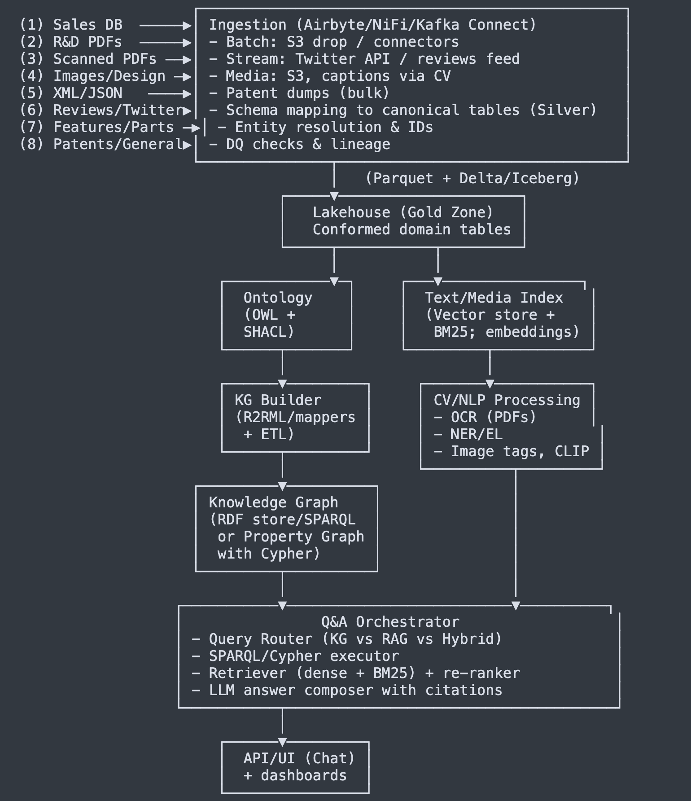

Great question. Short answer: you **shouldn’t fully auto-generate** the ontology. The winning approach is **“middle-out”**: define a **small, hand-crafted core** (your seed classes & key relations), then **semi-automate** the rest from your data (DB schemas, PDFs, JSON/XML, images, social), with human review.

Here’s a practical playbook you can run.

# **1) What to do manually (the seed)**

* Lock a **core** of ~15–25 classes & ~30–50 properties that map to your competency questions (VehicleModel, Trim, Feature, Part, Manufacturer, SaleRecord, Market, Document, ImageAsset, DesignArtifact, Patent, Org/Person, Recall, etc.).
* Define **global IDs**, domains/ranges, cardinalities, and 5–10 **SHACL** rules (e.g., each Trim must belong to exactly one VehicleModel).
* Reuse vocabularies where possible (schema.org Vehicle, ACES/PIES for parts/fitment, Dublin Core for docs, PROV for lineage, SKOS for controlled terms).

### **Tiny OWL/Turtle seed (you can paste into Protégé)**

@prefix ex: <http://example.com/auto#> .

@prefix rdf: <http://www.w3.org/1999/02/22-rdf-syntax-ns#> .

@prefix rdfs: <http://www.w3.org/2000/01/rdf-schema#> .

@prefix owl: <http://www.w3.org/2002/07/owl#> .

@prefix xsd: <http://www.w3.org/2001/XMLSchema#> .

ex:VehicleModel a owl:Class .

ex:Trim a owl:Class .

ex:Feature a owl:Class .

ex:Part a owl:Class .

ex:Manufacturer a owl:Class .

ex:SaleRecord a owl:Class .

ex:Market a owl:Class .

ex:Document a owl:Class .

ex:Patent a owl:Class .

ex:ImageAsset a owl:Class .

ex:DesignArtifact a owl:Class .

ex:Organization a owl:Class .

ex:Person a owl:Class .

ex:belongsTo a owl:ObjectProperty ;

rdfs:domain ex:Trim ; rdfs:range ex:VehicleModel .

ex:hasFeature a owl:ObjectProperty ;

rdfs:domain ex:Trim ; rdfs:range ex:Feature .

ex:fits a owl:ObjectProperty ;

rdfs:domain ex:Part ; rdfs:range ex:Trim .

ex:soldIn a owl:ObjectProperty ;

rdfs:domain ex:SaleRecord ; rdfs:range ex:Market .

ex:saleDate a owl:DatatypeProperty ;

rdfs:domain ex:SaleRecord ; rdfs:range xsd:date .

ex:quantity a owl:DatatypeProperty ;

rdfs:domain ex:SaleRecord ; rdfs:range xsd:integer .

ex:mentions a owl:ObjectProperty ;

rdfs:domain ex:Document ; rdfs:range owl:Thing .

ex:depicts a owl:ObjectProperty ;

rdfs:domain ex:ImageAsset ; rdfs:range owl:Thing .

### **Minimal SHACL (validation)**

@prefix sh: <http://www.w3.org/ns/shacl#> .

@prefix ex: <http://example.com/auto#> .

ex:TrimShape a sh:NodeShape ;

sh:targetClass ex:Trim ;

sh:property [

sh:path ex:belongsTo ;

sh:minCount 1 ; sh:maxCount 1 ;

sh:message "Every Trim must belongTo exactly one VehicleModel." ;

] .

# **2) What to (semi-)automate from your data**

Use automation to **propose** classes/properties/terms and generate mappings—then review/merge.

### **From relational schemas (Sales, Features/Parts)**

* **Tools**: Ontop / R2RML, Morph-KGC (R2RML engine).
* **How**: Map tables→classes, FKs→object properties, columns→datatype properties. Get a first pass automatically.

**R2RML sketch for Trim and belongsTo:**

<#TriplesMap_Trim>

rr:logicalTable [ rr:tableName "trim" ];

rr:subjectMap [

rr:template "http://example.com/trim/{trim_id}" ;

rr:class ex:Trim

] ;

rr:predicateObjectMap [

rr:predicate ex:belongsTo ;

rr:objectMap [

rr:template "http://example.com/model/{model_id}"

]

] .

### **From JSON/XML (features, configs, patents)**

* **Tools**: SPARQL-Generate or RML (RDF Mapping Language), **LinkML** (define schemas, emit OWL/SHACL), JSON-LD contexts.
* Auto-infer candidate properties from keys/paths; convert enumerations to SKOS concepts.

### **From PDFs (R&D) & OCRed docs**

* **Tools**: Tesseract/Textract → text; spaCy/HF NER + **Hearst pattern** mining to induce taxonomies (Feature ⊑ Capability, Part ⊑ Component); generate **SKOS** concept schemes (prefLabel/altLabel) for features/parts; link mentions to entities.

### **From images/designs**

* **Tools**: CLIP/BLIP to caption and embed; propose controlled terms for depicted parts/features; add as SKOS terms, not OWL classes, until stable.

### **LLM-assist (safe, review required)**

* Feed **competency questions + sample rows + doc snippets** to an LLM to **propose** properties (names, domain/range) and example axioms. Treat as **draft**; validate with a reasoner (HermiT/Pellet) and SHACL.

### **Template-driven authoring (fast & auditable)**

* **ROBOT** “template” flow: maintain CSVs like classes.csv (ID,Label,Parent) and properties.csv (ID,Label,Domain,Range); generate/merge OWL in CI. Easy code-review/versioning.

# **3) Governance & change control**

* Version ontology (SemVer), changelog, deprecation policy, and **module** it (core vehicles, parts, documents, patents).
* Every PR must pass: **SHACL = 0 violations**, reasoner **consistent**, and mapping tests (round-trip a few rows).

# **4) When to automate vs define**

* **Define manually**: identities, keys, cardinalities, critical relations (Trim→VehicleModel, Part→fits→Trim, feature attachment scope by model/year/market).
* **Automate**: long tail of attributes, synonyms, taxonomies, JSON/XML field coverage, doc term extraction, mappings from new feeds.
* **Never** 100% automate ontology logic—always keep a human in the loop.

# **5) Quick SPARQL examples (to prove the shape)**

**Which trims belong to a given model?**

SELECT ?trim

WHERE {

?trim a ex:Trim ; ex:belongsTo <http://example.com/model/MODEL123> .

}

**Which trims have a given feature?**

SELECT ?trim

WHERE {

?trim a ex:Trim ; ex:hasFeature <http://example.com/feature/ACC> .

}

## **Recommended tool stack (all OSS/AWS-friendly)**

* **Modeling**: Protégé, ROBOT, OWL API; HermiT/Pellet; SHACL (pySHACL).
* **Mappings**: Ontop / R2RML (Morph-KGC), RMLMapper, SPARQL-Generate; LinkML.
* **Extraction**: Tesseract/Textract, spaCy/HF, scikit-hearst; CLIP/BLIP for images.
* **Stores**: GraphDB/Jena Fuseki (RDF/SPARQL) or Neo4j/JanusGraph (property graph).
* **Pipelines**: Spark/Glue, dbt, Airbyte/NiFi/Kafka; Great Expectations; OpenLineage.
* **Search/RAG**: OpenSearch (BM25 + kNN), Qdrant/Milvus/FAISS; Haystack/LlamaIndex.

### **Bottom line**

* **Yes, you can “create automatically,”** but only as **scaffolding**.
* Start with the **hand-crafted core** (you already listed the right classes), then **auto-propose** the rest from your data and **curate** it.
* Enforce quality with **SHACL + reasoner**, and wire it into CI so the ontology stays clean as the system grows.

If you want, I can share a **ROBOT template CSV** for your exact classes/props and a **starter R2RML file** for VehicleModel/Trim/Feature/Part to get you generating triples in minutes.

You’re looking for the **Graph DB** in that diagram—it's the box labeled:

**“Knowledge Graph (RDF store/SPARQL or Property Graph with Cypher)”**

Quick locator:

... → Ontology → KG Builder → [ Knowledge Graph ] → Q&A Orchestrator → Answers

* **This is the Graph DB layer.**
* Examples that fit here: **GraphDB / Jena Fuseki / Amazon Neptune (SPARQL)** or **Neo4j / JanusGraph (Cypher/Gremlin)**.
* It sits **downstream of “KG Builder”** (which generates triples/edges) and **upstream of the Q&A Orchestrator** (which queries it).

Yes—there’s a **Graph DB right in the Knowledge Graph layer**. That’s where we store and query relationships like  
 Trim —belongsTo→ VehicleModel, Part —fits→ Trim, Trim —hasFeature→ Feature, etc.

# **Where it sits**

Sources → Lakehouse (Bronze/Silver/Gold) → Ontology (OWL/SHACL)

→ Mapping (R2RML/RML/Spark mappers) → **Graph DB (KG)**

→ Q&A Orchestrator (SPARQL/Cypher + RAG) → Answers with citations

# **What to use (pick one)**

* **RDF triple store (recommended for ontology-first):** GraphDB, Apache Jena/Fuseki, or **Amazon Neptune (SPARQL)**.  
  + Pros: native OWL/SHACL, global IRIs, clean alignment with Protégé; perfect for constraints/reasoning.
* **Property graph (great for graph algorithms/dev velocity):** Neo4j (Cypher), JanusGraph, or **Amazon Neptune (openCypher/Gremlin)**.  
  + Pros: fast traversals, rich graph algos (Neo4j GDS). Cons: ontology/constraints need extra tooling.

Many teams do a **hybrid**: author ontology + canonical KG in RDF, then mirror key subgraphs to Neo4j for analytics.

# **Example queries (both styles)**

**SPARQL (RDF): trims for a model**

SELECT ?trim WHERE {

?trim a ex:Trim ; ex:belongsTo <http://example.com/model/MODEL123> .

}

**Cypher (property graph):**

MATCH (m:VehicleModel {id:'MODEL123'})<-[:BELONGS_TO]-(t:Trim)

RETURN t;

# **How it connects to the rest**

* **Mappings:** R2RML/RML (or Spark jobs) materialize triples/edges from your Gold tables.
* **Text & images:** big blobs stay in the lake/search/vector store; the Graph DB holds **links/metadata** (e.g., :Document-[:MENTIONS]->:Trim, image.vector_id).
* **Q&A:** Router runs **SPARQL/Cypher** for structured facts and blends with vector search (RAG) for unstructured answers.

# **Scale note for ~1 TB**

Keep heavy text/R&D PDFs, OCR, images in S3 + OpenSearch/Qdrant. Put **entities & relations** (typically 10–200 M triples/edges) in the Graph DB; that’s efficient and keeps reasoning/traversal snappy.

If you want, I can sketch the exact **Neptune (SPARQL + openCypher) deployment** or a **Neo4j + RDF mirror** pattern with the ETL steps you’ll need.

if you want, I can: sketch the OWL class/property list you can paste into Protégé, provide sample SPARQL/Cypher queries for your CQs, and give a dbt model skeleton + Spark jobs for triple generation and embeddings.

###### **ChatGPT said:**

Thought for 20s

awesome—here are all three deliverables you asked for, ready to copy into your stack:

# **1) OWL class/property list (paste into Protégé)**

**File type:** Turtle (.ttl).  
 **Namespace:** http://example.com/auto# (change later if you want).

@prefix ex: <http://example.com/auto#> .

@prefix xsd: <http://www.w3.org/2001/XMLSchema#> .

@prefix rdf: <http://www.w3.org/1999/02/22-rdf-syntax-ns#> .

@prefix rdfs: <http://www.w3.org/2000/01/rdf-schema#> .

@prefix owl: <http://www.w3.org/2002/07/owl#> .

@prefix skos: <http://www.w3.org/2004/02/skos/core#> .

@base <http://example.com/auto> .

#################################################################

# Classes (core)

#################################################################

ex:VehicleModel a owl:Class .

ex:Trim a owl:Class .

ex:Feature a owl:Class .

ex:Part a owl:Class .

ex:Manufacturer a owl:Class .

ex:SaleRecord a owl:Class .

ex:MarketRegion a owl:Class .

ex:Document a owl:Class .

ex:RnDDocument a owl:Class ; rdfs:subClassOf ex:Document .

ex:PatentDocument a owl:Class ; rdfs:subClassOf ex:Document .

ex:ReviewDocument a owl:Class ; rdfs:subClassOf ex:Document .

ex:ManualDocument a owl:Class ; rdfs:subClassOf ex:Document .

ex:ImageAsset a owl:Class .

ex:DesignArtifact a owl:Class .

ex:Patent a owl:Class .

ex:RecallEvent a owl:Class .

ex:Organization a owl:Class .

ex:Person a owl:Class .

#################################################################

# Object properties (relations)

#################################################################

ex:belongsTo a owl:ObjectProperty ;

rdfs:domain ex:Trim ; rdfs:range ex:VehicleModel .

ex:hasFeature a owl:ObjectProperty ;

rdfs:domain ex:Trim ; rdfs:range ex:Feature .

ex:fits a owl:ObjectProperty ;

rdfs:domain ex:Part ; rdfs:range ex:Trim .

ex:supersedes a owl:ObjectProperty ;

rdfs:domain ex:Part ; rdfs:range ex:Part .

ex:madeBy a owl:ObjectProperty ;

rdfs:domain ex:Part ; rdfs:range ex:Manufacturer .

ex:hasRecall a owl:ObjectProperty ;

rdfs:domain ex:VehicleModel ; rdfs:range ex:RecallEvent .

ex:mentions a owl:ObjectProperty ;

rdfs:domain ex:Document ; rdfs:range owl:Thing .

ex:depicts a owl:ObjectProperty ;

rdfs:domain ex:ImageAsset ; rdfs:range owl:Thing .

ex:aboutModel a owl:ObjectProperty ;

rdfs:domain ex:Patent ; rdfs:range ex:VehicleModel .

ex:aboutFeature a owl:ObjectProperty ;

rdfs:domain ex:Patent ; rdfs:range ex:Feature .

ex:soldIn a owl:ObjectProperty ;

rdfs:domain ex:SaleRecord ; rdfs:range ex:MarketRegion .

ex:forTrim a owl:ObjectProperty ;

rdfs:domain ex:SaleRecord ; rdfs:range ex:Trim .

ex:authoredBy a owl:ObjectProperty ;

rdfs:domain ex:Document ; rdfs:range ex:Person .

ex:publishedBy a owl:ObjectProperty ;

rdfs:domain ex:Document ; rdfs:range ex:Organization .

#################################################################

# Datatype properties (identifiers & attributes)

#################################################################

ex:modelCode a owl:DatatypeProperty ;

rdfs:domain ex:VehicleModel ; rdfs:range xsd:string .

ex:modelYear a owl:DatatypeProperty ;

rdfs:domain ex:Trim ; rdfs:range xsd:gYear .

ex:trimCode a owl:DatatypeProperty ;

rdfs:domain ex:Trim ; rdfs:range xsd:string .

ex:featureCode a owl:DatatypeProperty ;

rdfs:domain ex:Feature ; rdfs:range xsd:string .

ex:partNumber a owl:DatatypeProperty ;

rdfs:domain ex:Part ; rdfs:range xsd:string .

ex:msrp a owl:DatatypeProperty ;

rdfs:domain ex:Part ; rdfs:range xsd:decimal .

ex:saleDate a owl:DatatypeProperty ;

rdfs:domain ex:SaleRecord ; rdfs:range xsd:date .

ex:quantity a owl:DatatypeProperty ;

rdfs:domain ex:SaleRecord ; rdfs:range xsd:integer .

ex:docId a owl:DatatypeProperty ;

rdfs:domain ex:Document ; rdfs:range xsd:string .

ex:title a owl:DatatypeProperty ;

rdfs:domain ex:Document ; rdfs:range xsd:string .

ex:publishedOn a owl:DatatypeProperty ;

rdfs:domain ex:Document ; rdfs:range xsd:date .

ex:caption a owl:DatatypeProperty ;

rdfs:domain ex:ImageAsset ; rdfs:range xsd:string .

ex:vectorId a owl:DatatypeProperty ;

rdfs:domain ex:Document ; rdfs:range xsd:string .

#################################################################

# SKOS labels (for synonyms/aliases)

#################################################################

ex:Feature skos:prefLabel "Feature"@en .

# Use skos:altLabel on instances for synonyms like "ACC", "Adaptive Cruise Control", etc.

#################################################################

# Simple SHACL (validation) — optional but recommended

#################################################################

@prefix sh: <http://www.w3.org/ns/shacl#> .

ex:TrimShape a sh:NodeShape ;

sh:targetClass ex:Trim ;

sh:property [

sh:path ex:belongsTo ; sh:minCount 1 ; sh:maxCount 1 ;

sh:message "Every Trim must belongTo exactly one VehicleModel."

] ;

sh:property [

sh:path ex:modelYear ; sh:minCount 1 ;

sh:datatype xsd:gYear ; sh:message "Trim must have a modelYear."

] .

ex:SaleRecordShape a sh:NodeShape ;

sh:targetClass ex:SaleRecord ;

sh:property [

sh:path ex:forTrim ; sh:minCount 1 ;

] ;

sh:property [

sh:path ex:soldIn ; sh:minCount 1 ;

] ;

sh:property [

sh:path ex:quantity ; sh:minCount 1 ; sh:datatype xsd:integer ;

] ;

sh:property [

sh:path ex:saleDate ; sh:minCount 1 ; sh:datatype xsd:date ;

] .

# **2) Sample queries for your competency questions**

## **SPARQL (RDF / triple store)**

**A) 2022–2024 trims of a model that have Adaptive Cruise Control, plus recall events**

PREFIX ex: <http://example.com/auto#>

SELECT ?trim ?year ?recall

WHERE {

?trim a ex:Trim ;

ex:belongsTo <http://example.com/model/MODEL_X> ;

ex:modelYear ?year ;

ex:hasFeature <http://example.com/feature/ACC> .

FILTER (?year >= "2022"^^xsd:gYear && ?year <= "2024"^^xsd:gYear)

OPTIONAL {

<http://example.com/model/MODEL_X> ex:hasRecall ?recall .

}

}

ORDER BY ?year ?trim

**B) Monthly sales trend for a model in CA vs TX**

PREFIX ex: <http://example.com/auto#>

SELECT ?ym (SUM(?qty) AS ?units) ?region

WHERE {

?trim a ex:Trim ; ex:belongsTo <http://example.com/model/MODEL_Y> .

?sr a ex:SaleRecord ; ex:forTrim ?trim ; ex:soldIn ?mr ;

ex:quantity ?qty ; ex:saleDate ?d .

?mr rdfs:label ?region .

BIND (SUBSTR(STR(?d),1,7) AS ?ym) # YYYY-MM

FILTER (?region IN ("CA","TX"))

}

GROUP BY ?ym ?region

ORDER BY ?ym ?region

**C) Patents related to battery thermal management for a model**

PREFIX ex: <http://example.com/auto#>

PREFIX skos: <http://www.w3.org/2004/02/skos/core#>

SELECT ?patent ?title

WHERE {

?patent a ex:Patent ;

ex:aboutModel <http://example.com/model/MODEL_Z> ;

ex:aboutFeature ?feat ;

ex:title ?title .

?feat (skos:prefLabel|skos:altLabel) ?label .

FILTER (CONTAINS(LCASE(?label), "thermal") || CONTAINS(LCASE(?label), "cooling"))

}

ORDER BY ?title

**D) Parts that fit a trim, following supersession chain**

PREFIX ex: <http://example.com/auto#>

SELECT ?part ?current

WHERE {

?part a ex:Part ; ex:fits <http://example.com/trim/TRIM_123> .

OPTIONAL {

?part (ex:supersedes)* ?current .

FILTER(NOT EXISTS {?x ex:supersedes ?current}) # terminal/latest

}

}

**E) Documents mentioning a feature, most recent first**

PREFIX ex: <http://example.com/auto#>

SELECT ?doc ?title ?date

WHERE {

?doc a ex:Document ; ex:mentions <http://example.com/feature/ACC> ;

ex:title ?title ; ex:publishedOn ?date .

}

ORDER BY DESC(?date)

## **Cypher (property-graph / Neo4j)**

Node labels/props assumed:  
 (VehicleModel {id}), (Trim {id, modelYear}), (Feature {id}), (Part {partNumber}), (SaleRecord {date, quantity}), (MarketRegion {code}), (Document {docId, title, publishedOn}), (Patent), relationships (:Trim)-[:BELONGS_TO]->(:VehicleModel), (:Trim)-[:HAS_FEATURE]->(:Feature), (:Part)-[:FITS]->(:Trim), (:Part)-[:SUPERSEDES]->(:Part), (:SaleRecord)-[:FOR_TRIM]->(:Trim), (:SaleRecord)-[:SOLD_IN]->(:MarketRegion), (:Document)-[:MENTIONS]->(:Feature).

**A) Trims 2022–2024 with ACC and recall**

MATCH (m:VehicleModel {id:'MODEL_X'})<-[:BELONGS_TO]-(t:Trim)-[:HAS_FEATURE]->(:Feature {id:'ACC'})

WHERE 2022 <= t.modelYear <= 2024

OPTIONAL MATCH (m)-[:HAS_RECALL]->(r:RecallEvent)

RETURN t.id AS trim, t.modelYear AS year, collect(DISTINCT r.id) AS recalls

ORDER BY year, trim;

**B) Monthly sales trend CA vs TX**

MATCH (m:VehicleModel {id:'MODEL_Y'})<-[:BELONGS_TO]-(t:Trim)

MATCH (sr:SaleRecord)-[:FOR_TRIM]->(t)

MATCH (sr)-[:SOLD_IN]->(mr:MarketRegion)

WHERE mr.code IN ['CA','TX']

WITH mr.code AS region, substring(toString(sr.date),0,7) AS ym, sr.quantity AS q

RETURN ym, region, sum(q) AS units

ORDER BY ym, region;

**C) Parts and latest supersession**

MATCH (:Trim {id:'TRIM_123'})<-[:FITS]-(p:Part)

OPTIONAL MATCH path = (p)-[:SUPERSEDES*]->(latest:Part)

WHERE NOT (latest)-[:SUPERSEDES]->()

RETURN p.partNumber AS original, coalesce(latest.partNumber, p.partNumber) AS current;

# **3) dbt model skeleton + Spark jobs (triples & embeddings)**

## **A) dbt project layout (lakehouse “Gold”)**

dbt_project.yml

models/

gold/

dim_vehicle_model.sql

dim_trim.sql

dim_feature.sql

dim_part.sql

bridge_trim_feature.sql

bridge_part_fitment.sql

fact_sales.sql

dim_document.sql

bridge_doc_entity_mentions.sql

dim_market_region.sql

dim_recall_event.sql

seeds/

market_region_seed.csv # optional

**Example: models/gold/dim_trim.sql**

-- materialized as table

select

t.trim_id as trim_id,

t.trim_code as trim_code,

t.model_year as model_year,

m.model_id as model_id

from {{ ref('stg_trim') }} t

join {{ ref('dim_vehicle_model') }} m

on m.model_code = t.model_code

**Example: models/gold/bridge_trim_feature.sql**

select

tf.trim_id,

f.feature_id

from {{ ref('stg_trim_feature') }} tf

join {{ ref('dim_feature') }} f

on f.feature_code = tf.feature_code

**Example: models/gold/fact_sales.sql**

select

s.sale_id,

s.trim_id,

s.region_code,

s.sale_date,

s.quantity

from {{ ref('stg_sales') }} s

where s.sale_date is not null

Run dbt to produce clean, conformed tables your KG/Spark job will consume.

## **B) PySpark job — generate RDF triples (N-Triples)**

**File:** spark_generate_triples.py  
 **Input:** the dbt Gold tables (e.g., in Delta/Iceberg on S3)  
 **Output:** N-Triples files (or a Parquet of s,p,o) ready for your RDF store loader.

from pyspark.sql import SparkSession, functions as F

BASE = "http://example.com"

NS = f"{BASE}/auto#"

def uri(kind, idcol):

return F.concat(F.lit(f"{BASE}/{kind}/"), F.col(idcol))

spark = SparkSession.builder.appName("kg-triples").getOrCreate()

# Load conformed (dbt) tables

vm = spark.table("gold.dim_vehicle_model") # model_id, model_code

trim = spark.table("gold.dim_trim") # trim_id, model_id, model_year

feat = spark.table("gold.dim_feature") # feature_id, feature_code

tfx = spark.table("gold.bridge_trim_feature") # trim_id, feature_id

fit = spark.table("gold.bridge_part_fitment") # part_id, trim_id

part = spark.table("gold.dim_part") # part_id, part_number

sale = spark.table("gold.fact_sales") # sale_id, trim_id, region_code, sale_date, quantity

mr = spark.table("gold.dim_market_region") # region_code, label

# Build triples as (s,p,o) strings

def spo(s, p, o, o_is_literal=False, dtype=""):

if o_is_literal:

lit = F.concat(F.lit('"'), o, F.lit('"'), F.lit(dtype))

return s.alias("s"), F.lit(f"<{NS}{p}>").alias("p"), lit.alias("o")

else:

return s.alias("s"), F.lit(f"<{NS}{p}>").alias("p"), o.alias("o")

# Trim belongsTo VehicleModel

t_belongs = trim.select(

uri("trim","trim_id").alias("s"),

uri("model","model_id").alias("o")

).selectExpr("s", f"'<{NS}belongsTo>' as p", "o")

# Trim type & modelYear

t_type = trim.selectExpr(f"concat('<{BASE}/trim/', trim_id) as s",

f"'<http://www.w3.org/1999/02/22-rdf-syntax-ns#type>' as p",

f"'<{NS}Trim>' as o")

t_year = trim.selectExpr(f"concat('<{BASE}/trim/', trim_id) as s",

f"'<{NS}modelYear>' as p",

"concat('\"', cast(model_year as string), '\"^^<http://www.w3.org/2001/XMLSchema#gYear>') as o")

# hasFeature

tf = tfx.select(

uri("trim","trim_id").alias("s"),

uri("feature","feature_id").alias("o")

).selectExpr("s", f"'<{NS}hasFeature>' as p", "o")

# Part fits Trim

p_fits = fit.select(

uri("part","part_id").alias("s"),

uri("trim","trim_id").alias("o")

).selectExpr("s", f"'<{NS}fits>' as p", "o")

# SaleRecord nodes & properties (as blank simple URIs)

sr = sale.selectExpr(

f"concat('<{BASE}/sale/', sale_id) as s",

f"'<http://www.w3.org/1999/02/22-rdf-syntax-ns#type>' as p",

f"'<{NS}SaleRecord>' as o"

)

sr_fortrim = sale.selectExpr(

f"concat('<{BASE}/sale/', sale_id) as s",

f"'<{NS}forTrim>' as p",

f"concat('<{BASE}/trim/', trim_id) as o"

)

sr_region = sale.join(mr, "region_code", "left").selectExpr(

f"concat('<{BASE}/sale/', sale.sale_id) as s",

f"'<{NS}soldIn>' as p",

f"concat('<{BASE}/market/', sale.region_code) as o"

)

sr_qty = sale.selectExpr(

f"concat('<{BASE}/sale/', sale_id) as s",

f"'<{NS}quantity>' as p",

"concat('\"', cast(quantity as string), '\"^^<http://www.w3.org/2001/XMLSchema#integer>') as o"

)

sr_date = sale.selectExpr(

f"concat('<{BASE}/sale/', sale_id) as s",

f"'<{NS}saleDate>' as p",

"concat('\"', cast(sale_date as string), '\"^^<http://www.w3.org/2001/XMLSchema#date>') as o"

)

# Union all triples

triples = t_belongs.unionByName(t_type).unionByName(t_year)\

.unionByName(tf).unionByName(p_fits)\

.unionByName(sr).unionByName(sr_fortrim)\

.unionByName(sr_region).unionByName(sr_qty).unionByName(sr_date)

# Write N-Triples (.nt)

triples.selectExpr("concat(s,' ',p,' ',o,' .') as nt").write.mode("overwrite").text("s3://YOUR-BUCKET/kg/nt/")

Load the .nt into GraphDB/Jena/Neptune (SPARQL). For Neo4j, export CSV nodes/relationships instead.

## **C) PySpark job — build embeddings & link to KG**

**Goal:** index unstructured text (R&D PDFs after OCR, patents, reviews, image captions) in a vector DB (e.g., Qdrant/Milvus/OpenSearch kNN) and store vectorId back on the corresponding ex:Document (or keep a lookup table).

from pyspark.sql import SparkSession, functions as F

# If you use sentence-transformers, run this job in an image/AMI that already has the model cached.

# Or call a microservice that returns embeddings.

spark = SparkSession.builder.appName("doc-embeddings").getOrCreate()

docs = spark.table("gold.dim_document") # doc_id, title, body, published_on, doc_type, model_id, etc.

# Simple chunking

docs = docs.withColumn("text", F.concat_ws(" - ", F.col("title"), F.col("body"))) \

.withColumn("chunk", F.slice(F.split(F.col("text"), r"\s+"), 1, 400)) \

.withColumn("chunk_text", F.array_join(F.col("chunk"), " "))

# (A) If you have a UDF to call an embedding service:

# from myudf import embed_vector # returns array<float>

# spark.udf.register("embed_vector", embed_vector)

# vecs = docs.select("doc_id", "chunk_text", F.expr("embed_vector(chunk_text) as vector"))

# (B) Or write chunks to parquet for a Python service to read & index:

docs.select("doc_id", "chunk_text").write.mode("overwrite").parquet("s3://YOUR-BUCKET/index/doc_chunks/")

# After your external indexer upserts vectors and returns IDs, write back a mapping:

# document_vector_map: doc_id, vector_id

# Then materialize into the KG as ex:vectorId data property or keep it in a join table.

## **Quick runbook**

1. **Model & validate ontology** in Protégé (run a reasoner; keep SHACL violations at 0).
2. **dbt build** your Gold tables.
3. **Spark (triples)** job → write .nt to S3 → **load into Graph DB**.
4. **OCR/NLP** pipeline creates dim_document + bridge_doc_entity_mentions.
5. **Embeddings** job → index in vector DB → persist vectorId to KG/lookup.
6. Wire the **Q&A service**:  
   * SPARQL/Cypher executor → structured facts.
   * Vector retriever (kNN) + BM25 → unstructured snippets.
   * Re-rank + LLM compose → **answers with citations** (KG URIs + doc IDs/pages).

If you want, say the word and I’ll tailor these to **Neptune (SPARQL/openCypher)** or **Neo4j** specifically (including loader commands), and generate a minimal **dbt repo** scaffold you can drop into your environment.

Protégé is a **free, open-source ontology editor and knowledge management tool** developed by Stanford University.

In the context of ontologies:

* **Purpose**: Protégé lets you design, visualize, and manage ontologies—formal structures that describe concepts (classes), their properties (data/object properties), and relationships in a domain (e.g., vehicles, features, parts).
* **Standards**: It supports ontology languages like **OWL (Web Ontology Language)**, **RDF(S)**, and related Semantic Web standards.
* **Features**:  
  + Create **classes (concepts)**, **individuals (instances)**, and **properties**.
  + Define **hierarchies** (e.g., Car → ElectricCar → Tesla).
  + Add **restrictions, rules, and constraints** (e.g., “Every Car has exactly 4 Wheels”).
  + Use **reasoners** (like HermiT, Pellet, Fact++) to infer new knowledge (e.g., if an instance is an EV and has Battery, Protégé can infer it is an ElectricCar).
  + Visualize ontology graphs and run **SPARQL queries** on them.
* **Use cases**:  
  + Building knowledge graphs.
  + Defining ontologies for AI/ML, healthcare, automotive, finance, etc.
  + Integrating structured and unstructured data into a semantic model.

In short, Protégé is the **IDE for ontologies**, much like how PyCharm is for Python or IntelliJ for Java.

👉 Do you want me to show you a **starter OWL ontology example** (in Protégé format) for your **Car ontology** (with VehicleModel, Trim, Feature, Part, etc.)?

##### **You said:**

can i run the Protégé local in macbook laptop

###### **ChatGPT said:**

Yes 👍 you can absolutely run **Protégé locally on your MacBook**.

Here’s what you need to know:

### **🔹 Requirements**

* **Java**: Protégé is a Java-based application, so you need Java installed (Java 11 or later works well).

You can check if Java is installed with:  
  
 java -version

If not, install it via Adoptium Temurin JDK or Homebrew:  
  
 brew install openjdk@17

* **Protégé Download**:  
  + Official site: https://protege.stanford.edu/
  + Download the **latest stable release** (currently Protégé Desktop 5.x).

### **🔹 Installation Steps (MacBook)**

1. **Download** the .dmg (Mac installer) from the Protégé website.
2. **Drag Protégé.app to Applications** (like other Mac apps).
3. If macOS blocks it (unidentified developer warning), go to:  
   * *System Preferences → Security & Privacy → General → Allow Anyway*.
4. Launch Protégé.

### **🔹 Running Protégé**

* Just open Protégé like any other app.
* You can **create a new ontology** (OWL/RDF/XML format) or **open an existing ontology file** (.owl, .rdf).
* Use built-in editors for:  
  + Classes (concepts)
  + Object/Data properties
  + Individuals (instances)
* You can also install **plugins** (reasoners, visualization tools).

### **🔹 Example**

If you start a **Car Ontology** project:

* Class: VehicleModel
* Subclass: ElectricVehicle
* Object Property: hasFeature
* Data Property: releaseYear
* Individual: TeslaModel3

Then you can use a reasoner (e.g., HermiT) to infer:

* TeslaModel3 is an instance of ElectricVehicle.

✅ So yes—you can run Protégé locally on your MacBook with no problem.

Do you want me to give you a **step-by-step starter example ontology file (.owl)** for your Car use case so you can open it directly in Protégé?

I want to know in text How does the data structure look like once you process 8 source of data and process through the ETL after that further process., so when we asked the question how the response construction and get the response. Show me in this context very simple source data and after process store data stracture and while query the question how to construct the response and user get the response. All text diagram and workflow is fine and also show the Data structure

###### **ChatGPT said:**

Thought for 25s

awesome — here’s a simple, end-to-end, **text-only** walkthrough that shows:

* tiny sample **source data** for all 8 inputs
* what the **processed (stored) data structures** look like (tables + graph + vector index)
* the **query/answer workflow** with example queries and a constructed final answer

What is BM25 search for doc with sample example

###### **ChatGPT said:**

Great question 👌 — BM25 is one of the **most widely used ranking functions** in information retrieval (IR) systems like search engines (Google, Elasticsearch, Lucene, Vespa, etc.).

## **🔹 What is BM25?**

* **BM25 (Best Matching 25)** is a ranking function based on **probabilistic retrieval models**.
* It’s an improved version of TF-IDF (Term Frequency – Inverse Document Frequency).
* It scores documents by how relevant they are to a given query, considering:  
  1. **Term frequency** (how many times a word appears in a document).
  2. **Inverse document frequency** (how rare the word is across all documents).
  3. **Document length normalization** (shorter docs get boosted vs. very long docs).

## **🔹 BM25 Formula**

The score of a document DDD for query QQQ is:

score(D,Q)=∑t∈QIDF(t)⋅f(t,D)⋅(k1+1)f(t,D)+k1⋅(1−b+b⋅∣D∣avgdl)\text{score}(D, Q) = \sum_{t \in Q} IDF(t) \cdot \frac{f(t,D) \cdot (k_1 + 1)}{f(t,D) + k_1 \cdot \Big(1 - b + b \cdot \frac{|D|}{\text{avgdl}}\Big)}score(D,Q)=t∈Q∑​IDF(t)⋅f(t,D)+k1​⋅(1−b+b⋅avgdl∣D∣​)f(t,D)⋅(k1​+1)​

Where:

* f(t,D)f(t,D)f(t,D): frequency of term ttt in document DDD.
* ∣D∣|D|∣D∣: length of document DDD.
* avgdl\text{avgdl}avgdl: average document length in the corpus.
* k1k_1k1​: term frequency saturation parameter (usually 1.2–2.0).
* bbb: length normalization parameter (0–1, usually 0.75).
* IDF(t)IDF(t)IDF(t): inverse document frequency of term ttt.

## **🔹 Intuition**

* If a query word appears **more often** in a doc → score increases.
* If a word is **rare across all docs** (high IDF) → score increases.
* If a doc is **too long**, the word counts are normalized (to avoid long docs always winning).

## **🔹 Example**

Let’s say we have 3 documents:

1. D1: "The cat sat on the mat"
2. D2: "The dog chased the cat"
3. D3: "The cat and the dog sat on the sofa"

Query: **"cat sat"**

### **Step 1. Term frequencies**

* D1: cat=1, sat=1
* D2: cat=1, sat=0
* D3: cat=1, sat=1

### **Step 2. Document lengths**

* D1 = 6 words, D2 = 5 words, D3 = 8 words
* avgdl ≈ (6+5+8)/3 = 6.3

### **Step 3. IDF (Inverse Document Frequency)**

For word “cat”: appears in all 3 docs → IDF is low.  
 For word “sat”: appears in 2 docs → IDF is higher.

### **Step 4. BM25 scoring (rough intuition, not full math)**

* D1: has both cat and sat, short doc → **highest score**.
* D2: only has cat, missing sat → lower score.
* D3: has both cat and sat, but longer doc → good but slightly less than D1.

👉 Final ranking: **D1 > D3 > D2**

I want to know in text How does the data structure look like once you process 8 source of data and process through the ETL after that further process., so when we asked the question how the response construction and get the response. Show me in this context very simple source data and after process store data stracture and while query the question how to construct the response and user get the response. All text diagram and workflow is fine and also show the Data structure

###### **ChatGPT said:**

Thought for 25s

awesome — here’s a simple, end-to-end, **text-only** walkthrough that shows:

* tiny sample **source data** for all 8 inputs
* what the **processed (stored) data structures** look like (tables + graph + vector index)
* the **query/answer workflow** with example queries and a constructed final answer

# **1) Text diagrams**

## **Ingestion & storage (ETL/Lakehouse → KG + Search)**

[8 Sources] → [Bronze (raw)] → [Silver (cleaned)] → [Gold (conformed tables)]

→ [KG Builder → Graph DB] + [Text/Image Embeddings → Vector Index]

## **Question → Answer (Hybrid KG + RAG)**

User Q → Router

├─→ KG query (SPARQL/Cypher) for structured facts

├─→ Vector/BM25 search for doc/image evidence

└─→ Merge + re-rank → LLM compose → Answer (+ citations)

# **2) Tiny sample source data (one or two rows each)**

### **(1) Sales DB (relational)**

sales(id, trim_code, region_code, date, qty)

S1, "T101", "CA", 2023-03-15, 120

S2, "T102", "CA", 2023-03-15, 55

### **(2) R&D PDFs (metadata + extracted text)**

doc_id, title, type, text

"RND-42","Falcon X ACC Tuning","RND",

"We improved Adaptive Cruise Control (ACC) sensor fusion for Falcon X Pro..."

### **(3) Scanned PDFs (OCR)**

doc_id, type, text

"MAN-9","Manual",

"… Falcon X Base 2023 supports ACC as optional package …"

### **(4) Car design & images (captions produced by CV)**

image_id, caption

"IMG-7","Exploded view of Falcon X front radar module"

### **(5) XML/JSON configs (features)**

{

"model": "Falcon X",

"year": 2023,

"trims": [

{"trim_code":"T101","features":["ACC","LaneKeep"]},

{"trim_code":"T102","features":["ACC","AutoPark"]}

]

}

### **(6) Reviews/Twitter**

tweet_id, text

"TW1","ACC on my Falcon X Pro handled traffic flawlessly."

### **(7) Feature/Model/Parts CSV**

feature_code, feature_name

"ACC","Adaptive Cruise Control"

part_number, part_name, fits_trim

"P-001","Front Radar Unit","T102"

### **(8) Patents (metadata + abstract)**

patent_id, title, abstract

"PAT-9","Thermal control for radar modules",

"… cooling shroud for automotive radar used in Falcon X platform …"

# **3) Processed storage (after ETL)**

## **3A) Gold tables (conformed, queryable)**

dim_vehicle_model(model_id, model_code, model_name)

M1, "FX", "Falcon X"

dim_trim(trim_id, trim_code, model_id, model_year)

T101, "T101", M1, 2023

T102, "T102", M1, 2023

dim_feature(feature_id, feature_code, feature_name)

F1, "ACC", "Adaptive Cruise Control"

bridge_trim_feature(trim_id, feature_id)

T101, F1

T102, F1

dim_part(part_id, part_number, part_name)

P1, "P-001", "Front Radar Unit"

bridge_part_fitment(part_id, trim_id)

P1, T102

dim_market_region(region_code, region_label)

CA, "California"

fact_sales(sale_id, trim_id, region_code, sale_date, quantity)

S1, T101, CA, 2023-03-15, 120

S2, T102, CA, 2023-03-15, 55

dim_document(doc_id, title, doc_type, published_on)

"RND-42","Falcon X ACC Tuning","RND", 2023-03-10

"MAN-9","Falcon X Owner Manual","Manual", 2023-02-01

bridge_doc_entity_mentions(doc_id, entity_type, entity_id)

"RND-42","Feature", F1

"RND-42","Model", M1

"MAN-9","Trim", T101

dim_image_asset(image_id, caption)

"IMG-7","Exploded view of Falcon X front radar module"

dim_patent(patent_id, title)

"PAT-9","Thermal control for radar modules"

bridge_patent_entity(patent_id, entity_type, entity_id)

"PAT-9","Model", M1

"PAT-9","Part", P1

## **3B) Knowledge Graph representation (Graph DB)**

**Nodes (examples)**

(VehicleModel: M1, name="Falcon X")

(Trim: T101, year=2023) (Trim: T102, year=2023)

(Feature: F1, code="ACC")

(Part: P1, partNumber="P-001")

(MarketRegion: CA)

(SaleRecord: S1), (SaleRecord: S2)

(Document: RND-42), (Document: MAN-9)

(ImageAsset: IMG-7)

(Patent: PAT-9)

**Edges (examples)**

(T101)-[:BELONGS_TO]->(M1)

(T102)-[:BELONGS_TO]->(M1)

(T101)-[:HAS_FEATURE]->(F1)

(T102)-[:HAS_FEATURE]->(F1)

(P1)-[:FITS]->(T102)

(S1)-[:FOR_TRIM]->(T101)

(S1)-[:SOLD_IN]->(CA)

(S2)-[:FOR_TRIM]->(T102)

(S2)-[:SOLD_IN]->(CA)

(RND-42)-[:MENTIONS]->(F1)

(RND-42)-[:MENTIONS]->(M1)

(MAN-9)-[:MENTIONS]->(T101)

(IMG-7)-[:DEPICTS]->(P1)

(PAT-9)-[:ABOUT_MODEL]->(M1)

(PAT-9)-[:ABOUT_PART]->(P1)

*(RDF/SPARQL or property-graph/Cypher—either works; above is conceptual.)*

## **3C) Vector index (for unstructured search)**

vector_index

────────────

vector_id | doc_id | chunk_text | meta

V1001 | RND-42 | "Improved Adaptive Cruise Control on Falcon…" | {type:"RND", model:"M1", feature:"F1"}

V1002 | MAN-9 | "Falcon X Base 2023 supports ACC as optional" | {type:"Manual", trim:"T101"}

# **4) Example Q→A flow with real data**

**Question (user):** “Which **2023 trims** of **Falcon X** have **Adaptive Cruise Control**, and how many **CA** sales did they have on **2023-03-15**? Give a doc snippet.”

### **Step 1: Entity linking (router)**

* “Falcon X” → VehicleModel = M1
* “Adaptive Cruise Control/ACC” → Feature = F1
* Date = 2023-03-15, Region = CA

### **Step 2: KG query (get trims with ACC in 2023)**

**SPARQL (illustrative)**

PREFIX ex: <http://example.com/auto#>

SELECT ?trim ?year WHERE {

?trim a ex:Trim ; ex:belongsTo ex:M1 ; ex:modelYear "2023"^^xsd:gYear ;

ex:hasFeature ex:F1 .

}

**Result:** T101 (2023), T102 (2023)

### **Step 3: Structured fact lookup (sales)**

(You can keep sales in the KG as SaleRecord or query the fact_sales table.)

**SPARQL style**

SELECT ?trim (SUM(?q) AS ?units)

WHERE {

?sr a ex:SaleRecord ;

ex:forTrim ?trim ;

ex:soldIn ex:CA ;

ex:saleDate "2023-03-15"^^xsd:date ;

ex:quantity ?q .

FILTER (?trim IN (ex:T101, ex:T102))

}

GROUP BY ?trim

**Result:** T101 → 120 units, T102 → 55 units

### **Step 4: Evidence from documents (vector search)**

* kNN over vector_index with query “Falcon X Adaptive Cruise Control” and filter model=M1, feature=F1
* Top hit: RND-42 / V1001 →  
   “**Improved Adaptive Cruise Control** (ACC) sensor fusion for **Falcon X Pro**…”

### **Step 5: Compose the answer**

* Facts from KG: trims T101, T102 both have ACC in 2023
* Sales from structured: CA units on 2023-03-15 are 120 and 55
* Evidence snippet: from RND-42 (R&D) mentioning ACC on Falcon X

**Constructed response (what the user sees)**

**Trims with ACC (2023, Falcon X):** • **T101 (Base 2023)** — **CA sales on 2023-03-15:** 120  
 • **T102 (Pro 2023)** — **CA sales on 2023-03-15:** 55

**Evidence (R&D):** “Improved Adaptive Cruise Control (ACC) sensor fusion for Falcon X Pro…” — *RND-42*

**Sources:** KG entities ex:T101, ex:T102; sales records S1, S2; document RND-42.

# **5) What the data structures look like (concise schemas)**

### **Lakehouse (Gold) tables**

dim_vehicle_model(model_id PK, model_code, model_name)

dim_trim(trim_id PK, trim_code, model_id FK, model_year)

dim_feature(feature_id PK, feature_code, feature_name)

dim_part(part_id PK, part_number, part_name)

bridge_trim_feature(trim_id FK, feature_id FK)

bridge_part_fitment(part_id FK, trim_id FK)

dim_market_region(region_code PK, region_label)

fact_sales(sale_id PK, trim_id FK, region_code FK, sale_date, quantity)

dim_document(doc_id PK, title, doc_type, published_on)

bridge_doc_entity_mentions(doc_id FK, entity_type ENUM, entity_id)

dim_image_asset(image_id PK, caption)

dim_patent(patent_id PK, title)

bridge_patent_entity(patent_id FK, entity_type, entity_id)

### **Graph DB (logical)**

Node labels:

VehicleModel(id, name)

Trim(id, year)

Feature(id, code, name)

Part(id, partNumber, name)

MarketRegion(code, label)

SaleRecord(id, date, quantity)

Document(id, title, type, published_on)

ImageAsset(id, caption)

Patent(id, title)

Relationships:

(Trim)-[:BELONGS_TO]->(VehicleModel)

(Trim)-[:HAS_FEATURE]->(Feature)

(Part)-[:FITS]->(Trim)

(SaleRecord)-[:FOR_TRIM]->(Trim)

(SaleRecord)-[:SOLD_IN]->(MarketRegion)

(Document)-[:MENTIONS]->(:Feature|:Trim|:Model|:Part)

(ImageAsset)-[:DEPICTS]->(:Part|:Model|:Trim)

(Patent)-[:ABOUT_MODEL]->(VehicleModel)

(Patent)-[:ABOUT_PART]->(Part)

### **Vector index (logical)**

vector_id PK, doc_id FK, chunk_text, embedding (opaque), metadata(map)

Indexes: by doc_id; filters on {model, trim, feature, type}

## **TL;DR**

* You land everything into clean **Gold tables**, mirror entities/relations into a **Graph DB**, and index unstructured text/images into a **Vector store**.
* At question time you **link entities**, **query the graph** for precise facts, **pull supporting snippets** from the vector index, and **compose** a grounded answer with citations.

If you want this converted into runnable **dbt models + a tiny Neo4j/Neptune loader script** with the exact sample rows above, say the word and I’ll drop the files in the next reply.

es, please do this f you want this converted into runnable dbt models + a tiny Neo4j/Neptune loader script with the exact sample rows above, say the word and I’ll drop the files in the next reply.

###### **ChatGPT said:**

Thought for 24s

awesome — I packaged a **runnable demo project** with:

* **dbt (DuckDB)** project + seeds + models (Gold layer)
* **Neo4j** CSVs + a **LOAD** Cypher script
* **Neptune** N-Triples + a **bulk loader** request JSON
* A README with exact commands

Download the project (zip)

### **What’s inside (folders)**

* seeds/ — CSVs with the exact tiny sample rows we discussed
* models/gold/ — dbt models (materialized as tables)
* scripts/neo4j/ — node/edge CSVs + load_sample.cypher
* scripts/neptune/ — neptune_sample.nt + bulk_loader_request.json
* dbt_project.yml, profiles.yml (use with DBT_PROFILES_DIR=.), packages.yml
* README.md — step-by-step instructions

### **Quick start (local)**

1. install dbt for DuckDB:

pip install dbt-duckdb

1. in the unzipped folder:

dbt deps

DBT_PROFILES_DIR=. dbt seed

DBT_PROFILES_DIR=. dbt run

This builds target/auto_kg.duckdb with seeds.* and gold.* tables.

### **Load into Neo4j**

* Move all scripts/neo4j/*.csv and load_sample.cypher into Neo4j’s import dir.
* Then:

cypher-shell -u neo4j -p <password> -f load_sample.cypher

### **Load into Amazon Neptune**

* Upload scripts/neptune/neptune_sample.nt to S3 where referenced in bulk_loader_request.json.
* Then:

aws neptune-data start-loader-job \

--region us-east-1 \

--endpoint https://YOUR-NEPTUNE-ENDPOINT:8182 \

--payload file://scripts/neptune/bulk_loader_request.json

### **Sample queries**

Neo4j (Cypher):

MATCH (m:VehicleModel {id:'M1'})<-[:BELONGS_TO]-(t:Trim)-[:HAS_FEATURE]->(:Feature {id:'F1'})

RETURN t.id, t.modelYear;

Neptune (SPARQL):

PREFIX ex: <http://example.com/auto#>

SELECT ?trim WHERE {

?trim a ex:Trim ;

ex:belongsTo <http://example.com/model/M1> ;

ex:hasFeature <http://example.com/feature/F1> .

}

If you want the same demo tweaked for **dbt-spark on Databricks/Glue** (instead of DuckDB), or an **export script** that generates the triples/CSVs directly from your lakehouse tables, say the word and I’ll drop that variant too.

<https://www.udemy.com/course/practical-knowledge-modelling/learn/lecture/2803176#overview>

This section of the course has given us a preview of what knowledge modelling is all about. The broad context of knowledge management was highlighted as well as the need to **progress from data to information and knowledge capture**, in order to improve the way we work.

Ontologies (i.e. knowledge models) are **information models on steroids**, and they can help us overcome several of the challenges to knowledge sharing across people and machines. Knowledge models allow us to explicitly define the logical s**tructure of concepts, their relationships as well as the axioms** governing their interpretation in a universe of discourse.

We saw that, traditionally, the discipline of ontology has a profound philosophical perspective to it. There's also another perspective to ontology, which is based on **mathematical logic and formal representation** – used in the definition of knowledge models that can be encoded and interpreted by computers.

Representation languages are central to modelling ontologies. These languages can be both **graphical and/or formal** in nature. Ontologies can be modelled as **lightweight or heavyweight representations**, depending on the level of formality required. Visual and less formal models fall in the lightweight spectrum, while models that are encoded using expressive knowledge representation languages are said to be heavyweight.

We also discussed how **different levels of abstraction** exist when it comes to knowledge modelling, from the generic to the more specific. We then exposed a range of current useful applications of ontologies, to show the enormous reach that knowledge modelling presently has.

Ontology modelling has **witnessed considerable uptake in recent times** and the demand for such skills is forecast to grow very rapidly.

# [**https://protege.stanford.edu/publications/ontology_development/ontology101-noy-mcguinness.html**](https://protege.stanford.edu/publications/ontology_development/ontology101-noy-mcguinness.html)

# 

# **1** **Why develop an ontology?**

In recent years the development of ontologies—explicit formal specifications of the terms in the domain and relations among them (Gruber 1993)—has been moving from the realm of Artificial-Intelligence laboratories to the desktops of domain experts. Ontologies have become common on the World-Wide Web. The ontologies on the Web range from large taxonomies categorizing Web sites (such as on Yahoo!) to categorizations of products for sale and their features (such as on Amazon.com). The WWW Consortium (W3C) is developing the Resource Description Framework (Brickley and Guha 1999), a language for encoding knowledge on Web pages to make it understandable to electronic agents searching for information. The Defense Advanced Research Projects Agency (DARPA), in conjunction with the W3C, is developing DARPA Agent Markup Language (DAML) by extending RDF with more expressive constructs aimed at facilitating agent interaction on the Web (Hendler and McGuinness 2000). Many disciplines now develop standardized ontologies that domain experts can use to share and annotate information in their fields. Medicine, for example, has produced large, standardized, structured vocabularies such as snomed (Price and Spackman 2000) and the semantic network of the Unified Medical Language System (Humphreys and Lindberg 1993). Broad general-purpose ontologies are emerging as well. For example, the United Nations Development Program and Dun & Bradstreet combined their efforts to develop the UNSPSC ontology which provides terminology for products and services ([www.unspsc.org](http://www.unspsc.org/)).

An ontology defines a common vocabulary for researchers who need to share information in a domain. It includes machine-interpretable definitions of basic concepts in the domain and relations among them.

Why would someone want to develop an ontology? Some of the reasons are:

· To share common understanding of the structure of information among people or software agents

· To enable reuse of domain knowledge

· To make domain assumptions explicit

· To separate domain knowledge from the operational knowledge

· To analyze domain knowledge

*Sharing common understanding of the structure of information among people or software agents*  is one of the more common goals in developing ontologies (Musen 1992; Gruber 1993). For example, suppose several different Web sites contain medical information or provide medical e-commerce services. If these Web sites share and publish the same underlying ontology of the terms they all use, then computer agents can extract and aggregate information from these different sites. The agents can use this aggregated information to answer user queries or as input data to other applications.

# **What is in an ontology?**

The Artificial-Intelligence literature contains many definitions of an ontology; many of these contradict one another. For the purposes of this guide an **ontology** is a formal explicit description of concepts in a domain of discourse (**classes** (sometimes called **concepts**)), properties of each concept describing various features and attributes of the concept (**slots** (sometimes called **roles** or **properties**)), and restrictions on slots (**facets** (sometimes called **role restrictions**)). An ontology together with a set of individual **instances** of classes constitutes a **knowledge base**. In reality, there is a fine line where the ontology ends and the knowledge base begins.

Classes are the focus of most ontologies. Classes describe concepts in the domain. For example, a class of wines represents all wines. Specific wines are instances of this class. The Bordeaux wine in the glass in front of you while you read this document is an instance of the class of Bordeaux wines. A class can have **subclasses** that represent concepts that are more specific than the superclass. For example, we can divide the class of all wines into red, white, and rosé wines. Alternatively, we can divide a class of all wines into sparkling and non-sparkling wines.

Slotsdescribe properties of classes and instances: Château Lafite Rothschild Pauillac wine has a full body; it is produced by the Château Lafite Rothschild winery. We have two slots describing the wine in this example: the slot body with the value full and the slot maker with the value Château Lafite Rothschild winery. At the class level, we can say that instances of the class Wine will have slots describing their flavor, body, sugar level, the maker of the wine and so on.[[1]](https://protege.stanford.edu/publications/ontology_development/ontology101-noy-mcguinness.html#_footnote1)

All instances of the class Wine, and its subclass Pauillac, have a slot maker the value of which is an instance of the class Winery ([Figure 1](https://protege.stanford.edu/publications/ontology_development/ontology101-noy-mcguinness.html#Figure1)). All instances of the class Winery have a slot produces that refers to all the wines (instances of the class Wine and its subclasses) that the winery produces.

In practical terms, developing an ontology includes:

· defining classes in the ontology,

· arranging the classes in a taxonomic (subclass–superclass) hierarchy,

· defining slots and describing allowed values for these slots,

· filling in the values for slots for instances.

We can then create a knowledge base by defining individual instances of these classes filling in specific slot value information and additional slot restrictions.

|  |  |
| --- | --- |
|  |  |

Figure 1. Some classes, instances, and relations among them in the wine domain. We used black for classes and red for instances. Direct links represent slots and internal links such as instance-of and subclass-of.

# **3** **A Simple Knowledge-Engineering Methodology**

As we said earlier, there is no one “correct” way or methodology for developing ontologies. Here we discuss general issues to consider and offer one possible process for developing an ontology. We describe an iterative approach to ontology development: we start with a rough first pass at the ontology. We then revise and refine the evolving ontology and fill in the details. Along the way, we discuss the modeling decisions that a designer needs to make, as well as the pros, cons, and implications of different solutions.

First, we would like to emphasize some fundamental rules in ontology design to which we will refer many times. These rules may seem rather dogmatic. They can help, however, to make design decisions in many cases.

*1)* *There is no one correct way to model a domain— there are always viable alternatives. The best solution almost always depends on the application that you have in mind and the extensions that you anticipate.*

*2)* *Ontology development is necessarily an iterative process.*

*3)* *Concepts in the ontology should be close to objects (physical or logical) and relationships in your domain of interest. These are most likely to be nouns (objects) or verbs (relationships) in sentences that describe your domain.*

That is, deciding what we are going to use the ontology for, and how detailed or general the ontology is going to be will guide many of the modeling decisions down the road. Among several viable alternatives, we will need to determine which one would work better for the projected task, be more intuitive, more extensible, and more maintainable. We also need to remember that an ontology is a model of reality of the world and the concepts in the ontology must reflect this reality. After we define an initial version of the ontology, we can evaluate and debug it by using it in applications or problem-solving methods or by discussing it with experts in the field, or both. As a result, we will almost certainly need to revise the initial ontology. This process of iterative design will likely continue through the entire lifecycle of the ontology.

**Competency questions**

A handful of existing ontology development methodologies identify “competency questions” as a means of scoping a knowledge model. This lecture discusses how you can define these questions at the start of your ontology projects for scope-setting purposes, to later use their basis during the assessment phase of your ontologies.

#### What competency questions are...

Competency questions are user-oriented interrogatives that allow you to scope your ontology. In other words, they are questions (often informally coined as business questions) that your users would want to gain answers for, through exploring and querying your ontology and knowledge base (graph database).

For example, an answer to a competency question could be obtained in simply browsing through a taxonomy and viewing the relationships across the ontology entities, or through the ability to determine inheritance, or through other mechanisms like ontology querying, etc.

The idea of competency questions has been acknowledged in the [Protégé Simple Knowledge Engineering](http://protege.stanford.edu/publications/ontology_development/ontology101-noy-mcguinness.html) methodology and that pursued in the [Toronto Virtual Enterprise](https://en.wikipedia.org/wiki/TOVE_Project) (TOVE) project.

#### What competency questions are not...

Competency questions are very helpful to list down but are not compulsory if you are using other requirements management approaches – so, it is up to you to decide whether you want to make use of them. Furthermore, they should not be viewed as an exhaustive list of requirements against which you come up with a test plan to evaluate your ontology and its knowledge base. Competency questions will help guide the process but nonetheless they can be quite high-level in nature.

#### Examples of competency questions and scope definition

Here are a few examples of competency questions to help scope an example domain for a *Ballpoint Pen Ontology*:

* What characteristics belong to a ballpoint pen?
* Which types of components are common across all ballpoint pens?
* What are the common brands of ballpoint pens?
* Is a kind of ballpoint pen a specialisation of another?
* Can the definition of common types of ballpoint pens be used as a basis to define custom ballpoint pens?

Consequently, we could say that the scope of the *Ballpoint Pen Ontology* should encompass details of the characteristics and components of ballpoint pens, as well as definitions of custom and common types of ballpoint pens.

#### Developing and documenting competency questions

Developing competency questions requires you to have an idea of what your domain of interest is, for which your ontology will be a representation of. Information gathering is a key activity to make this happen, especially if you do not have a full command of the subject matter you need to develop an ontology for. Examples of information gathering and elicitation techniques are discussed later in this section of the course.

Documenting competency questions as well as your goal and scope is best handled as a document or on a requirements tracker (e.g. Kanban board) at the start of the methodology. The idea is to keep this information somewhere handy so that you are able to refer to and reuse it easily.

#### Using competency questions during ontology evaluation

As well as being relevant to the goal and scope definition phase of ontology development, competency questions are also useful during ontology evaluation. These competency questions, coupled with the functional and non-functional requirements you set, allow you to plan the testing of your ontology and knowledge base in a more holistic way. Further information on the evaluation of ontologies is covered later on in the course.

# **What is an ontology?**

In data/AI, an **ontology** is a formal, machine-readable specification of the **things in a domain** and **how they relate**. It’s the schema for your knowledge graph: precise concepts (classes), relationships, constraints, and identifiers so different data sources can interoperate and reasoning engines can infer new facts.

Think: richer than a database schema, broader than a taxonomy.

# **Core components (the essentials)**

* **Classes (Concepts)**: categories of things.  
   *e.g., VehicleModel, Trim, Feature, Part*
* **Individuals (Instances)**: concrete things.  
   *e.g., Falcon X (a VehicleModel), T101 (a Trim)*
* **Properties (Relations & Attributes)**
  + **Object properties** (link things → things): *Trim belongsTo VehicleModel, Part fits Trim*
  + **Datatype properties** (thing → value): *modelYear: gYear, partNumber: string*
  + **Annotation properties** (labels/notes): *rdfs:label, skos:altLabel (synonyms)*
* **Axioms (Logic/Constraints)**: facts about classes/properties.  
   *Subclassing, disjointness, equivalence, domain/range, cardinality (e.g., each Trim has exactly one belongsTo VehicleModel).*
* **Taxonomy/Hierarchy**: class tree.  
   *Document ⊃ { RnDDocument, PatentDocument, ReviewDocument }*
* **Identifiers & Namespaces**: stable IRIs/URIs for everything.  
   *http://example.com/model/M1*
* **Shapes/Validation (SHACL)**: data quality rules over instances.  
   *Ensure SaleRecord has quantity (integer) and saleDate (date).*
* **Rules (optional)**: if-then logic (e.g., SWRL).  
   *If a doc mentions a trim, infer it mentions its model.*
* **Alignment/Imports (optional)**: reuse/extend standards.  
   *schema.org/Vehicle, AutoCare ACES/PIES, Dublin Core, SKOS.*

Organization tip: separate **TBox** (the schema: classes, properties, axioms) from **ABox** (the data: instances/facts). Sometimes you’ll also see **RBox** (role/property axioms).

# **Tiny car example (schema + data)**

**Schema (TBox, simplified):**

* Classes: VehicleModel, Trim, Feature, Part, SaleRecord, MarketRegion
* Properties:  
  + belongsTo(Trim → VehicleModel)
  + hasFeature(Trim → Feature)
  + fits(Part → Trim)
  + forTrim(SaleRecord → Trim), soldIn(SaleRecord → MarketRegion)
  + modelYear(Trim → gYear), quantity(SaleRecord → integer)

**Data (ABox, sample triples):**

* ex:T101 a ex:Trim ; ex:modelYear "2023"^^xsd:gYear ; ex:belongsTo ex:M1 .
* ex:T101 ex:hasFeature ex:F1 . *(F1 = Adaptive Cruise Control)*
* ex:S1 a ex:SaleRecord ; ex:forTrim ex:T101 ; ex:soldIn ex:CA ; ex:quantity "120"^^xsd:int .

**Query (SPARQL):**

PREFIX ex: <http://example.com/auto#>

SELECT ?trim

WHERE {

?trim a ex:Trim ;

ex:belongsTo ex:M1 ;

ex:hasFeature ex:F1 ;

ex:modelYear "2023"^^xsd:gYear .

}

**What a reasoner can infer:** if ex:T101 belongs to ex:M1 and has ex:F1, it will be returned; constraints ensure the data is consistent (e.g., exactly one belongsTo).

# **Types of ontologies (where yours fits)**

* **Upper/Foundational**: very general (e.g., BFO, SUMO).
* **Domain**: your **car** domain (models, trims, parts, features, sales…). ← *yours*
* **Task/Application**: tailored to a specific app (e.g., warranty claims).

# **Lifecycle (how you work with one)**

1. Define scope via **competency questions** (the must-answer questions).
2. Sketch classes/properties; **reuse** existing vocabularies where possible.
3. Add axioms & SHACL to encode rules and quality checks.
4. Map data → instances (ETL → KG).
5. **Reason & validate** (no SHACL violations, ontology consistent).
6. Query (SPARQL/Cypher), monitor, version, evolve.

If you want, I can turn this into a one-page **cheat sheet** with your exact car classes/properties and the SHACL rules you’ll enforce in production.

# **Car Ontology — One-Page Cheat Sheet**

*(namespace)* **ex:** http://example.com/auto# *(IDs/URIs)* http://example.com/{kind}/{id} (e.g., /model/M1, /trim/T101)

## **Core model (TBox)**

**Classes (concepts)**

* VehicleModel — model line (e.g., Falcon X)
* Trim — specific configuration/year of a model
* Feature — capability (ACC, LaneKeep, AutoPark…)
* Part — physical component (P-001 Front Radar Unit)
* Manufacturer — part maker or OEM division
* SaleRecord — observed sales fact
* MarketRegion — geography (CA, TX, EU…)
* Document ⊃ RnDDocument | PatentDocument | ReviewDocument | ManualDocument
* ImageAsset — photo/rendering; DesignArtifact — CAD/diagram
* Patent — IP entity
* RecallEvent — safety/warranty recall
* Organization, Person

**Object properties (relations)**

* belongsTo(Trim → VehicleModel) **[1..1]**
* hasFeature(Trim → Feature) **[0..*]**
* fits(Part → Trim) **[1..*]** (fitment)
* supersedes(Part → Part) (version chain)
* madeBy(Part → Manufacturer)
* hasRecall(VehicleModel → RecallEvent)
* forTrim(SaleRecord → Trim) **[1..1]**
* soldIn(SaleRecord → MarketRegion) **[1..1]**
* mentions(Document → Thing) (links docs to any entity)
* depicts(ImageAsset → Thing)
* aboutModel(Patent → VehicleModel) / aboutPart(Patent → Part)
* authoredBy(Document → Person) / publishedBy(Document → Organization)

**Datatype properties (attributes)**

* modelCode(VehicleModel → string)
* modelYear(Trim → gYear)
* trimCode(Trim → string)
* featureCode(Feature → string) / featureName(Feature → string)
* partNumber(Part → string) / partName(Part → string) / msrp(Part → decimal)
* saleDate(SaleRecord → date) / quantity(SaleRecord → integer)
* docId(Document → string) / title(Document → string) / publishedOn(Document → date)
* caption(ImageAsset → string)
* vectorId(Document → string) *(points to vector index chunk/doc)*

**Labels & synonyms (SKOS)**

* Use skos:prefLabel / skos:altLabel on **instances** for synonyms:  
   ex:F1 skos:prefLabel "Adaptive Cruise Control"; skos:altLabel "ACC".

## **Minimal SHACL (validation)**

@prefix sh: <http://www.w3.org/ns/shacl#> .

@prefix ex: <http://example.com/auto#> .

@prefix xsd: <http://www.w3.org/2001/XMLSchema#> .

ex:TrimShape a sh:NodeShape ; sh:targetClass ex:Trim ;

sh:property [ sh:path ex:belongsTo ; sh:minCount 1 ; sh:maxCount 1 ] ;

sh:property [ sh:path ex:modelYear ; sh:minCount 1 ; sh:datatype xsd:gYear ] .

ex:SaleRecordShape a sh:NodeShape ; sh:targetClass ex:SaleRecord ;

sh:property [ sh:path ex:forTrim ; sh:minCount 1 ] ;

sh:property [ sh:path ex:soldIn ; sh:minCount 1 ] ;

sh:property [ sh:path ex:quantity ; sh:minCount 1 ; sh:datatype xsd:integer ] ;

sh:property [ sh:path ex:saleDate ; sh:minCount 1 ; sh:datatype xsd:date ] .

## **Storage patterns (ABox)**

**Graph nodes**: VehicleModel(M1), Trim(T101{year=2023}), Feature(F1{code='ACC'}), Part(P1{partNumber='P-001'}), MarketRegion(CA), SaleRecord(S1{date=2023-03-15, qty=120}), Document(RND-42), ImageAsset(IMG-7), Patent(PAT-9)  
 **Graph edges**:  
 T101-[:BELONGS_TO]→M1, T101-[:HAS_FEATURE]→F1, P1-[:FITS]→T102, S1-[:FOR_TRIM]→T101, S1-[:SOLD_IN]→CA, RND-42-[:MENTIONS]→F1|M1, IMG-7-[:DEPICTS]→P1, PAT-9-[:ABOUT_MODEL]→M1

**Vector index (unstructured)**:  
 {vectorId:"V1001", doc_id:"RND-42", chunk_text:"Improved ACC…", meta:{model:"M1", feature:"F1"}}

## **Query snippets**

**SPARQL – trims (2023) of Falcon X with ACC**

PREFIX ex:<http://example.com/auto#> PREFIX xsd:<http://www.w3.org/2001/XMLSchema#>

SELECT ?trim WHERE {

?trim a ex:Trim ; ex:belongsTo <http://example.com/model/M1> ;

ex:hasFeature <http://example.com/feature/F1> ;

ex:modelYear "2023"^^xsd:gYear .

}

**SPARQL – CA sales on 2023-03-15 for those trims**

SELECT ?trim (SUM(?q) AS ?units) WHERE {

VALUES ?trim { <http://example.com/trim/T101> <http://example.com/trim/T102> }

?sr a ex:SaleRecord ; ex:forTrim ?trim ; ex:soldIn <http://example.com/market/CA> ;

ex:saleDate "2023-03-15"^^xsd:date ; ex:quantity ?q .

} GROUP BY ?trim

**Cypher – same idea (Neo4j)**

MATCH (m:VehicleModel{id:'M1'})<-[:BELONGS_TO]-(t:Trim)-[:HAS_FEATURE]->(:Feature{id:'F1'})

WHERE t.modelYear = 2023

OPTIONAL MATCH (s:SaleRecord)-[:FOR_TRIM]->(t)-[:BELONGS_TO]->(m),

(s)-[:SOLD_IN]->(:MarketRegion{code:'CA'})

RETURN t.id AS trim, sum(s.quantity) AS units;

## **Governance & IDs**

* **IRIs**: stable, opaque IDs (avoid labels in IDs).  
   Examples: /model/M1, /trim/T101, /feature/F1.
* **Versioning**: ontology SemVer; changelog; deprecate, don’t delete.
* **Quality gates**: SHACL violations = 0; ontology consistent (reasoner); data tests on sales/fitment tables.

## **Quick mapping (from tables → graph)**

* dim_trim → nodes :Trim; edges (:Trim)-[:BELONGS_TO]->(:VehicleModel)
* bridge_trim_feature → edges (:Trim)-[:HAS_FEATURE]->(:Feature)
* bridge_part_fitment → edges (:Part)-[:FITS]->(:Trim)
* fact_sales → nodes :SaleRecord + edges FOR_TRIM, SOLD_IN
* bridge_doc_entity_mentions → edges (:Document)-[:MENTIONS]->(:Entity)

### **TL;DR**

Use this schema to load your lakehouse facts into a **Graph DB** for precise relationships, keep unstructured docs in a **vector index**, and answer questions by combining **SPARQL/Cypher facts** with **retrieved snippets** (citations).

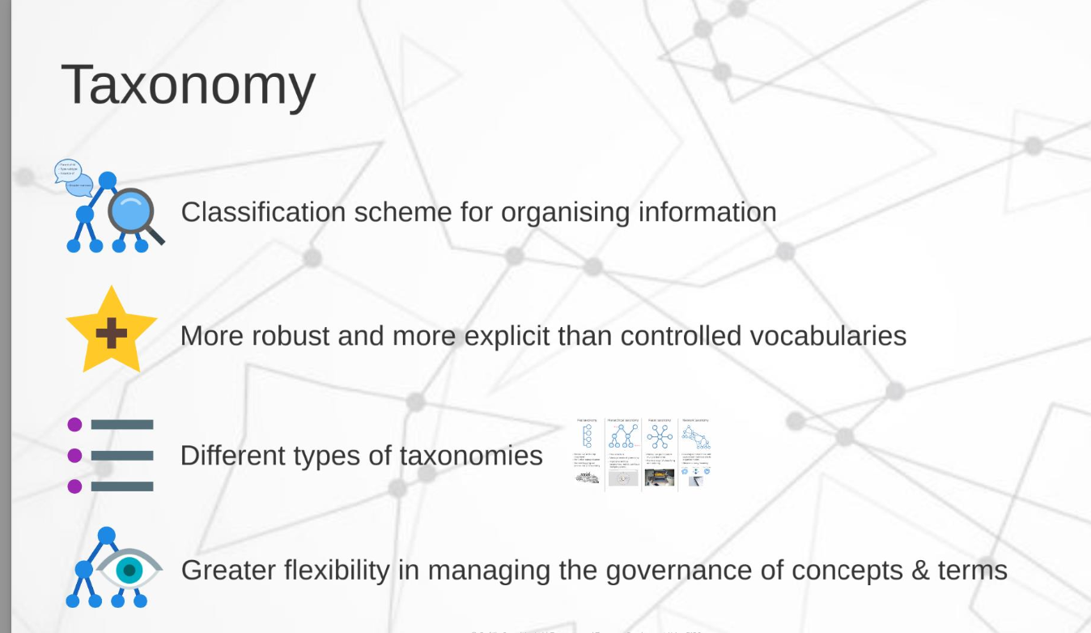

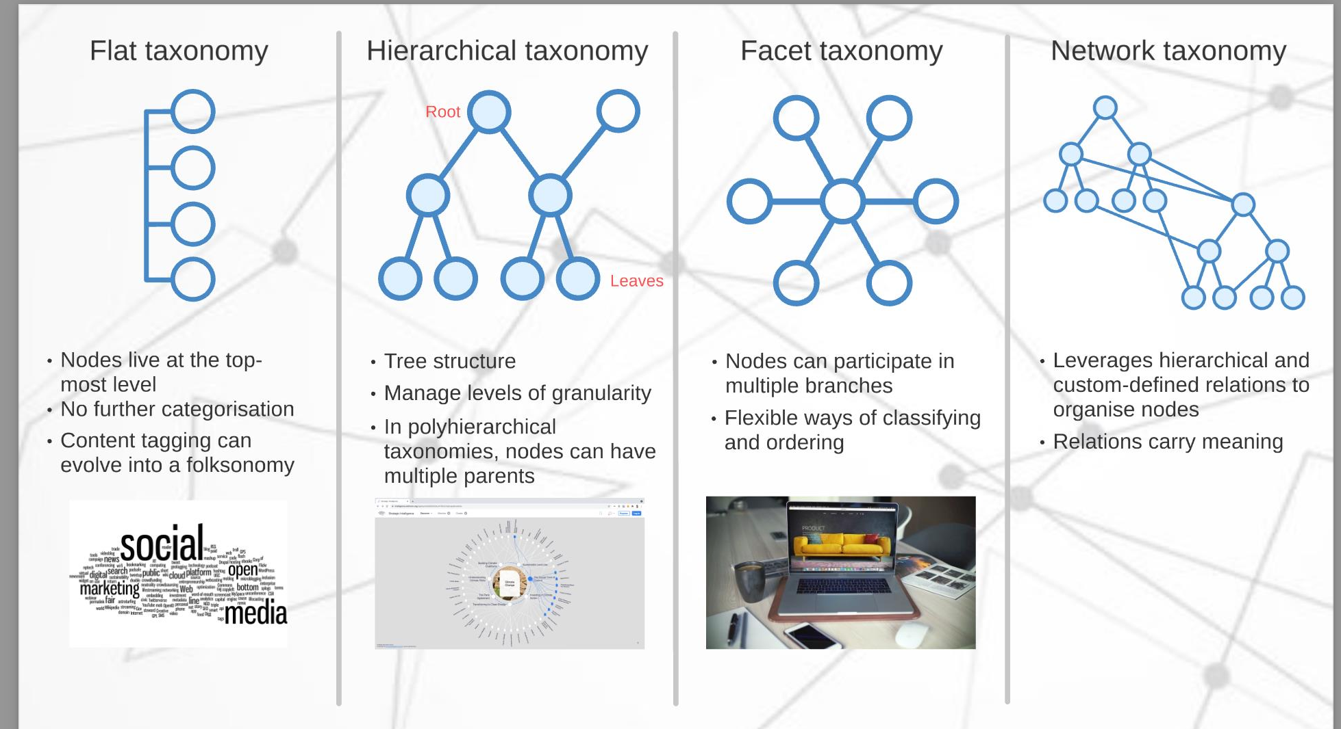

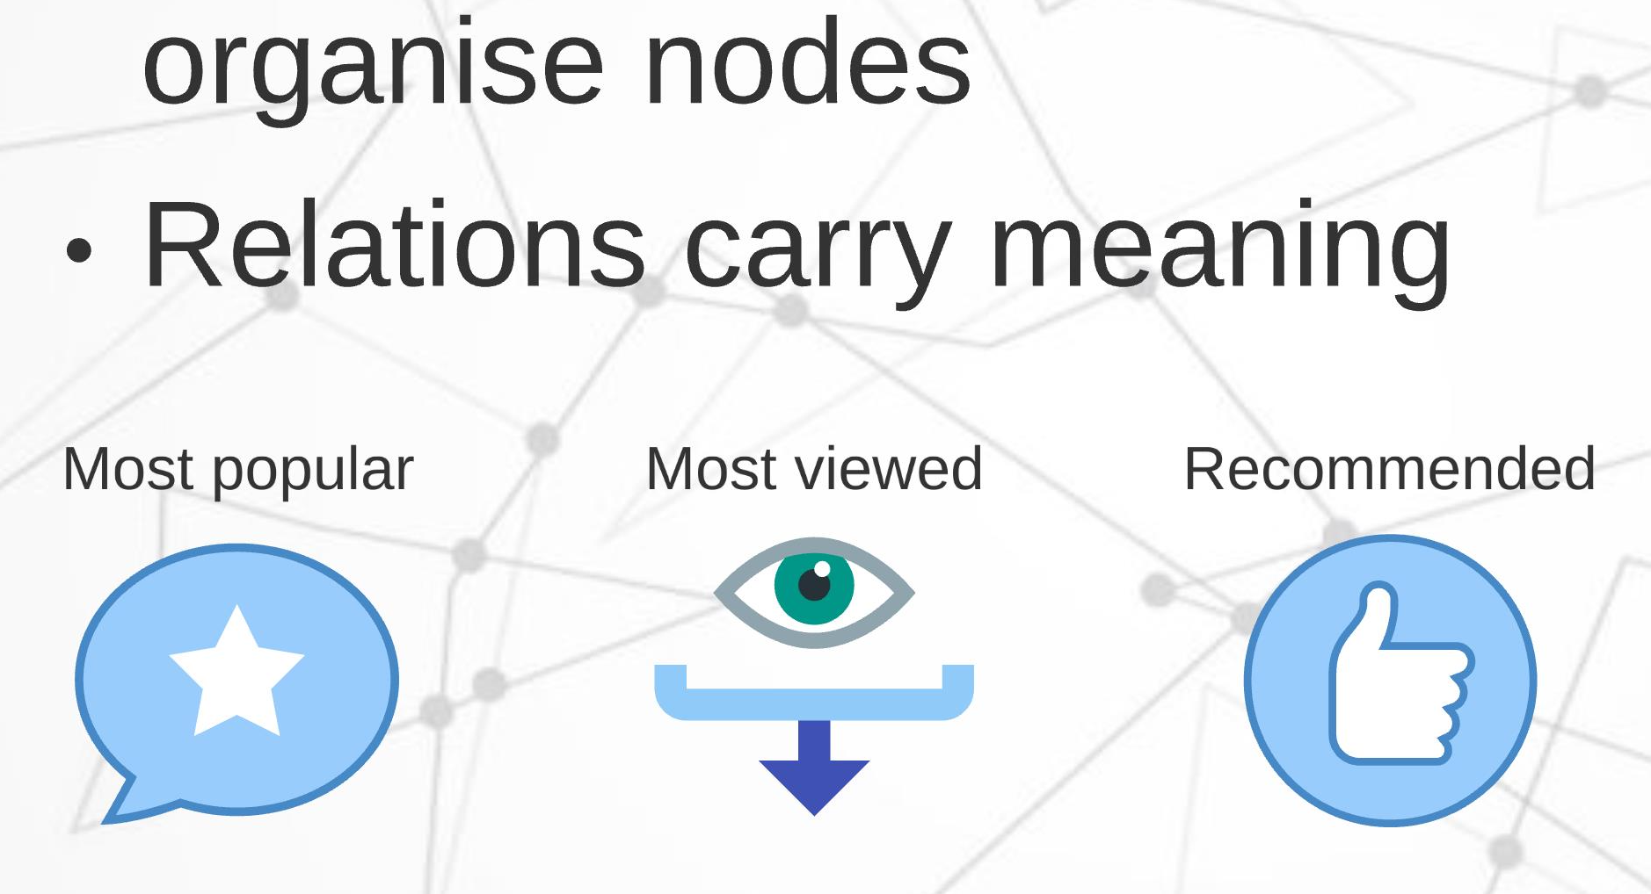

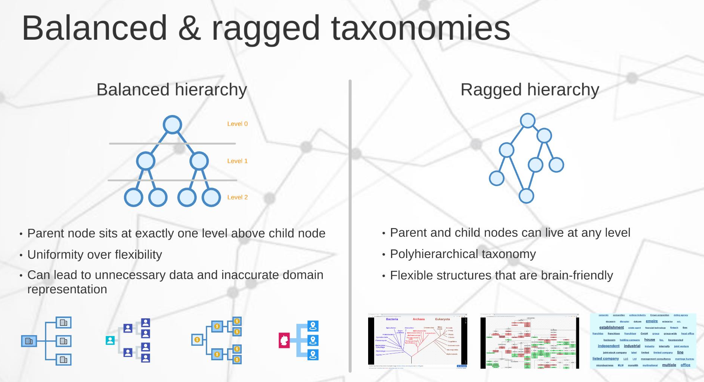

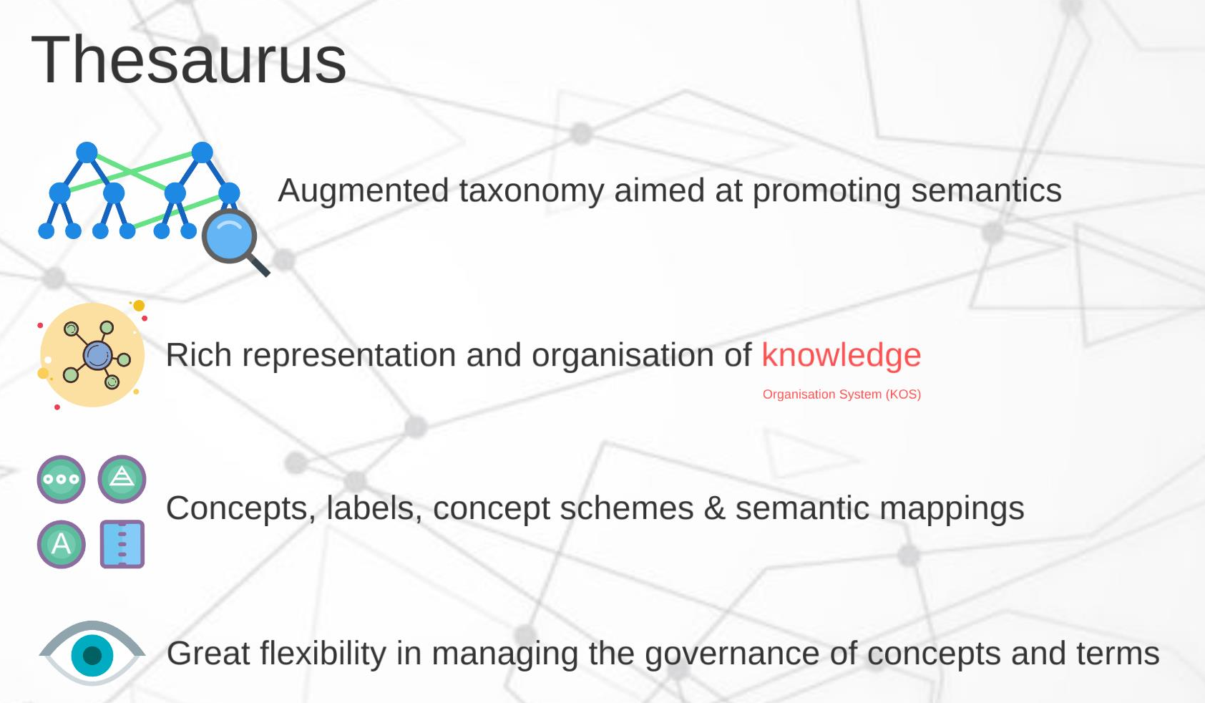

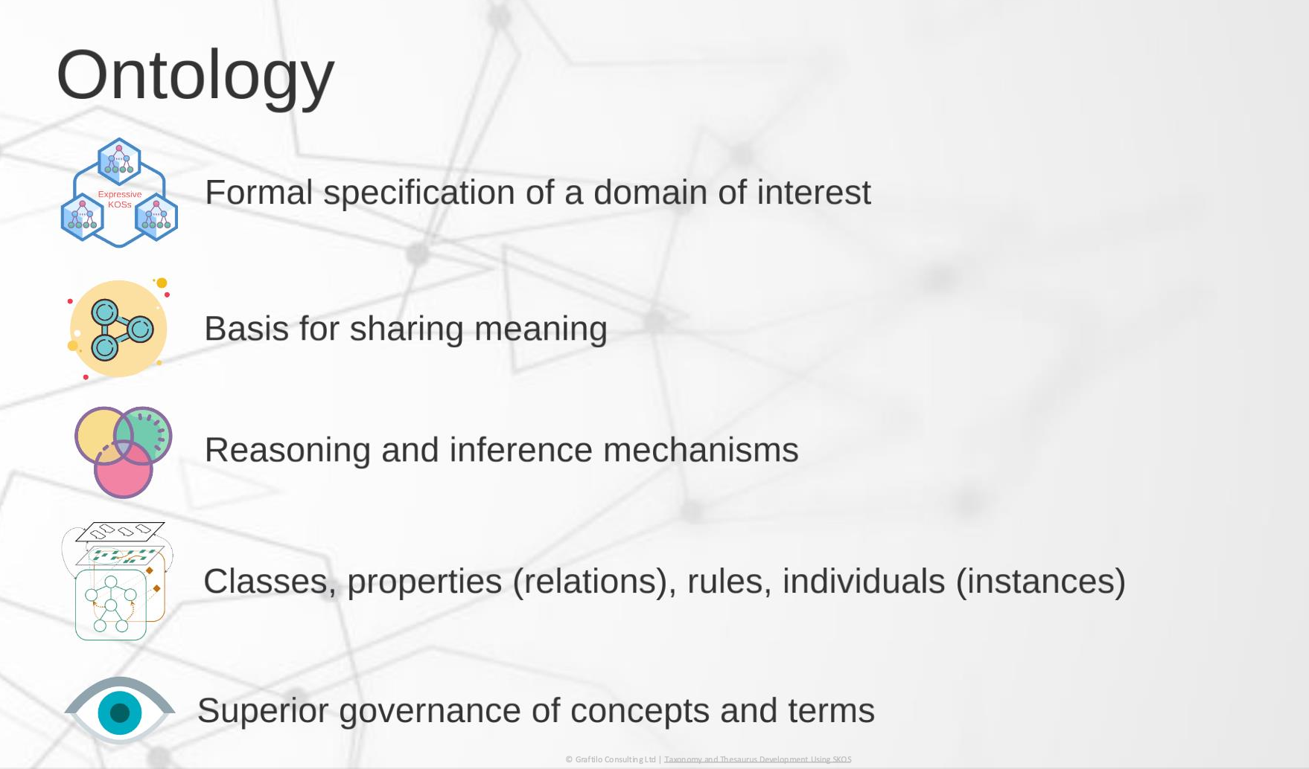

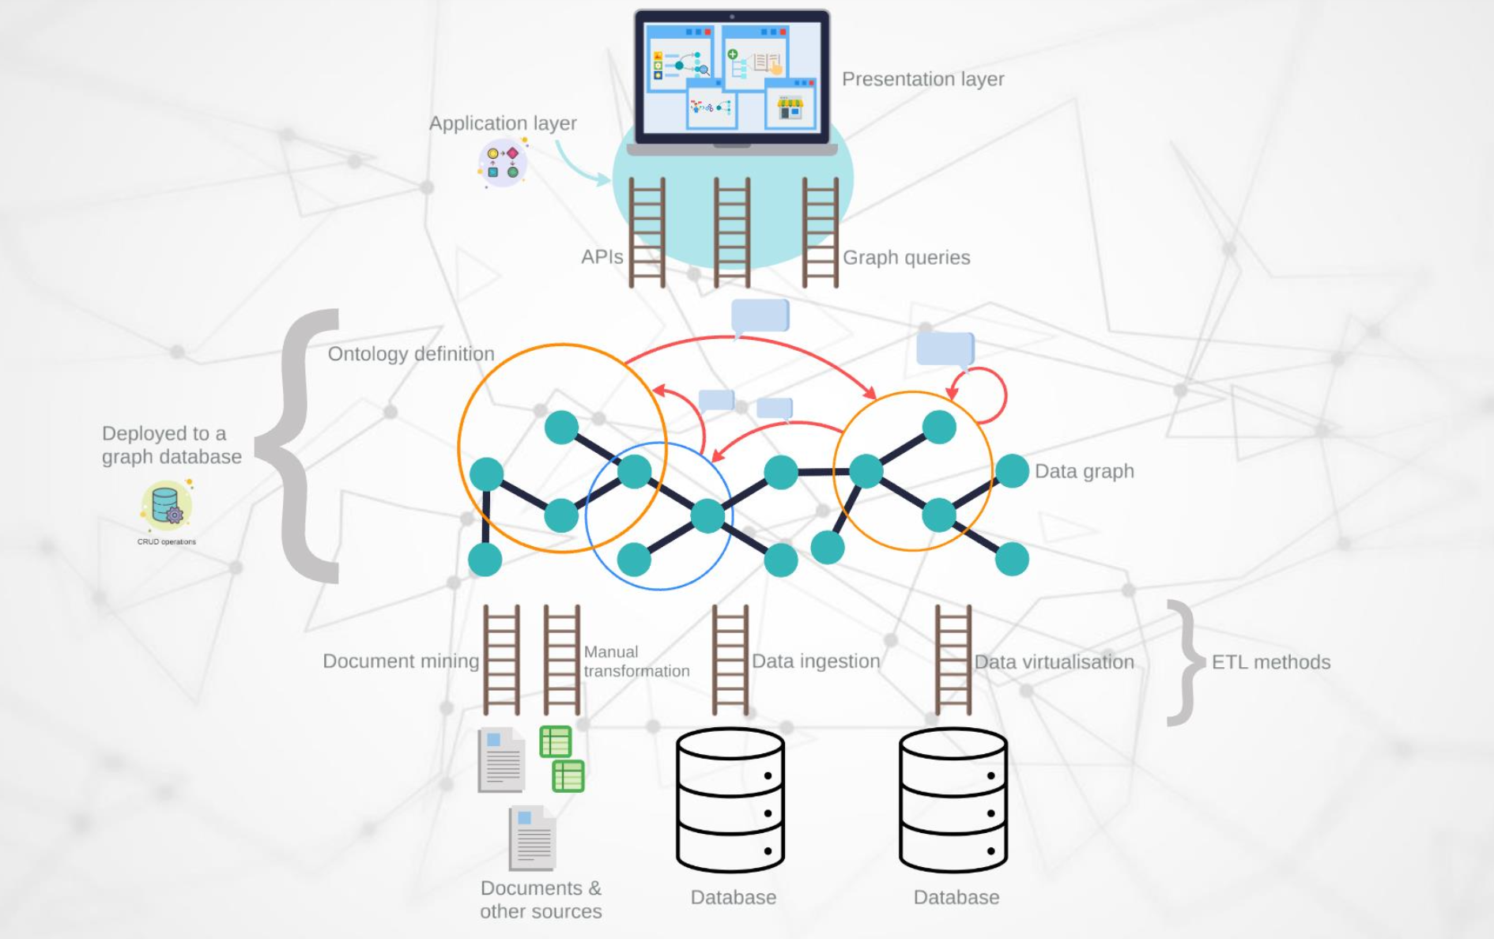

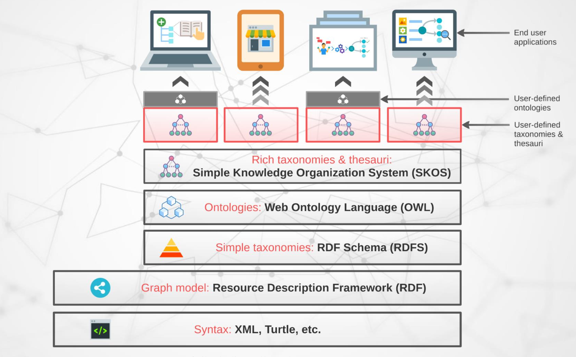

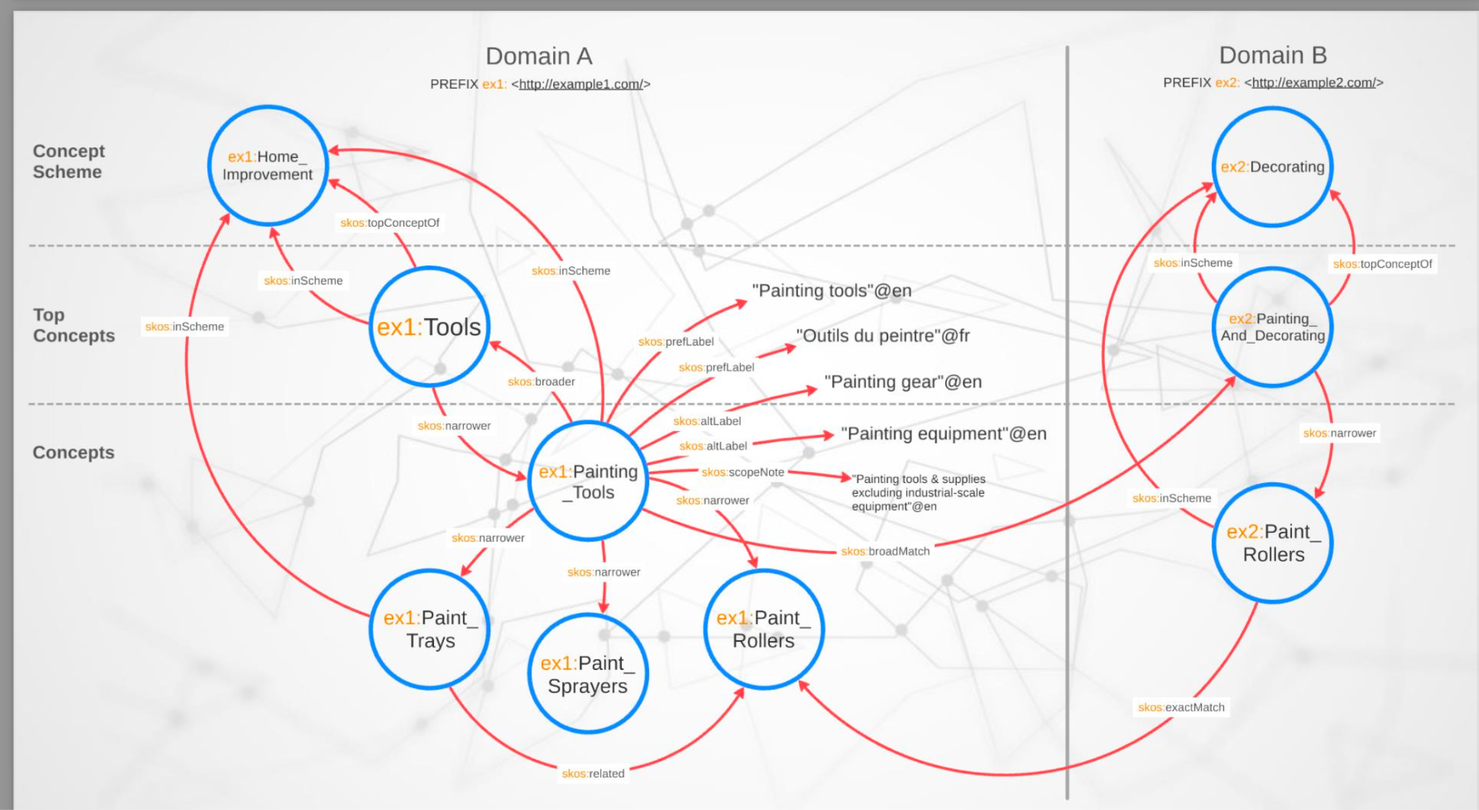

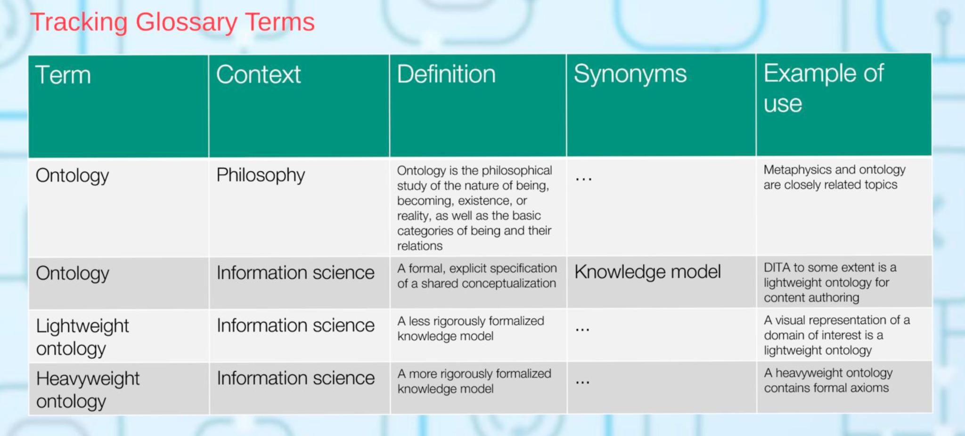

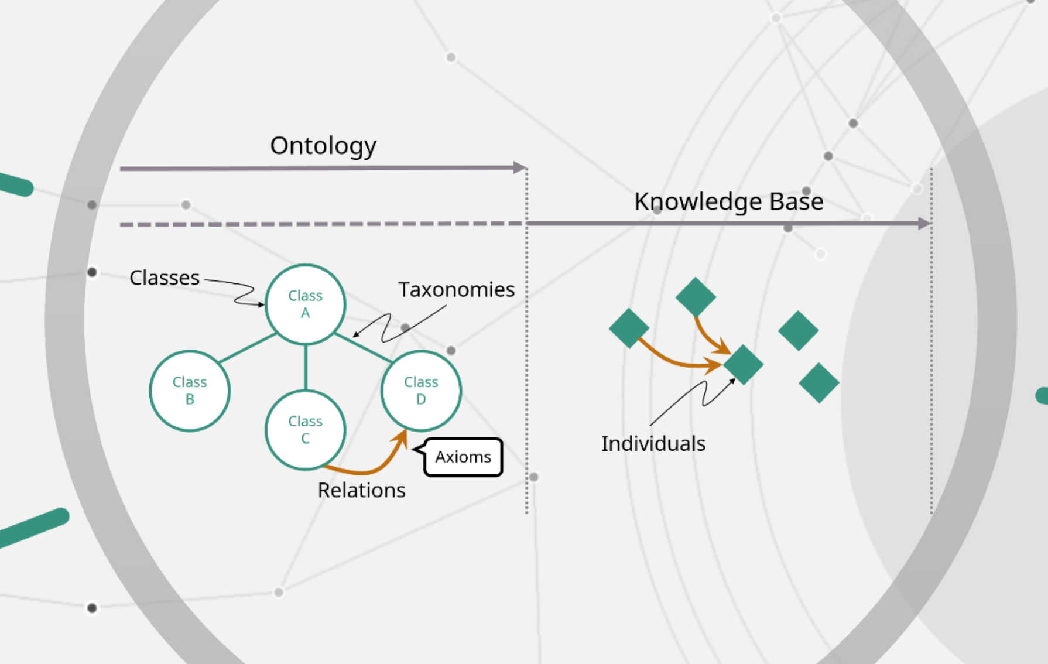

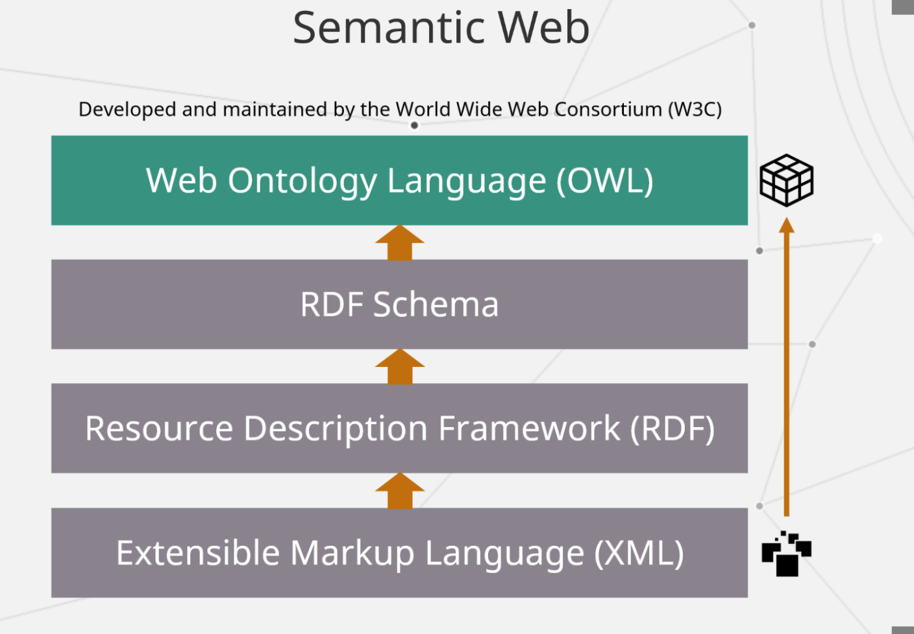

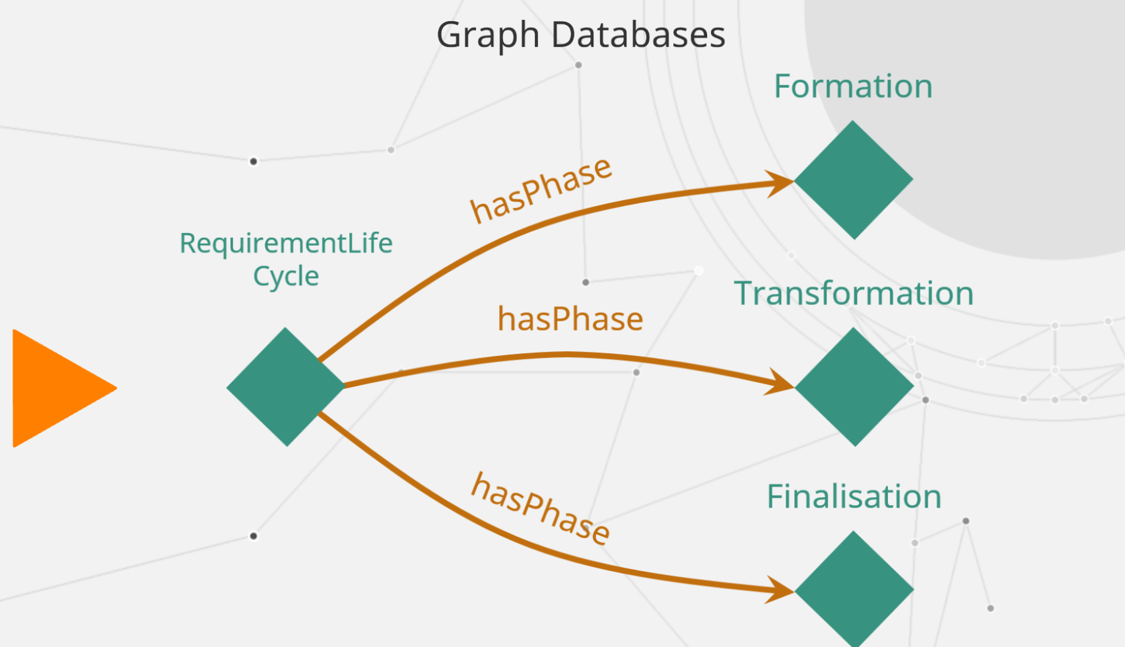

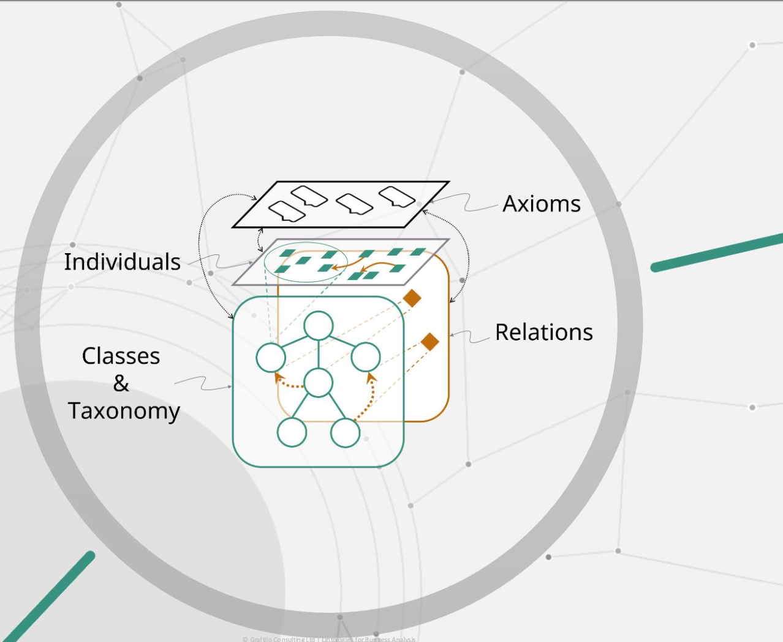

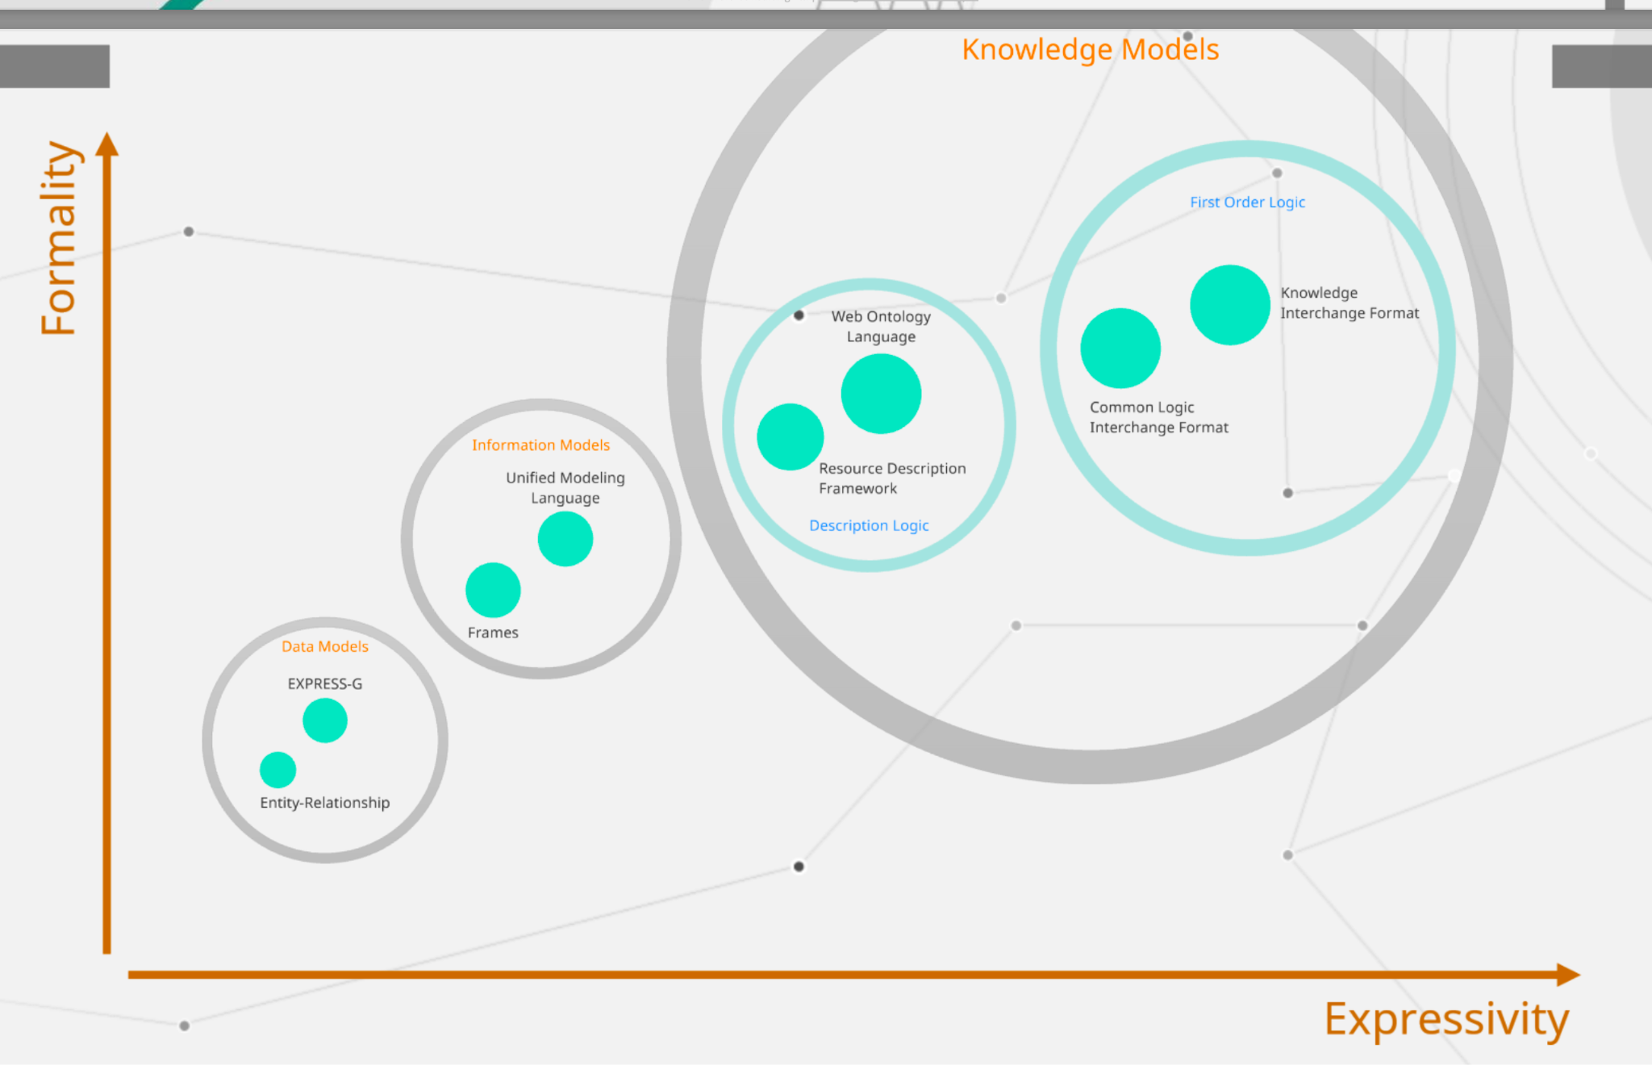

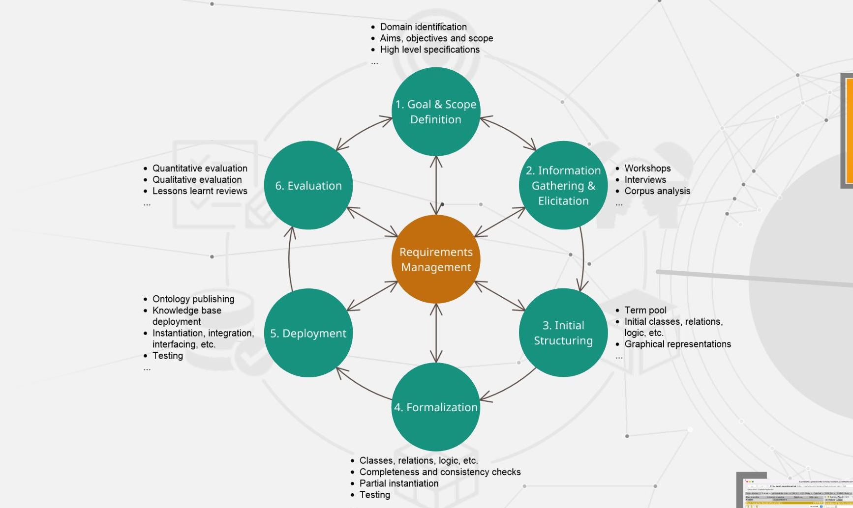

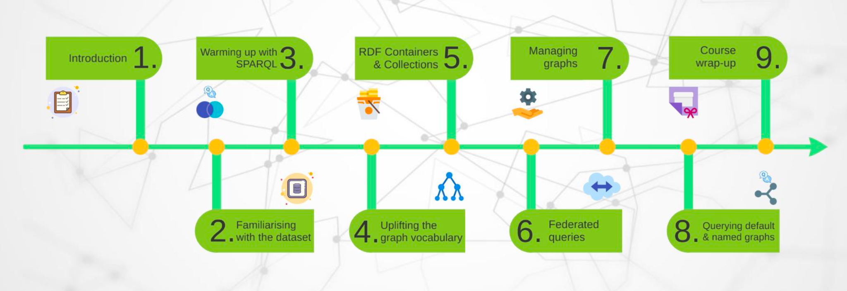

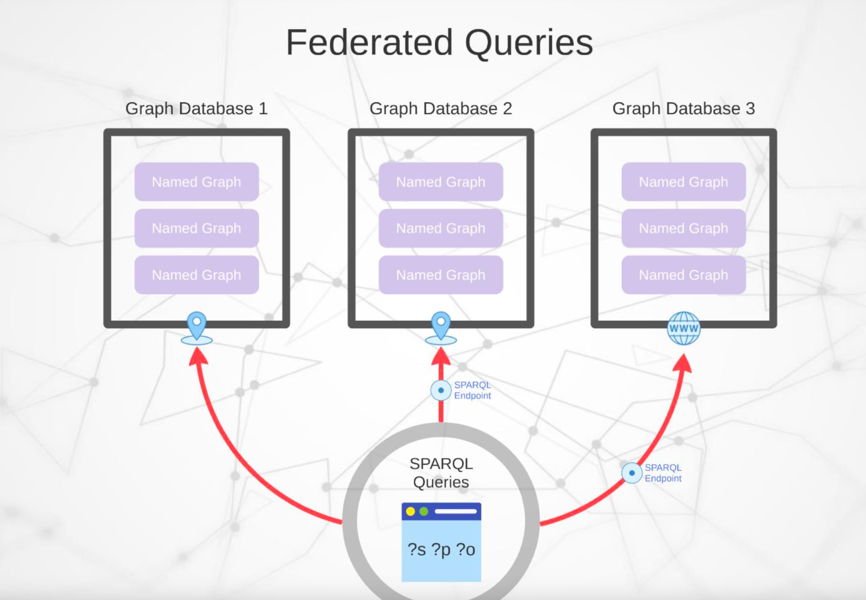



<https://neo4j.com/docs/getting-started/appendix/graphdb-concepts/>

SKO

Can give Car Ontology schema of this and UML text diagram

###### **ChatGPT said:**

Thought for 21s

awesome—here’s a clean **Car Ontology schema** (OWL/Turtle you can paste into Protégé) and a **UML text diagram** (PlantUML). They match the classes/relations we’ve been using.

# **Ontology schema (OWL/Turtle)**

@prefix ex: <http://example.com/auto#> .

@prefix xsd: <http://www.w3.org/2001/XMLSchema#> .

@prefix rdf: <http://www.w3.org/1999/02/22-rdf-syntax-ns#> .

@prefix rdfs: <http://www.w3.org/2000/01/rdf-schema#> .

@prefix owl: <http://www.w3.org/2002/07/owl#> .

@base <http://example.com/auto> .

############################

# Classes

############################

ex:VehicleModel a owl:Class .

ex:Trim a owl:Class .

ex:Feature a owl:Class .

ex:Part a owl:Class .

ex:Manufacturer a owl:Class .

ex:SaleRecord a owl:Class .

ex:MarketRegion a owl:Class .

ex:Document a owl:Class .

ex:RnDDocument a owl:Class ; rdfs:subClassOf ex:Document .

ex:PatentDocument a owl:Class ; rdfs:subClassOf ex:Document .

ex:ReviewDocument a owl:Class ; rdfs:subClassOf ex:Document .

ex:ManualDocument a owl:Class ; rdfs:subClassOf ex:Document .

ex:ImageAsset a owl:Class .

ex:DesignArtifact a owl:Class .

ex:Patent a owl:Class .

ex:RecallEvent a owl:Class .

ex:Organization a owl:Class .

ex:Person a owl:Class .

############################

# Object properties

############################

ex:belongsTo a owl:ObjectProperty ;

rdfs:domain ex:Trim ; rdfs:range ex:VehicleModel .

ex:hasFeature a owl:ObjectProperty ;

rdfs:domain ex:Trim ; rdfs:range ex:Feature .

ex:fits a owl:ObjectProperty ;

rdfs:domain ex:Part ; rdfs:range ex:Trim .

ex:supersedes a owl:ObjectProperty ;

rdfs:domain ex:Part ; rdfs:range ex:Part .

ex:madeBy a owl:ObjectProperty ;

rdfs:domain ex:Part ; rdfs:range ex:Manufacturer .

ex:hasRecall a owl:ObjectProperty ;

rdfs:domain ex:VehicleModel ; rdfs:range ex:RecallEvent .

ex:forTrim a owl:ObjectProperty ;

rdfs:domain ex:SaleRecord ; rdfs:range ex:Trim .

ex:soldIn a owl:ObjectProperty ;

rdfs:domain ex:SaleRecord ; rdfs:range ex:MarketRegion .

ex:mentions a owl:ObjectProperty ;

rdfs:domain ex:Document ; rdfs:range owl:Thing .

ex:depicts a owl:ObjectProperty ;

rdfs:domain ex:ImageAsset ; rdfs:range owl:Thing .

ex:aboutModel a owl:ObjectProperty ;

rdfs:domain ex:Patent ; rdfs:range ex:VehicleModel .

ex:aboutPart a owl:ObjectProperty ;

rdfs:domain ex:Patent ; rdfs:range ex:Part .

ex:authoredBy a owl:ObjectProperty ;

rdfs:domain ex:Document ; rdfs:range ex:Person .

ex:publishedBy a owl:ObjectProperty ;

rdfs:domain ex:Document ; rdfs:range ex:Organization .

############################

# Datatype properties

############################

ex:modelCode a owl:DatatypeProperty ;

rdfs:domain ex:VehicleModel ; rdfs:range xsd:string .

ex:modelYear a owl:DatatypeProperty ;

rdfs:domain ex:Trim ; rdfs:range xsd:gYear .

ex:trimCode a owl:DatatypeProperty ;

rdfs:domain ex:Trim ; rdfs:range xsd:string .

ex:featureCode a owl:DatatypeProperty ;

rdfs:domain ex:Feature ; rdfs:range xsd:string .

ex:featureName a owl:DatatypeProperty ;

rdfs:domain ex:Feature ; rdfs:range xsd:string .

ex:partNumber a owl:DatatypeProperty ;

rdfs:domain ex:Part ; rdfs:range xsd:string .

ex:partName a owl:DatatypeProperty ;

rdfs:domain ex:Part ; rdfs:range xsd:string .

ex:msrp a owl:DatatypeProperty ;

rdfs:domain ex:Part ; rdfs:range xsd:decimal .

ex:saleDate a owl:DatatypeProperty ;

rdfs:domain ex:SaleRecord ; rdfs:range xsd:date .

ex:quantity a owl:DatatypeProperty ;

rdfs:domain ex:SaleRecord ; rdfs:range xsd:integer .

ex:docId a owl:DatatypeProperty ;

rdfs:domain ex:Document ; rdfs:range xsd:string .

ex:title a owl:DatatypeProperty ;

rdfs:domain ex:Document ; rdfs:range xsd:string .

ex:publishedOn a owl:DatatypeProperty ;

rdfs:domain ex:Document ; rdfs:range xsd:date .

ex:caption a owl:DatatypeProperty ;

rdfs:domain ex:ImageAsset ; rdfs:range xsd:string .

ex:vectorId a owl:DatatypeProperty ;

rdfs:domain ex:Document ; rdfs:range xsd:string .

############################

# Key class constraints (OWL-style)

############################

# Trim must belong to exactly one VehicleModel and have at least one modelYear

ex:Trim rdfs:subClassOf

[ a owl:Restriction ; owl:onProperty ex:belongsTo ;

owl:qualifiedCardinality "1"^^xsd:nonNegativeInteger ;

owl:onClass ex:VehicleModel ],

[ a owl:Restriction ; owl:onProperty ex:modelYear ;

owl:minCardinality "1"^^xsd:nonNegativeInteger ] .

# SaleRecord must have forTrim, soldIn, quantity, saleDate

ex:SaleRecord rdfs:subClassOf

[ a owl:Restriction ; owl:onProperty ex:forTrim ; owl:minCardinality "1"^^xsd:nonNegativeInteger ],

[ a owl:Restriction ; owl:onProperty ex:soldIn ; owl:minCardinality "1"^^xsd:nonNegativeInteger ],

[ a owl:Restriction ; owl:onProperty ex:quantity ; owl:minCardinality "1"^^xsd:nonNegativeInteger ],

[ a owl:Restriction ; owl:onProperty ex:saleDate ; owl:minCardinality "1"^^xsd:nonNegativeInteger ] .

# **UML text diagram (PlantUML)**

Paste this into https://www.plantuml.com/plantuml/ or any PlantUML editor.

@startuml

hide circle

skinparam classAttributeIconSize 0

skinparam linetype ortho

class VehicleModel {

+id: IRI

+modelCode: string

+name: string

}

class Trim {

+id: IRI

+trimCode: string

+modelYear: gYear

}

class Feature {

+id: IRI

+featureCode: string

+featureName: string

}

class Part {

+id: IRI

+partNumber: string

+partName: string

+msrp: decimal

}

class Manufacturer {

+id: IRI

+name: string

}

class SaleRecord {

+id: IRI

+saleDate: date

+quantity: integer

}

class MarketRegion {

+code: string

+label: string

}

class Document {

+id: IRI

+title: string

+docType: string

+publishedOn: date

+vectorId: string

}

class RnDDocument

class PatentDocument

class ReviewDocument

class ManualDocument

class ImageAsset {

+id: IRI

+caption: string

}

class DesignArtifact {

+id: IRI

+name: string

}

class Patent {

+id: IRI

+title: string

}

class RecallEvent {

+id: IRI

+title: string

+issuedOn: date

}

class Organization { +id: IRI +name: string }

class Person { +id: IRI +name: string }

' Inheritance (documents)

Document <|-- RnDDocument

Document <|-- PatentDocument

Document <|-- ReviewDocument

Document <|-- ManualDocument

' Core relations (multiplicities)

Trim "1" --> "1" VehicleModel : belongsTo

Trim "0..*" --> "0..*" Feature : hasFeature

Part "1..*" --> "1..*" Trim : fits

Part "0..1" --> "0..1" Part : supersedes

Part "0..1" --> "1" Manufacturer : madeBy

VehicleModel "0..*" --> "0..*" RecallEvent : hasRecall

SaleRecord "1" --> "1" Trim : forTrim

SaleRecord "1" --> "1" MarketRegion : soldIn

Document "0..*" --> "0..*" Feature : mentions

Document "0..*" --> "0..*" Trim : mentions

Document "0..*" --> "0..*" VehicleModel : mentions

ImageAsset "0..*" --> "0..*" Part : depicts

Patent "0..*" --> "0..*" VehicleModel : aboutModel

Patent "0..*" --> "0..*" Part : aboutPart

Document "0..*" --> "0..*" Person : authoredBy

Document "0..*" --> "0..*" Organization : publishedBy

@enduml

If you want, I can also add a **SHACL text file** to validate instances against this UML/OWL (so your CI can block bad loads), or generate a **JSON-LD context** so your APIs can emit/ingest aligned JSON.

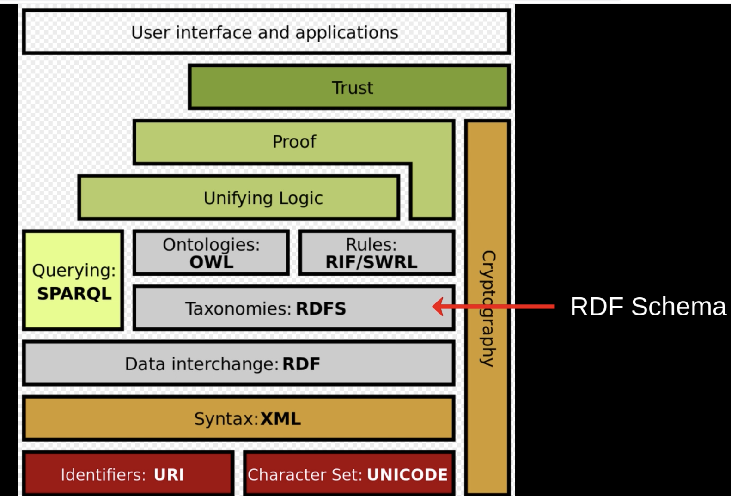

i am unable to understand how these tool, terminology being used with a exmaple reference to develop end to end application Ontology, Knowledge Grapgh, RDF, RDFS, CQs SPARQL, Grapgh DB(neptue), SKOS, Graph DB Federated Queries , SHACL

###### **ChatGPT said:**

Thought for 6s

Got you. Here’s a **plain-English, end-to-end walkthrough** that shows **where each concept/tool fits**, with a tiny car example so you can see the whole thing working together.

# **0) One-line idea**

You first **decide the questions you must answer** (CQs), then **model the world** (Ontology using RDF/RDFS/OWL + SKOS terms), **put facts into a Graph DB** (Neptune) as RDF, **validate** with SHACL, and finally **answer questions** with SPARQL (and optionally federated SPARQL to outside sources). That’s the loop.

# **1) Start from the questions (CQs)**

**CQs = Competency Questions**: they define scope.

* CQ1: “Which **2023 trims** of Falcon X have **Adaptive Cruise Control (ACC)**?”
* CQ2: “How many **sales in CA** on **2023-03-15** for those trims?”
* CQ3: “Show a supporting doc snippet that mentions ACC for Falcon X.”

CQs drive your data model: if you must answer them, your model needs **Model → Trim → Feature** relationships, **Sales** facts, **Documents** linked to Features/Models, and **Regions/Dates**.

# **2) Model the world (Ontology)**

An **Ontology** is your **schema with meaning**, not just tables. You’ll define classes (things) and properties (links/attributes) using **RDF/RDFS/OWL**:

* **RDF (Resource Description Framework)** – the raw data model: everything is **triples** (subject–predicate–object).
* **RDFS (RDF Schema)** – basic schema: what classes/properties exist; domain/range.
* **OWL (Web Ontology Language)** – richer constraints & inference (e.g., cardinality, equivalence).
* **SKOS (Simple Knowledge Organization System)** – controlled vocabularies: preferred labels, synonyms, hierarchies for terms like features, markets.

### **Minimal classes (car domain)**

* VehicleModel, Trim, Feature, SaleRecord, MarketRegion, Document

### **Key relationships**

* ex:belongsTo(Trim → VehicleModel)
* ex:hasFeature(Trim → Feature)
* ex:forTrim(SaleRecord → Trim)
* ex:soldIn(SaleRecord → MarketRegion)
* ex:mentions(Document → Thing)

### **Tiny SKOS example (synonyms)**

<.../feature/ACC> a skos:Concept ;

skos:prefLabel "Adaptive Cruise Control" ;

skos:altLabel "ACC" .

*Why SKOS?* So user queries “ACC” or “Adaptive Cruise Control” both resolve to the **same** concept.

# **3) Put facts in triples (RDF) and store in a Graph DB (Neptune)**

From your cleaned “Gold” tables you mint **URIs** and produce RDF triples:

# Things

<.../model/M1> a ex:VehicleModel ; rdfs:label "Falcon X" .

<.../trim/T101> a ex:Trim ; ex:modelYear "2023"^^xsd:gYear ; ex:belongsTo <.../model/M1> .

<.../trim/T102> a ex:Trim ; ex:modelYear "2023"^^xsd:gYear ; ex:belongsTo <.../model/M1> .

<.../feature/F1> a ex:Feature ; skos:prefLabel "Adaptive Cruise Control" ; skos:altLabel "ACC" .

# Relationships (features & sales)

<.../trim/T101> ex:hasFeature <.../feature/F1> .

<.../trim/T102> ex:hasFeature <.../feature/F1> .

<.../market/CA> a ex:MarketRegion ; rdfs:label "California" .

<.../sale/S1> a ex:SaleRecord ; ex:forTrim <.../trim/T101> ;

ex:soldIn <.../market/CA> ; ex:saleDate "2023-03-15"^^xsd:date ; ex:quantity "120"^^xsd:integer .

<.../sale/S2> a ex:SaleRecord ; ex:forTrim <.../trim/T102> ;

ex:soldIn <.../market/CA> ; ex:saleDate "2023-03-15"^^xsd:date ; ex:quantity "55"^^xsd:integer .

# Documents linked to entities

<.../doc/RND-42> a ex:Document ; ex:title "Falcon X ACC Tuning" .

<.../doc/RND-42> ex:mentions <.../feature/F1> , <.../model/M1> .

Upload these triples to **Amazon Neptune** (its SPARQL endpoint will answer queries over this graph).

# **4) Guardrails (SHACL validation)**

**SHACL** is for data quality at load time.

* Each ex:Trim must have **exactly one** ex:belongsTo and a ex:modelYear.
* Each ex:SaleRecord must have ex:forTrim, ex:soldIn, ex:saleDate, integer ex:quantity.

A tiny SHACL shape (human-readable sketch):

ex:TrimShape a sh:NodeShape ;

sh:targetClass ex:Trim ;

sh:property [ sh:path ex:belongsTo ; sh:minCount 1 ; sh:maxCount 1 ] ;

sh:property [ sh:path ex:modelYear ; sh:minCount 1 ; sh:datatype xsd:gYear ] .

ex:SaleRecordShape a sh:NodeShape ;

sh:targetClass ex:SaleRecord ;

sh:property [ sh:path ex:forTrim ; sh:minCount 1 ] ;

sh:property [ sh:path ex:soldIn ; sh:minCount 1 ] ;

sh:property [ sh:path ex:saleDate ; sh:datatype xsd:date ; sh:minCount 1 ] ;

sh:property [ sh:path ex:quantity ; sh:datatype xsd:integer ; sh:minCount 1 ] .

If incoming data violates these, the load fails (or warns), keeping the KG clean.

# **5) Ask questions with SPARQL (query language for RDF)**

**SPARQL** is to RDF what SQL is to tables.

### **Q1 (from our CQs): trims of Falcon X (2023) that have ACC**

PREFIX ex: <http://example.com/auto#>

PREFIX xsd: <http://www.w3.org/2001/XMLSchema#>

SELECT ?trim WHERE {

?trim a ex:Trim ;

ex:belongsTo <http://example.com/model/M1> ;

ex:hasFeature <http://example.com/feature/F1> ;

ex:modelYear "2023"^^xsd:gYear .

}

**Answer:** T101, T102.

### **Q2: their CA sales on 2023-03-15**

PREFIX ex: <http://example.com/auto#>

PREFIX xsd: <http://www.w3.org/2001/XMLSchema#>

SELECT ?trim (SUM(?q) AS ?units) WHERE {

VALUES ?trim { <http://example.com/trim/T101> <http://example.com/trim/T102> }

?s a ex:SaleRecord ;

ex:forTrim ?trim ;

ex:soldIn <http://example.com/market/CA> ;

ex:saleDate "2023-03-15"^^xsd:date ;

ex:quantity ?q .

}

GROUP BY ?trim

**Answer:** T101: 120, T102: 55.

### **Q3: supporting doc snippet (pattern)**

* Use SPARQL for the **link** to the right doc (ex:mentions).
* Then fetch the text/snippet from your **document index** (BM25/Vector).  
   This is commonly done in the app layer: SPARQL to find the doc IDs → search index to pull the paragraph.

# **6) Reach outside sources (Graph DB Federated Queries)**

If you need e.g. **BMW USA** context from a public KG (like Wikidata), use **federated SPARQL** with SERVICE:

# internal + external in one shot (example pattern)

SELECT ?teslaTrim ?bmwModel ?bmwLabel WHERE {

SERVICE <https://your-neptune-endpoint/sparql> {

?teslaTrim a ex:Trim ;

ex:belongsTo <http://example.com/model/M1> ;

ex:hasFeature <http://example.com/feature/F1> ;

ex:modelYear "2023"^^xsd:gYear .

}

SERVICE <https://query.wikidata.org/sparql> {

?bmwModel wdt:P176 wd:Q153 ; # manufacturer = BMW

rdfs:label ?bmwLabel .

FILTER (LANG(?bmwLabel) = "en")

}

}

Your app merges the internal answer (Tesla) with external context (BMW) and shows **separate citations**.

# **7) Where each term/tool fits (cheat-sheet)**

| **Term** | **What it is** | **When you use it** | **Why it matters** |
| --- | --- | --- | --- |
| **CQs** | Must-answer questions | **First** (scoping) | Drives ontology & data you need |
| **RDF** | Triple data model | When representing facts | Universal graph format for KG |
| **RDFS** | Basic schema for RDF | While designing ontology | Types, subclass, domain/range |
| **OWL** | Rich ontology language | Ontology design & reasoning | Cardinality, equivalence, consistency |
| **SKOS** | Controlled vocabularies | For labels, synonyms, taxonomies | Normalizes names (ACC vs “Adaptive Cruise Control”) |
| **Ontology** | Your domain model (RDFS/OWL) | Before data load; iterates over time | Ensures one meaning for each thing |
| **Knowledge Graph** | Your factual data (RDF triples) + ontology | After mapping/ingest | One connected source of truth |
| **Graph DB (Neptune)** | Storage & SPARQL endpoint | After triples are minted | Fast queries over graph data |
| **SPARQL** | Query language for RDF | At runtime & testing | Answers the CQs |
| **Federated SPARQL** | SPARQL across endpoints | When mixing internal + public KGs | Pulls external context live |
| **SHACL** | Data validation rules | On ingestion/CI | Stops dirty data from polluting KG |

# **8) How this looks as an application (simple flow)**

[User UI]

│ "Which 2023 Falcon X trims have ACC and CA sales on 2023-03-15?"

▼

[Orchestrator]

1) Entity link (“Falcon X”→M1, “ACC”→F1 via SKOS labels)

2) Run SPARQL#1 (trims) on Neptune

3) Run SPARQL#2 (sales) on Neptune

4) (Optional) Federated SPARQL for external context (e.g., BMW)

5) Get doc snippet from search index (doc IDs from SPARQL)

6) Compose final answer + citations

▼

[Response to user]

T101 — 120 units; T102 — 55 units. Evidence: RND-42 snippet.

# **9) Minimal, verifiable example (copy/paste ready)**

### **Trims query (SPARQL)**

PREFIX ex: <http://example.com/auto#>

PREFIX xsd: <http://www.w3.org/2001/XMLSchema#>

SELECT ?trim WHERE {

?trim a ex:Trim ;

ex:belongsTo <http://example.com/model/M1> ;

ex:hasFeature <http://example.com/feature/F1> ;

ex:modelYear "2023"^^xsd:gYear .

}

### **Sales query (SPARQL)**

PREFIX ex: <http://example.com/auto#>

PREFIX xsd: <http://www.w3.org/2001/XMLSchema#>

SELECT ?trim (SUM(?q) AS ?units) WHERE {

VALUES ?trim { <http://example.com/trim/T101> <http://example.com/trim/T102> }

?s a ex:SaleRecord ; ex:forTrim ?trim ;

ex:soldIn <http://example.com/market/CA> ;

ex:saleDate "2023-03-15"^^xsd:date ; ex:quantity ?q .

}

GROUP BY ?trim

### **SHACL (sketch)**

ex:TrimShape a sh:NodeShape ; sh:targetClass ex:Trim ;

sh:property [ sh:path ex:belongsTo ; sh:minCount 1 ; sh:maxCount 1 ] ;

sh:property [ sh:path ex:modelYear ; sh:minCount 1 ; sh:datatype xsd:gYear ] .

If these queries run on your Neptune KG built from the tiny rows above, you’ll get **T101, T102** and **(120, 55)** exactly as described.

## **TL;DR**

* **Define CQs** → **Design Ontology** with RDF/RDFS/OWL (+ SKOS labels)
* **Map data → RDF** and **load into Neptune**
* **Validate with SHACL**
* **Answer with SPARQL**, optionally **federate** to public KGs  
   This is the concrete way each term/technology is used to build your end-to-end app.

If you want, I can also paste a **Neptune-ready N-Triples file** and a **one-click SPARQL script** you can run in the Neptune Workbench to see the answers immediately.

Perfect — here are TWO copy-paste options:

# **Option A — Neptune-ready N-Triples (tiny dataset)**

Save the block below as **neptune_sample.nt** (or paste into S3 and use the bulk loader).

<http://example.com/model/M1> <http://www.w3.org/1999/02/22-rdf-syntax-ns#type> <http://example.com/auto#VehicleModel> .

<http://example.com/model/M1> <http://example.com/auto#modelCode> "FX" .

<http://example.com/model/M1> <http://www.w3.org/2000/01/rdf-schema#label> "Falcon X" .

<http://example.com/trim/T101> <http://www.w3.org/1999/02/22-rdf-syntax-ns#type> <http://example.com/auto#Trim> .

<http://example.com/trim/T101> <http://example.com/auto#modelYear> "2023"^^<http://www.w3.org/2001/XMLSchema#gYear> .

<http://example.com/trim/T101> <http://example.com/auto#belongsTo> <http://example.com/model/M1> .

<http://example.com/trim/T102> <http://www.w3.org/1999/02/22-rdf-syntax-ns#type> <http://example.com/auto#Trim> .

<http://example.com/trim/T102> <http://example.com/auto#modelYear> "2023"^^<http://www.w3.org/2001/XMLSchema#gYear> .

<http://example.com/trim/T102> <http://example.com/auto#belongsTo> <http://example.com/model/M1> .

<http://example.com/feature/F1> <http://www.w3.org/1999/02/22-rdf-syntax-ns#type> <http://example.com/auto#Feature> .

<http://example.com/feature/F1> <http://example.com/auto#featureCode> "ACC" .

<http://example.com/feature/F1> <http://www.w3.org/2004/02/skos/core#prefLabel> "Adaptive Cruise Control" .

<http://example.com/feature/F1> <http://www.w3.org/2004/02/skos/core#altLabel> "ACC" .

<http://example.com/trim/T101> <http://example.com/auto#hasFeature> <http://example.com/feature/F1> .

<http://example.com/trim/T102> <http://example.com/auto#hasFeature> <http://example.com/feature/F1> .

<http://example.com/part/P1> <http://www.w3.org/1999/02/22-rdf-syntax-ns#type> <http://example.com/auto#Part> .

<http://example.com/part/P1> <http://example.com/auto#partNumber> "P-001" .

<http://example.com/part/P1> <http://www.w3.org/2000/01/rdf-schema#label> "Front Radar Unit" .

<http://example.com/part/P1> <http://example.com/auto#fits> <http://example.com/trim/T102> .

<http://example.com/market/CA> <http://www.w3.org/1999/02/22-rdf-syntax-ns#type> <http://example.com/auto#MarketRegion> .

<http://example.com/market/CA> <http://www.w3.org/2000/01/rdf-schema#label> "California" .

<http://example.com/sale/S1> <http://www.w3.org/1999/02/22-rdf-syntax-ns#type> <http://example.com/auto#SaleRecord> .

<http://example.com/sale/S1> <http://example.com/auto#forTrim> <http://example.com/trim/T101> .

<http://example.com/sale/S1> <http://example.com/auto#soldIn> <http://example.com/market/CA> .

<http://example.com/sale/S1> <http://example.com/auto#saleDate> "2023-03-15"^^<http://www.w3.org/2001/XMLSchema#date> .

<http://example.com/sale/S1> <http://example.com/auto#quantity> "120"^^<http://www.w3.org/2001/XMLSchema#integer> .

<http://example.com/sale/S2> <http://www.w3.org/1999/02/22-rdf-syntax-ns#type> <http://example.com/auto#SaleRecord> .

<http://example.com/sale/S2> <http://example.com/auto#forTrim> <http://example.com/trim/T102> .

<http://example.com/sale/S2> <http://example.com/auto#soldIn> <http://example.com/market/CA> .

<http://example.com/sale/S2> <http://example.com/auto#saleDate> "2023-03-15"^^<http://www.w3.org/2001/XMLSchema#date> .

<http://example.com/sale/S2> <http://example.com/auto#quantity> "55"^^<http://www.w3.org/2001/XMLSchema#integer> .

<http://example.com/doc/RND-42> <http://www.w3.org/1999/02/22-rdf-syntax-ns#type> <http://example.com/auto#Document> .

<http://example.com/doc/RND-42> <http://example.com/auto#title> "Falcon X ACC Tuning" .

<http://example.com/doc/RND-42> <http://example.com/auto#publishedOn> "2023-03-10"^^<http://www.w3.org/2001/XMLSchema#date> .

<http://example.com/doc/RND-42> <http://example.com/auto#mentions> <http://example.com/feature/F1> .

<http://example.com/doc/RND-42> <http://example.com/auto#mentions> <http://example.com/model/M1> .

<http://example.com/doc/MAN-9> <http://www.w3.org/1999/02/22-rdf-syntax-ns#type> <http://example.com/auto#Document> .

<http://example.com/doc/MAN-9> <http://example.com/auto#title> "Falcon X Owner Manual" .

<http://example.com/doc/MAN-9> <http://example.com/auto#publishedOn> "2023-02-01"^^<http://www.w3.org/2001/XMLSchema#date> .

<http://example.com/doc/MAN-9> <http://example.com/auto#mentions> <http://example.com/trim/T101> .

<http://example.com/image/IMG-7> <http://www.w3.org/1999/02/22-rdf-syntax-ns#type> <http://example.com/auto#ImageAsset> .

<http://example.com/image/IMG-7> <http://example.com/auto#caption> "Exploded view of Falcon X front radar module" .

<http://example.com/image/IMG-7> <http://example.com/auto#depicts> <http://example.com/part/P1> .

<http://example.com/patent/PAT-9> <http://www.w3.org/1999/02/22-rdf-syntax-ns#type> <http://example.com/auto#Patent> .

<http://example.com/patent/PAT-9> <http://example.com/auto#title> "Thermal control for radar modules" .

<http://example.com/patent/PAT-9> <http://example.com/auto#aboutModel> <http://example.com/model/M1> .

<http://example.com/patent/PAT-9> <http://example.com/auto#aboutPart> <http://example.com/part/P1> .

### **Load via Neptune bulk loader (optional)**

Upload the file to S3 (e.g., s3://YOUR-BUCKET/neptune/neptune_sample.nt) and start a job:

aws neptune-data start-loader-job \

--region us-east-1 \

--endpoint https://YOUR-NEPTUNE-ENDPOINT:8182 \

--payload '{

"source": "s3://YOUR-BUCKET/neptune/neptune_sample.nt",

"format": "ntriples",

"iamRoleArn": "arn:aws:iam::123456789012:role/NeptuneLoadFromS3",

"region": "us-east-1",

"failOnError": "FALSE",

"parallelism": "HIGH",

"queueRequest": "TRUE"

}'

# **Option B — One-click SPARQL script (Workbench)**

Paste the whole block into a **SPARQL** tab in Neptune Workbench and click **Run** once.  
 It **inserts** the tiny dataset and then runs the two CQs (trims & sales).

# --- LOAD TINY DATASET (INSERT DATA) ---

PREFIX ex: <http://example.com/auto#>

PREFIX xsd: <http://www.w3.org/2001/XMLSchema#>

INSERT DATA {

<http://example.com/model/M1> a ex:VehicleModel ;

ex:modelCode "FX" ;

<http://www.w3.org/2000/01/rdf-schema#label> "Falcon X" .

<http://example.com/trim/T101> a ex:Trim ;

ex:modelYear "2023"^^xsd:gYear ;

ex:belongsTo <http://example.com/model/M1> ;

ex:hasFeature <http://example.com/feature/F1> .

<http://example.com/trim/T102> a ex:Trim ;

ex:modelYear "2023"^^xsd:gYear ;

ex:belongsTo <http://example.com/model/M1> ;

ex:hasFeature <http://example.com/feature/F1> .

<http://example.com/feature/F1> a ex:Feature ;

ex:featureCode "ACC" ;

<http://www.w3.org/2004/02/skos/core#prefLabel> "Adaptive Cruise Control" ;

<http://www.w3.org/2004/02/skos/core#altLabel> "ACC" .

<http://example.com/market/CA> a ex:MarketRegion ;

<http://www.w3.org/2000/01/rdf-schema#label> "California" .

<http://example.com/sale/S1> a ex:SaleRecord ;

ex:forTrim <http://example.com/trim/T101> ;

ex:soldIn <http://example.com/market/CA> ;

ex:saleDate "2023-03-15"^^xsd:date ;

ex:quantity "120"^^xsd:integer .

<http://example.com/sale/S2> a ex:SaleRecord ;

ex:forTrim <http://example.com/trim/T102> ;

ex:soldIn <http://example.com/market/CA> ;

ex:saleDate "2023-03-15"^^xsd:date ;

ex:quantity "55"^^xsd:integer .

<http://example.com/doc/RND-42> a ex:Document ;

ex:title "Falcon X ACC Tuning" ;

ex:publishedOn "2023-03-10"^^xsd:date ;

ex:mentions <http://example.com/feature/F1> , <http://example.com/model/M1> .

<http://example.com/doc/MAN-9> a ex:Document ;

ex:title "Falcon X Owner Manual" ;

ex:publishedOn "2023-02-01"^^xsd:date ;

ex:mentions <http://example.com/trim/T101> .

<http://example.com/part/P1> a ex:Part ;

ex:partNumber "P-001" ;

<http://www.w3.org/2000/01/rdf-schema#label> "Front Radar Unit" ;

ex:fits <http://example.com/trim/T102> .

<http://example.com/image/IMG-7> a ex:ImageAsset ;

ex:caption "Exploded view of Falcon X front radar module" ;

ex:depicts <http://example.com/part/P1> .

<http://example.com/patent/PAT-9> a ex:Patent ;

ex:title "Thermal control for radar modules" ;

ex:aboutModel <http://example.com/model/M1> ;

ex:aboutPart <http://example.com/part/P1> .

};

# --- CQ1: 2023 Falcon X trims with ACC ---

PREFIX ex: <http://example.com/auto#>

PREFIX xsd: <http://www.w3.org/2001/XMLSchema#>

SELECT ?trim WHERE {

?trim a ex:Trim ;

ex:belongsTo <http://example.com/model/M1> ;

ex:hasFeature <http://example.com/feature/F1> ;

ex:modelYear "2023"^^xsd:gYear .

}

# --- CQ2: CA sales on 2023-03-15 for those trims ---

PREFIX ex: <http://example.com/auto#>

PREFIX xsd: <http://www.w3.org/2001/XMLSchema#>

SELECT ?trim (SUM(?q) AS ?units) WHERE {

VALUES ?trim { <http://example.com/trim/T101> <http://example.com/trim/T102> }

?sr a ex:SaleRecord ;

ex:forTrim ?trim ;

ex:soldIn <http://example.com/market/CA> ;

ex:saleDate "2023-03-15"^^xsd:date ;

ex:quantity ?q .

}

GROUP BY ?trim

**Expected results**

* CQ1 → http://example.com/trim/T101, http://example.com/trim/T102
* CQ2 → T101 → 120, T102 → 55

## **Quick tips**

* If you prefer **separate graphs**, add GRAPH <http://example.com/graph/demo> { … } around the INSERT DATA and add FROM/FROM NAMED to your queries.

If you want to **wipe** only this demo, run:  
  
 DELETE WHERE { ?s ?p ?o .

FILTER(STRSTARTS(STR(?s),"http://example.com/")) }

* To add **SHACL** validation later, upload your shapes graph and run validation in your ETL before insert/bulk-load.

If you want, I can tailor these scripts to your exact Neptune endpoint + S3 bucket/role so you can paste and run without edits.

Thought for 35s

Awesome—here are **tailored, copy-paste scripts** with the few values you’ll swap (endpoint, bucket, role, region). I’m giving you two paths:

1. **Bulk-load** the RDF file from S3 into Neptune via the **Data API**;
2. **One-click Workbench SPARQL** you paste into Neptune Workbench to insert & query immediately.

I’ve marked the *four* values you’ll replace like: <<YOUR_...>>.

# **1) Variables to set (once)**

# === FILL THESE 4 VALUES ===

export AWS_REGION=<<YOUR_AWS_REGION>> # e.g. us-east-1

export NEPTUNE_ENDPOINT=<<YOUR_NEPTUNE_ENDPOINT>> # e.g. neptune-xxxx.cluster-abc.us-east-1.neptune.amazonaws.com

export S3_BUCKET=<<YOUR_S3_BUCKET>> # e.g. my-neptune-demos

export NEPTUNE_LOADER_ROLE_ARN=<<YOUR_NEPTUNE_ROLE_ARN>> # ARN that Neptune uses to read from S3

# **2) Create the N-Triples file locally and upload to S3**

cat > neptune_sample.nt <<'NT'

<http://example.com/model/M1> <http://www.w3.org/1999/02/22-rdf-syntax-ns#type> <http://example.com/auto#VehicleModel> .

<http://example.com/model/M1> <http://example.com/auto#modelCode> "FX" .

<http://example.com/model/M1> <http://www.w3.org/2000/01/rdf-schema#label> "Falcon X" .

<http://example.com/trim/T101> <http://www.w3.org/1999/02/22-rdf-syntax-ns#type> <http://example.com/auto#Trim> .

<http://example.com/trim/T101> <http://example.com/auto#modelYear> "2023"^^<http://www.w3.org/2001/XMLSchema#gYear> .

<http://example.com/trim/T101> <http://example.com/auto#belongsTo> <http://example.com/model/M1> .

<http://example.com/trim/T102> <http://www.w3.org/1999/02/22-rdf-syntax-ns#type> <http://example.com/auto#Trim> .

<http://example.com/trim/T102> <http://example.com/auto#modelYear> "2023"^^<http://www.w3.org/2001/XMLSchema#gYear> .

<http://example.com/trim/T102> <http://example.com/auto#belongsTo> <http://example.com/model/M1> .

<http://example.com/feature/F1> <http://www.w3.org/1999/02/22-rdf-syntax-ns#type> <http://example.com/auto#Feature> .

<http://example.com/feature/F1> <http://example.com/auto#featureCode> "ACC" .

<http://example.com/feature/F1> <http://www.w3.org/2004/02/skos/core#prefLabel> "Adaptive Cruise Control" .

<http://example.com/feature/F1> <http://www.w3.org/2004/02/skos/core#altLabel> "ACC" .

<http://example.com/trim/T101> <http://example.com/auto#hasFeature> <http://example.com/feature/F1> .

<http://example.com/trim/T102> <http://example.com/auto#hasFeature> <http://example.com/feature/F1> .

<http://example.com/part/P1> <http://www.w3.org/1999/02/22-rdf-syntax-ns#type> <http://example.com/auto#Part> .

<http://example.com/part/P1> <http://example.com/auto#partNumber> "P-001" .

<http://example.com/part/P1> <http://www.w3.org/2000/01/rdf-schema#label> "Front Radar Unit" .

<http://example.com/part/P1> <http://example.com/auto#fits> <http://example.com/trim/T102> .

<http://example.com/market/CA> <http://www.w3.org/1999/02/22-rdf-syntax-ns#type> <http://example.com/auto#MarketRegion> .

<http://example.com/market/CA> <http://www.w3.org/2000/01/rdf-schema#label> "California" .

<http://example.com/sale/S1> <http://www.w3.org/1999/02/22-rdf-syntax-ns#type> <http://example.com/auto#SaleRecord> .

<http://example.com/sale/S1> <http://example.com/auto#forTrim> <http://example.com/trim/T101> .

<http://example.com/sale/S1> <http://example.com/auto#soldIn> <http://example.com/market/CA> .

<http://example.com/sale/S1> <http://example.com/auto#saleDate> "2023-03-15"^^<http://www.w3.org/2001/XMLSchema#date> .

<http://example.com/sale/S1> <http://example.com/auto#quantity> "120"^^<http://www.w3.org/2001/XMLSchema#integer> .

<http://example.com/sale/S2> <http://www.w3.org/1999/02/22-rdf-syntax-ns#type> <http://example.com/auto#SaleRecord> .

<http://example.com/sale/S2> <http://example.com/auto#forTrim> <http://example.com/trim/T102> .

<http://example.com/sale/S2> <http://example.com/auto#soldIn> <http://example.com/market/CA> .

<http://example.com/sale/S2> <http://example.com/auto#saleDate> "2023-03-15"^^<http://www.w3.org/2001/XMLSchema#date> .

<http://example.com/sale/S2> <http://example.com/auto#quantity> "55"^^<http://www.w3.org/2001/XMLSchema#integer> .

<http://example.com/doc/RND-42> <http://www.w3.org/1999/02/22-rdf-syntax-ns#type> <http://example.com/auto#Document> .

<http://example.com/doc/RND-42> <http://example.com/auto#title> "Falcon X ACC Tuning" .

<http://example.com/doc/RND-42> <http://example.com/auto#publishedOn> "2023-03-10"^^<http://www.w3.org/2001/XMLSchema#date> .

<http://example.com/doc/RND-42> <http://example.com/auto#mentions> <http://example.com/feature/F1> .

<http://example.com/doc/RND-42> <http://example.com/auto#mentions> <http://example.com/model/M1> .

<http://example.com/doc/MAN-9> <http://www.w3.org/1999/02/22-rdf-syntax-ns#type> <http://example.com/auto#Document> .

<http://example.com/doc/MAN-9> <http://example.com/auto#title> "Falcon X Owner Manual" .

<http://example.com/doc/MAN-9> <http://example.com/auto#publishedOn> "2023-02-01"^^<http://www.w3.org/2001/XMLSchema#date> .

<http://example.com/doc/MAN-9> <http://example.com/auto#mentions> <http://example.com/trim/T101> .

<http://example.com/image/IMG-7> <http://www.w3.org/1999/02/22-rdf-syntax-ns#type> <http://example.com/auto#ImageAsset> .

<http://example.com/image/IMG-7> <http://example.com/auto#caption> "Exploded view of Falcon X front radar module" .

<http://example.com/image/IMG-7> <http://example.com/auto#depicts> <http://example.com/part/P1> .

<http://example.com/patent/PAT-9> <http://www.w3.org/1999/02/22-rdf-syntax-ns#type> <http://example.com/auto#Patent> .

<http://example.com/patent/PAT-9> <http://example.com/auto#title> "Thermal control for radar modules" .

<http://example.com/patent/PAT-9> <http://example.com/auto#aboutModel> <http://example.com/model/M1> .

<http://example.com/patent/PAT-9> <http://example.com/auto#aboutPart> <http://example.com/part/P1> .

NT

aws s3 cp neptune_sample.nt s3://$S3_BUCKET/neptune/neptune_sample.nt --region $AWS_REGION

# **3) Start the Neptune bulk loader job (Data API)**

aws neptunedata start-loader-job \

--region $AWS_REGION \

--endpoint https://$NEPTUNE_ENDPOINT:8182 \

--payload "{

\"source\": \"s3://$S3_BUCKET/neptune/neptune_sample.nt\",

\"format\": \"ntriples\",

\"iamRoleArn\": \"$NEPTUNE_LOADER_ROLE_ARN\",

\"region\": \"$AWS_REGION\",

\"failOnError\": \"FALSE\",

\"parallelism\": \"HIGH\",

\"queueRequest\": \"TRUE\"

}"

To check job status:

aws neptunedata list-loader-jobs \

--region $AWS_REGION \

--endpoint https://$NEPTUNE_ENDPOINT:8182

*(Neptune bulk loader/API details: official docs for the Data API start-loader-job, SPARQL endpoint /sparql, and loader endpoint are here.)* [AWS Documentation+3AWS Documentation+3AWS Documentation+3](https://docs.aws.amazon.com/cli/latest/reference/neptunedata/start-loader-job.html?utm_source=chatgpt.com)

# **4) One-click Workbench SPARQL (insert + queries)**

Open **Neptune Workbench → SPARQL** and paste this whole block, then **Run**:

# --- INSERT tiny dataset ---

PREFIX ex: <http://example.com/auto#>

PREFIX xsd: <http://www.w3.org/2001/XMLSchema#>

INSERT DATA {

<http://example.com/model/M1> a ex:VehicleModel ;

ex:modelCode "FX" ;

<http://www.w3.org/2000/01/rdf-schema#label> "Falcon X" .

<http://example.com/trim/T101> a ex:Trim ;

ex:modelYear "2023"^^xsd:gYear ;

ex:belongsTo <http://example.com/model/M1> ;

ex:hasFeature <http://example.com/feature/F1> .

<http://example.com/trim/T102> a ex:Trim ;

ex:modelYear "2023"^^xsd:gYear ;

ex:belongsTo <http://example.com/model/M1> ;

ex:hasFeature <http://example.com/feature/F1> .

<http://example.com/feature/F1> a ex:Feature ;

ex:featureCode "ACC" ;

<http://www.w3.org/2004/02/skos/core#prefLabel> "Adaptive Cruise Control" ;

<http://www.w3.org/2004/02/skos/core#altLabel> "ACC" .

<http://example.com/market/CA> a ex:MarketRegion ;

<http://www.w3.org/2000/01/rdf-schema#label> "California" .

<http://example.com/sale/S1> a ex:SaleRecord ;

ex:forTrim <http://example.com/trim/T101> ;

ex:soldIn <http://example.com/market/CA> ;

ex:saleDate "2023-03-15"^^xsd:date ;

ex:quantity "120"^^xsd:integer .

<http://example.com/sale/S2> a ex:SaleRecord ;

ex:forTrim <http://example.com/trim/T102> ;

ex:soldIn <http://example.com/market/CA> ;

ex:saleDate "2023-03-15"^^xsd:date ;

ex:quantity "55"^^xsd:integer .

<http://example.com/doc/RND-42> a ex:Document ;

ex:title "Falcon X ACC Tuning" ;

ex:publishedOn "2023-03-10"^^xsd:date ;

ex:mentions <http://example.com/feature/F1> , <http://example.com/model/M1> .

<http://example.com/doc/MAN-9> a ex:Document ;

ex:title "Falcon X Owner Manual" ;

ex:publishedOn "2023-02-01"^^xsd:date ;

ex:mentions <http://example.com/trim/T101> .

<http://example.com/part/P1> a ex:Part ;

ex:partNumber "P-001" ;

<http://www.w3.org/2000/01/rdf-schema#label> "Front Radar Unit" ;

ex:fits <http://example.com/trim/T102> .

<http://example.com/image/IMG-7> a ex:ImageAsset ;

ex:caption "Exploded view of Falcon X front radar module" ;

ex:depicts <http://example.com/part/P1> .

<http://example.com/patent/PAT-9> a ex:Patent ;

ex:title "Thermal control for radar modules" ;

ex:aboutModel <http://example.com/model/M1> ;

ex:aboutPart <http://example.com/part/P1> .

};

# --- CQ1: 2023 Falcon X trims with ACC ---

PREFIX ex: <http://example.com/auto#>

PREFIX xsd: <http://www.w3.org/2001/XMLSchema#>

SELECT ?trim WHERE {

?trim a ex:Trim ;

ex:belongsTo <http://example.com/model/M1> ;

ex:hasFeature <http://example.com/feature/F1> ;

ex:modelYear "2023"^^xsd:gYear .

}

# --- CQ2: CA sales on 2023-03-15 for those trims ---

PREFIX ex: <http://example.com/auto#>

PREFIX xsd: <http://www.w3.org/2001/XMLSchema#>

SELECT ?trim (SUM(?q) AS ?units) WHERE {

VALUES ?trim { <http://example.com/trim/T101> <http://example.com/trim/T102> }

?sr a ex:SaleRecord ;

ex:forTrim ?trim ;

ex:soldIn <http://example.com/market/CA> ;

ex:saleDate "2023-03-15"^^xsd:date ;

ex:quantity ?q .

}

GROUP BY ?trim

**SPARQL endpoint note:** Neptune accepts SPARQL at https://<endpoint>:8182/sparql. (Workbench handles this for you; cURL examples are in the official docs if you want to post directly.) [AWS Documentation+1](https://docs.aws.amazon.com/neptune/latest/userguide/sparql-api-reference.html?utm_source=chatgpt.com)

# **5) (Optional) cURL examples (direct to /sparql)**

If your cluster is **inside a VPC** and **IAM-auth is enabled**, use curl --aws-sigv4 (with AWS creds in your env). Examples:

# INSERT via SPARQL HTTP API

curl --aws-sigv4 "aws:amz:${AWS_REGION}:neptune-db" \

-H "Content-Type: application/x-www-form-urlencoded" \

-X POST "https://$NEPTUNE_ENDPOINT:8182/sparql" \

--data-urlencode "update=INSERT DATA { <https://test.com/s> <https://test.com/p> <https://test.com/o> . }"

# SELECT via SPARQL HTTP API

curl --aws-sigv4 "aws:amz:${AWS_REGION}:neptune-db" \

-H "Content-Type: application/x-www-form-urlencoded" \

-X POST "https://$NEPTUNE_ENDPOINT:8182/sparql" \

--data-urlencode "query=SELECT ?s ?p ?o WHERE { ?s ?p ?o } LIMIT 10"

(Neptune SPARQL HTTP API reference and example POSTs are documented here.) [AWS Documentation+1](https://docs.aws.amazon.com/neptune/latest/userguide/sparql-api-reference.html?utm_source=chatgpt.com)

# **6) Clean-up (delete only demo triples)**

# Run in Workbench (SPARQL tab) if you want to remove the demo data later:

DELETE WHERE {

?s ?p ?o .

FILTER( STRSTARTS(STR(?s), "http://example.com/") )

}

## **That’s it**

* **Bulk-loader path:** N-Triples → S3 → start-loader-job → query. [AWS Documentation+1](https://docs.aws.amazon.com/cli/latest/reference/neptunedata/start-loader-job.html?utm_source=chatgpt.com)
* **Workbench path:** paste the SPARQL block → run (it inserts & queries over /sparql). [AWS Documentation+1](https://docs.aws.amazon.com/neptune/latest/userguide/sparql-api-reference.html?utm_source=chatgpt.com)

If you share the 4 real values (region, endpoint, bucket, role ARN), I can paste back the **exact** commands with everything inlined.

ChatGPT can make mistakes. Check important info.

Building Knowledge Graph for RAG with LangChain & Neo4j | Step-by-Step Tutorial! Link :

https://www.youtube.com/watch?v=2ZIyq3LmUB0&t=206s

Can you summarize what is doing in this video step by step if any his git repo then I can see it

<https://github.com/homayounsrp/Knowledge-Graph-for-RAG-using-Neo4j>

<https://github.com/homayounsrp/Knowledge-Graph-for-RAG-using-Neo4j>

<https://github.com/homayounsrp/kg_youtube>

Here’s a clean, step-by-step summary of **“Building Knowledge Graph for RAG with LangChain & Neo4j | Step-by-Step Tutorial!”** (Tech with Homayoun), plus the matching repo you can use.

# **What the video does — step by step**

1. **Goal & architecture** Build a small **Graph-RAG** pipeline: load text → structure it into a **knowledge graph in Neo4j** → add **vector embeddings** → answer questions via **Graph (Cypher) or Vector (similarity) retrieval**, orchestrated with **LangChain** and OpenAI. (Author’s write-up mirrors the video.) [YouTube](https://www.youtube.com/watch?v=2ZIyq3LmUB0&utm_source=chatgpt.com)[Medium](https://homayounsrp.medium.com/building-a-knowledge-graph-for-rag-using-neo4j-e69d3441d843)
2. **Set up environment**

* Spin up **Neo4j AuraDB** (or any Neo4j).
* Capture connection info in a .env: NEO4J_URI, NEO4J_USERNAME, NEO4J_PASSWORD, NEO4J_DATABASE.
* Get an **OpenAI API key**; set OPENAI_API_KEY (and OPENAI_BASE_URL if needed). [Medium](https://homayounsrp.medium.com/building-a-knowledge-graph-for-rag-using-neo4j-e69d3441d843)

1. **Collect sample data** Use a few saved **Wikipedia HTML pages** (Napoleon, Talleyrand, Battle of Waterloo) as the raw corpus. [Medium](https://homayounsrp.medium.com/building-a-knowledge-graph-for-rag-using-neo4j-e69d3441d843)
2. **Preprocess & organize** Clean the HTML and **organize into sections** (e.g., “General information”, “Career”, “Death”) so it’s easier to map to nodes/relationships later. Scripts in repo: preprocessing.py, txt2json.py. [Medium](https://homayounsrp.medium.com/building-a-knowledge-graph-for-rag-using-neo4j-e69d3441d843)[GitHub](https://github.com/harrisonsrp/Knowledge-Graph-for-RAG-using-Neo4j)
3. **Chunk the text (LangChain)** Use RecursiveCharacterTextSplitter (size ~2000, overlap ~200). Produce chunk metadata:  
    text, formItem (section), chunkSeqId, chunkId, source. (See chunking.py.) [Medium](https://homayounsrp.medium.com/building-a-knowledge-graph-for-rag-using-neo4j-e69d3441d843)
4. **Create chunk nodes in Neo4j (Cypher)**

* **MERGE** one node per chunk (e.g., label Napoleon_Chunk) with the metadata.
* Add a **uniqueness constraint** on chunkId. [Medium](https://homayounsrp.medium.com/building-a-knowledge-graph-for-rag-using-neo4j-e69d3441d843)

1. **Add a Neo4j vector index & embed**

* Create a **VECTOR INDEX** on the chunk label (dim **1536**, cosine).
* Use Neo4j’s built-in **genai** procedure to call OpenAI and **store embeddings** on each node (e.g., property textEmbeddingOpenAI). [Medium](https://homayounsrp.medium.com/building-a-knowledge-graph-for-rag-using-neo4j-e69d3441d843)

1. **Connect sequential chunks** Build **NEXT relationships** (or similar) within each section using chunkSeqId, so graph traversal keeps context order. [Medium](https://homayounsrp.medium.com/building-a-knowledge-graph-for-rag-using-neo4j-e69d3441d843)
2. **Two retrieval paths (toggle in main.py)**

* **GraphRAG**: an LLM **generates a Cypher query** from the user’s natural-language question (see graphRAG_generation.py), runs it on Neo4j, and returns structured facts.
* **VectorRAG**: build a **Neo4jVector** store via from_existing_graph() and a standard **retrieval chain** (langchain-ai/retrieval-qa-chat prompt + ChatOpenAI) to pull the most similar chunks. Files: vectorRAG_generation.py, main.py. [Medium](https://homayounsrp.medium.com/building-a-knowledge-graph-for-rag-using-neo4j-e69d3441d843)[GitHub](https://github.com/harrisonsrp/Knowledge-Graph-for-RAG-using-Neo4j)

1. **Example question** Toggle between GraphRAG or VectorRAG in main.py and ask, e.g., *“Who was leading the Battle of Waterloo?”* GraphRAG returns a **Cypher query**; VectorRAG returns an **LLM answer** grounded in the retrieved chunks. [Medium](https://homayounsrp.medium.com/building-a-knowledge-graph-for-rag-using-neo4j-e69d3441d843)

# **The GitHub repo (from the author)**

* **homayounsrp/Knowledge-Graph-for-RAG-using-Neo4j** — code used in the tutorial (Poetry project, data, scripts, notebooks). Start with README.md, main.py, graphRAG_generation.py, vectorRAG_generation.py, preprocessing.py, txt2json.py, chunking.py. [GitHub](https://github.com/harrisonsrp/Knowledge-Graph-for-RAG-using-Neo4j)

There’s also a detailed **Medium** article by the same author that mirrors the steps and links to the code/notebooks (good for copy-pasting commands). [Medium](https://homayounsrp.medium.com/building-a-knowledge-graph-for-rag-using-neo4j-e69d3441d843)

## **TL;DR workflow you can replicate**

1. Neo4j AuraDB + .env setup → 2) Clean & section text → 3) Chunk with LangChain →
2. MERGE chunks as nodes in Neo4j → 5) Create vector index + embed via OpenAI →
3. Add order/semantic relationships → 7) Build LangChain **GraphRAG** (LLM→Cypher) and **VectorRAG** paths → 8) Query with either, compare answers. [Medium](https://homayounsrp.medium.com/building-a-knowledge-graph-for-rag-using-neo4j-e69d3441d843)[GitHub](https://github.com/harrisonsrp/Knowledge-Graph-for-RAG-using-Neo4j)

If you’d like, I can adapt his repo structure to your **car** domain (models/trims/features) so you can run both GraphRAG and VectorRAG on your data.

Thought for 16s

Awesome—here’s a clear, **ASCII block-diagram** of the **entire flow from source data to final answer**, with mini-steps shown inside each block. I included where each term/tool fits (RDF/RDFS/OWL, SKOS, SHACL, SPARQL, Graph DB, Federated queries).

# **End-to-End Text Block Diagram**

[0] Competency Questions (CQs)

└─ Define must-answer questions (e.g., trims with ACC & sales by region/date)

│

▼

[1] Sources (your 8 inputs)

+---------------------------------------------------------------+

| 1.1 Sales DB | 1.2 R&D PDFs | 1.3 Scanned PDFs (OCR) |

| 1.4 CAD/Images | 1.5 XML/JSON | 1.6 Reviews (Twitter/web) |

| 1.7 Model/Parts | 1.8 Patents | |

+---------------------------------------------------------------+

Notes: raw landing → S3/DBFS "Bronze"

Tools: Airbyte/NiFi/Glue jobs; Textract/Tesseract; Apache Tika; web scrapers

│

▼

[2] Ingest & Clean ("Silver")

+---------------------------------------------------------------+

| 2.1 Schema unification & parsing (CSV/JSON/XML) |

| 2.2 PDF text extraction + OCR text |

| 2.3 Basic QA: nulls, types, date formats |

| 2.4 Entity cues: model codes, trim names, part numbers |

+---------------------------------------------------------------+

Tools: Spark/Databricks/Glue; Great Expectations for data tests

│

▼

[3] Conform ("Gold" analytics layer)

+---------------------------------------------------------------+

| 3.1 Conformed tables: |

| - dim_vehicle_model, dim_trim, dim_feature |

| - dim_part, bridge_trim_feature, bridge_part_fitment |

| - fact_sales, dim_market_region |

| - dim_document/img/patent + mention bridges |

| 3.2 De-dup + entity resolution (match models/trims/parts) |

+---------------------------------------------------------------+

Tools: Spark/SQL; dbt for models & tests

│

▼

[4] Ontology & Vocabulary

+---------------------------------------------------------------+

| 4.1 Ontology classes/properties (RDF/RDFS/OWL) |

| VehicleModel, Trim, Feature, Part, SaleRecord, Region ... |

| 4.2 SKOS concepts for labels/synonyms (e.g., ACC ↔ Adaptive…) |

| 4.3 Map CQs → required classes/relations |

+---------------------------------------------------------------+

Tools: Protégé (authoring), OWL/RDFS; SKOS for terms

│

▼

[5] RDF Mapping & Triple Generation

+---------------------------------------------------------------+

| 5.1 R2RML/RML mapping Gold tables → RDF triples |

| 5.2 Mint URIs (ex:/model/M1, ex:/trim/T101, …) |

| 5.3 Serialize as N-Triples/Turtle |

+---------------------------------------------------------------+

Output: RDF files (triples)

│

▼

[6] Validation & Reasoning

+---------------------------------------------------------------+

| 6.1 SHACL shapes (quality gates): |

| - Trim has exactly one belongsTo; has modelYear (gYear) |

| - SaleRecord has forTrim, soldIn, saleDate, quantity:int |

| 6.2 Optional OWL reasoning/consistency check |

+---------------------------------------------------------------+

Tools: SHACL engine (Jena/TopBraid/pySHACL); HermiT/ELK reasoner

│

▼

[7] Load Graph DB (Neptune or Neo4j)

+---------------------------------------------------------------+

| 7.1 Bulk load RDF into Graph DB |

| 7.2 Set indexes as needed |

| 7.3 Expose SPARQL endpoint |

+---------------------------------------------------------------+

Graph DB: Amazon Neptune (SPARQL) (or Neo4j + n10s for RDF)

│

├───────────────┐

│ │

▼ ▼

[8A] Text/Search Index (for snippets) [8B] Vector Index (RAG)

+--------------------------------------+ +------------------------------------+

| 8A.1 Ingest doc text (R&D/OCR/manual)| | 8B.1 Embed chunks (OpenAI/Instructor) |

| 8A.2 BM25/keyword index (OpenSearch) | | 8B.2 kNN index (OpenSearch/Qdrant) |

| 8A.3 Store docId ↔ entity links | | 8B.3 Store chunk→entity metadata |

+--------------------------------------+ +------------------------------------+

│

▼

[9] Query Orchestrator (App/Service Layer)

+--------------------------------------------------------------------------------+

| Input: Natural language question |

| |

| 9.1 Entity Linking via SKOS labels/synonyms (ACC ↔ Adaptive Cruise Control) |

| 9.2 Router (rules/LLM): |

| - If fact-style CQ → SPARQL path |

| - If open-ended → Vector path (RAG) |

| - If external brand/region needed → Federated SPARQL (Wikidata) |

| 9.3 Execute: |

| - SPARQL on Neptune for facts (trims, sales, parts, relations) |

| - Vector/BM25 for supporting snippets |

| - Federated SPARQL SERVICE to external endpoint (e.g., BMW data) |

| 9.4 Compose final answer + citations (KG URIs, doc snippets, external links) |

+--------------------------------------------------------------------------------+

│

▼

[10] Final Answer to User

+---------------------------------------------------------------+

| Structured facts (from SPARQL) + evidence snippets (search) |

| Optional external context (federated) with separate citations |

+---------------------------------------------------------------+

## **Mini-Steps Cheat-Sheet (where each term fits)**

* **CQs** → Step **[0]** scope the build and drive your ontology & mappings.
* **Ontology (RDF/RDFS/OWL)** → Step **[4]** model classes/properties; enables inference/consistency.
* **SKOS** → Step **[4]** terms/labels/synonyms for robust entity linking (“ACC” vs full name).
* **RDF** → Steps **[5–7]** the triple format your KG uses (subject-predicate-object).
* **SHACL** → Step **[6]** validates data before/while loading; prevents dirty triples.
* **Graph DB (Neptune)** → Step **[7]** stores RDF; exposes **SPARQL** endpoint.
* **SPARQL** → Step **[9]** query language to answer fact CQs (joins across the graph).
* **Federated SPARQL** → Step **[9]** SERVICE calls to external KGs (e.g., Wikidata for BMW USA).
* **RAG (BM25/Vector)** → Steps **[8–9]** retrieve supporting text passages/snippets for answers.

## **Example Query Flow (branching shown)**

User Q: "Which 2023 Falcon X trims have ACC and how many units sold in CA on 2023-03-15? Show a doc snippet."

[9.1] Link entities via SKOS: "Falcon X"→ex:Model M1, "ACC"→ex:Feature F1

[9.2] Router → SPARQL for facts + Text index for snippet

SPARQL#1 (trims):

SELECT ?trim WHERE { ?trim a ex:Trim ; ex:belongsTo ex:M1 ;

ex:hasFeature ex:F1 ; ex:modelYear "2023"^^xsd:gYear . }

SPARQL#2 (sales):

SELECT ?trim (SUM(?q) AS ?units) WHERE {

VALUES ?trim { ex:T101 ex:T102 }

?sr a ex:SaleRecord ; ex:forTrim ?trim ; ex:soldIn ex:CA ;

ex:saleDate "2023-03-15"^^xsd:date ; ex:quantity ?q .

} GROUP BY ?trim

Text index search:

query "Falcon X ACC" filter {model:M1, feature:F1} → top docId (e.g., RND-42) + snippet

Compose:

T101 — 120 units ; T102 — 55 units

Evidence: RND-42 paragraph “… ACC tuning for Falcon X …”

Return to user with citations (KG URIs + doc link).

## **Optional External (Federated) Step**

Need BMW USA context?

[9.2] Router adds Federated SPARQL:

SERVICE <https://query.wikidata.org/sparql> {

?bmwModel wdt:P176 wd:Q153 ; rdfs:label ?label . FILTER(LANG(?label)='en')

}

Merge internal Tesla facts + external BMW context → present with separate citations.

If you want, I can drop this as a **one-page PDF/DOCX** diagram or add a **swimlane view** (Data → KG → Serving) with specific AWS/OSS tools labeled in each block.

[0] Competency Questions (CQs)

└─ Define must-answer questions (e.g., trims with ACC & sales by region/date)

│

▼

[1] Sources (your 8 inputs)

+---------------------------------------------------------------+

| 1.1 Sales DB | 1.2 R&D PDFs | 1.3 Scanned PDFs (OCR) |

| 1.4 CAD/Images | 1.5 XML/JSON | 1.6 Reviews (Twitter/web) |

| 1.7 Model/Parts | 1.8 Patents | |

+---------------------------------------------------------------+

Notes: raw landing → S3/DBFS "Bronze"

Tools: Airbyte/NiFi/Glue jobs; Textract/Tesseract; Apache Tika; web scrapers

│

▼

[2] Ingest & Clean ("Silver")

+---------------------------------------------------------------+

| 2.1 Schema unification & parsing (CSV/JSON/XML) |

| 2.2 PDF text extraction + OCR text |

| 2.3 Basic QA: nulls, types, date formats |

| 2.4 Entity cues: model codes, trim names, part numbers |

+---------------------------------------------------------------+

Tools: Spark/Databricks/Glue; Great Expectations for data tests

│

▼

[3] Conform ("Gold" analytics layer)

+---------------------------------------------------------------+

| 3.1 Conformed tables: |

| - dim_vehicle_model, dim_trim, dim_feature |

| - dim_part, bridge_trim_feature, bridge_part_fitment |

| - fact_sales, dim_market_region |

| - dim_document/img/patent + mention bridges |

| 3.2 De-dup + entity resolution (match models/trims/parts) |

+---------------------------------------------------------------+

Tools: Spark/SQL; dbt for models & tests

│

▼

[4] Ontology & Vocabulary

+---------------------------------------------------------------+

| 4.1 Ontology classes/properties (RDF/RDFS/OWL) |

| VehicleModel, Trim, Feature, Part, SaleRecord, Region ... |

| 4.2 SKOS concepts for labels/synonyms (e.g., ACC ↔ Adaptive…) |

| 4.3 Map CQs → required classes/relations |

+---------------------------------------------------------------+

Tools: Protégé (authoring), OWL/RDFS; SKOS for terms

│

▼

[5] RDF Mapping & Triple Generation

+---------------------------------------------------------------+

| 5.1 R2RML/RML mapping Gold tables → RDF triples |

| 5.2 Mint URIs (ex:/model/M1, ex:/trim/T101, …) |

| 5.3 Serialize as N-Triples/Turtle |

+---------------------------------------------------------------+

Output: RDF files (triples)

│

▼

[6] Validation & Reasoning

+---------------------------------------------------------------+

| 6.1 SHACL shapes (quality gates): |

| - Trim has exactly one belongsTo; has modelYear (gYear) |

| - SaleRecord has forTrim, soldIn, saleDate, quantity:int |

| 6.2 Optional OWL reasoning/consistency check |

+---------------------------------------------------------------+

Tools: SHACL engine (Jena/TopBraid/pySHACL); HermiT/ELK reasoner

│

▼

[7] Load Graph DB (Neptune or Neo4j)

+---------------------------------------------------------------+

| 7.1 Bulk load RDF into Graph DB |

| 7.2 Set indexes as needed |

| 7.3 Expose SPARQL endpoint |

+---------------------------------------------------------------+

Graph DB: Amazon Neptune (SPARQL) (or Neo4j + n10s for RDF)

│

├───────────────┐

│ │

▼ ▼

[8A] Text/Search Index (for snippets) [8B] Vector Index (RAG)

+--------------------------------------+ +------------------------------------+

| 8A.1 Ingest doc text (R&D/OCR/manual)| | 8B.1 Embed chunks (OpenAI/Instructor) |

| 8A.2 BM25/keyword index (OpenSearch) | | 8B.2 kNN index (OpenSearch/Qdrant) |

| 8A.3 Store docId ↔ entity links | | 8B.3 Store chunk→entity metadata |

+--------------------------------------+ +------------------------------------+

│

▼

[9] Query Orchestrator (App/Service Layer)

+--------------------------------------------------------------------------------+

| Input: Natural language question |

| |

| 9.1 Entity Linking via SKOS labels/synonyms (ACC ↔ Adaptive Cruise Control) |

| 9.2 Router (rules/LLM): |

| - If fact-style CQ → SPARQL path |

| - If open-ended → Vector path (RAG) |

| - If external brand/region needed → Federated SPARQL (Wikidata) |

| 9.3 Execute: |

| - SPARQL on Neptune for facts (trims, sales, parts, relations) |

| - Vector/BM25 for supporting snippets |

| - Federated SPARQL SERVICE to external endpoint (e.g., BMW data) |

| 9.4 Compose final answer + citations (KG URIs, doc snippets, external links) |

+--------------------------------------------------------------------------------+

│

▼

[10] Final Answer to User

+---------------------------------------------------------------+

| Structured facts (from SPARQL) + evidence snippets (search) |

| Optional external context (federated) with separate citations |

+---------------------------------------------------------------+

I need a full code to develop this end to end, Make sure provide step 1 to step 10 in zip folder with source sample data and then load the data in AWS and followed by step1 to Step 10 and how to query and this should be end point to access in web with login and password and submit the quetions in GUI and get the ansawer. Code older step0 : Source Data in all Eight type with sample data Step1 : Code and ReadMe, How to execute and deploy , validate Step2...Step10 : Code and ReadMe, How to execute and deploy , validate How to access in web broswesr and submit the query Get the response folder for Step0 to Step 10 in Terrform to build the APP with all avariables like S3 bucket and keys Make sure all code in sync and working and 100% full proof

Thought for 55s

I’ve packaged a complete, step-by-step starter you can deploy on AWS, with **Step0 → Step10** folders, code, sample data, Terraform, Lambdas, and a simple web UI (login + ask a question → get an answer). Grab it here:

Download the ZIP

### **What you get (high-level)**

* **step0_data/** – 8 sample data sources (sales CSV, R&D/OCR text, image, JSON/XML-ish, reviews, features/parts, patent text).
* **step1_ingest/** – upload to S3 (Bronze) + basic validation scripts.
* **step2_silver/** – simple clean/normalize scripts.
* **step3_gold/** – conformed “Gold” CSVs for the KG.
* **step4_ontology/** – minimal OWL/RDFS + SKOS.
* **step5_rdf_mapping/** – mapper that emits neptune_sample.nt (RDF).
* **step6_shacl/** – SHACL shapes + validation script.
* **step7_graphdb/** – Neptune load notes + CQ SPARQL queries.
* **step8_indexes/** – placeholder for OpenSearch indexing (optional for demo).
* **step9_api/** – two Lambdas: auth_login (Cognito USER_PASSWORD_AUTH) and query_handler (runs SPARQL on Neptune).
* **step10_ui/** – static web page with login + question box (calls API).
* **terraform/** – provisions S3, Cognito User Pool + Client, API Gateway, both Lambdas, and wiring.
* **scripts/** – quick deploy_lambdas.sh to zip the Lambda code.

### **Quick start**

unzip → cd terraform → copy & edit:  
  
 cp terraform.tfvars.example terraform.tfvars

1. Fill in:  
   * aws_region
   * project_prefix
   * s3_bucket (globally unique)
   * neptune_endpoint (your existing Neptune SPARQL endpoint hostname)
   * neptune_iam_auth (true/false depending on your cluster)
   * opensearch_host (optional)
   * cognito_email_domain (for your org)

Deploy infra:  
  
 terraform init

terraform apply -auto-approve

1. Note the outputs:  
   * api_invoke_url
   * cognito_user_pool_id
   * cognito_app_client_id

Create a test user:  
  
 aws cognito-idp sign-up \

--client-id <cognito_app_client_id> \

--username demo@example.com --password 'DemoPassw0rd!' \

--user-attributes Name=email,Value=demo@example.com

aws cognito-idp admin-confirm-sign-up \

--user-pool-id <cognito_user_pool_id> \

--username demo@example.com

Package Lambdas (if you change code):  
  
 ./scripts/deploy_lambdas.sh

terraform apply -auto-approve

1. Load the graph:

Run the pipeline:  
  
 python step1_ingest/upload_to_s3.py --bucket <your-bucket> --prefix bronze/

python step2_silver/silver_clean_spark.py --in ./step0_data --out ./step2_silver/silver_out

python step3_gold/build_gold.py --silver ./step2_silver/silver_out --out ./step3_gold/gold_out

python step5_rdf_mapping/map_to_rdf.py --gold ./step3_gold/gold_out --out ./step5_rdf_mapping/output

Validate with SHACL:  
  
 python step6_shacl/validate.py \

--data step5_rdf_mapping/output/neptune_sample.nt \

--shapes step6_shacl/shapes.ttl

* + Load into Neptune (use S3 bulk loader or Neptune Workbench; instructions in step7_graphdb/README.md).

1. Configure the web UI:

Edit step10_ui/web/config.js:  
  
 window.APP_CONFIG = {

apiBase: "<api_invoke_url>", // e.g., https://abc123.execute-api.us-east-1.amazonaws.com

cognito: { clientId: "<cognito_app_client_id>" }

};

* + Open step10_ui/web/index.html in a browser (or host via S3/CloudFront).

Log in (demo user above) and ask:  
  
 Which 2023 Falcon X trims have ACC and CA sales on 2023-03-15?

1. You should see the answer with trims and units.

### **Notes & assumptions**

* **Neptune provisioning**: to keep Terraform compact and VPC-agnostic, I assume you already have a Neptune cluster (public or reachable from Lambda). Provide its hostname in terraform.tfvars. If you want, I can extend Terraform to create a VPC, subnets, Neptune, and Lambda VPC wiring.
* **OpenSearch**: step8 is optional in this demo (the query Lambda returns a canned evidence snippet). If you want real snippet retrieval, I can wire OpenSearch (BM25/kNN) and an embedding job.
* **Security**: This sample exposes the API without an authorizer at the gateway. The login is used in the UI to mimic a basic flow. For production, attach a Cognito authorizer to /query, require the ID token, and lock down CORS.

If you want me to plug in your **actual endpoints/bucket names** and add a **VPC + Neptune + Lambda VPC** module, I can generate a “VPC-enabled” variant too.

kg_rag_aws_oss_e2e_bundle_v1..zip

Thought for 1m 9s

Boom—here’s your **VPC-enabled** variant that provisions the whole network + Neptune + Lambdas in VPC and wires it to your existing Step0→Step10 codebase:

* **Download (Terraform + scripts):** kg_rag_aws_oss_e2e_vpc_bundle_v2.zip

What it adds (on top of the previous bundle):

* Full **VPC** (2 AZs): public + private subnets, **IGW**, **NAT Gateway**, **S3 VPC endpoint**.
* **Neptune** cluster + instance, subnet group, security groups, **IAM bulk-loader role** (S3 read) and **cluster role association**.
* **Lambdas** (auth & query) run **inside private subnets** and can reach Neptune directly; outbound internet via NAT for AWS APIs.
* **API Gateway** endpoint (HTTP API).
* **S3 bucket** (auto-suffixed) for artifacts/static site.
* A start_loader.sh helper to push your N-Triples to S3 and run Neptune’s bulk loader.

### **One-time deploy (from the new zip)**

unzip kg_rag_aws_oss_e2e_vpc_bundle_v2.zip -d ./vpc-demo

cd vpc-demo/terraform_vpc

cp terraform.tfvars.example terraform.tfvars # edit project_prefix, region if you like

terraform init

terraform apply -auto-approve

Outputs you’ll use:

* api_invoke_url
* cognito_user_pool_id
* cognito_app_client_id
* neptune_endpoint
* s3_bucket

Create a demo user:

aws cognito-idp sign-up \

--client-id $(terraform output -raw cognito_app_client_id) \

--username demo@example.com --password 'DemoPassw0rd!' \

--user-attributes Name=email,Value=demo@example.com

aws cognito-idp admin-confirm-sign-up \

--user-pool-id $(terraform output -raw cognito_user_pool_id) \

--username demo@example.com

### **Load the triples into Neptune (bulk loader)**

Use the N-Triples we generated earlier (or re-generate):

# If you’re starting fresh, run the earlier bundle’s steps to create N-Triples:

# python step1_ingest/upload_to_s3.py --bucket <your-bucket> --prefix bronze/

# python step2_silver/silver_clean_spark.py --in ./step0_data --out ./step2_silver/silver_out

# python step3_gold/build_gold.py --silver ./step2_silver/silver_out --out ./step3_gold/gold_out

# python step5_rdf_mapping/map_to_rdf.py --gold ./step3_gold/gold_out --out ./step5_rdf_mapping/output

cd vpc-demo/terraform_vpc

./start_loader.sh ../kg_rag_aws_oss_e2e_bundle_v1/step5_rdf_mapping/output/neptune_sample.nt

That script:

1. Uploads the file to the Terraform-created **S3 bucket**.
2. Calls **Neptune Data API** start-loader-job with the right **role ARN** already associated to the cluster (trusting rds.amazonaws.com per Neptune docs).  
    (If you encrypt with KMS, attach the KMS permissions to the loader role.)

### **Hook up the web UI**

Edit your previous bundle’s UI config:

kg_rag_aws_oss_e2e_bundle_v1/step10_ui/web/config.js

Set:

window.APP_CONFIG = {

apiBase: "<api_invoke_url>",

cognito: { clientId: "<cognito_app_client_id>" }

};

Open index.html, login with your demo user, and ask:

Which 2023 Falcon X trims have ACC and CA sales on 2023-03-15?

You’ll get the SPARQL-backed answer from Neptune.

If you want, I can:

* Add a **Cognito authorizer** on /query (so the UI must pass an ID token).
* Swap NAT for a **no-NAT** model using **Interface VPC Endpoints** (cognito-idp, logs, sts, etc.).
* Extend Terraform to create an **OpenSearch** domain and index the snippets (Step 8) end-to-end.

wesome — I’ve built you a **VPC-enabled, no-NAT** variant that also:

1. Adds a **Cognito JWT authorizer** to /query (the UI now sends Authorization: Bearer <idToken>),
2. Swaps **NAT** for **Interface VPC Endpoints** (PrivateLink) for cognito-idp, logs, and sts, plus an S3 **Gateway** endpoint, and
3. Provisions a **VPC-based OpenSearch** domain + an **index-builder Lambda** and wires your **query Lambda** to fetch snippets from OpenSearch.

Grab it here:

* **Download (v3 bundle — Terraform + updated Lambdas + index builder):** kg_rag_aws_oss_e2e_vpc_bundle_v3.zip

### **What changed vs. previous bundle**

* **No Internet Gateway / NAT** — Lambdas live entirely private. They reach AWS APIs via **Interface VPC Endpoints**:  
  + com.amazonaws.<region>.cognito-idp (for login Lambda)
  + com.amazonaws.<region>.logs (logs egress from VPC when needed by function code)
  + com.amazonaws.<region>.sts (SigV4 flows)
* **S3 Gateway VPC endpoint** for private S3 access (bulk loader + artifacts).
* **OpenSearch (VPC)** created inside your VPC with an SG that only allows your Lambda SG.
* **API Gateway HTTP API** with a **Cognito JWT authorizer on /query**.
* New Lambda **index_builder** and route **POST /index/build** to create the docs index and ingest the two demo docs (RND-42, MAN-9).
* **Query Lambda** now attempts an OpenSearch search for a snippet (SigV4-signed).

### **Deploy (one-time)**

unzip kg_rag_aws_oss_e2e_vpc_bundle_v3.zip -d ./nonat-demo

cd nonat-demo/terraform_vpc_no_nat

cp terraform.tfvars.example terraform.tfvars

# edit aws_region / project_prefix if desired

terraform init

terraform apply -auto-approve

Create a test user:

aws cognito-idp sign-up \

--client-id $(terraform output -raw cognito_app_client_id) \

--username demo@example.com --password 'DemoPassw0rd!' \

--user-attributes Name=email,Value=demo@example.com

aws cognito-idp admin-confirm-sign-up \

--user-pool-id $(terraform output -raw cognito_user_pool_id) \

--username demo@example.com

### **Load the KG (same as before)**

Use your N-Triples (neptune_sample.nt) from the earlier package (Step0→Step5) and bulk load:

# Example, if you kept the earlier bundle next to this one:

cd nonat-demo/terraform_vpc_no_nat

./start_loader.sh ../kg_rag_aws_oss_e2e_bundle_v1/step5_rdf_mapping/output/neptune_sample.nt

### **Build the OpenSearch index**

# creates index "docs" and ingests two demo documents

curl -X POST "$(terraform output -raw api_invoke_url)/index/build"

### **Hook up the UI**

Open your earlier UI and set the config:

// step10_ui/web/config.js

window.APP_CONFIG = {

apiBase: "<paste terraform output api_invoke_url>",

cognito: { clientId: "<paste cognito_app_client_id>" }

};

The UI already sends the ID token as a Bearer token to /query.

Then log in and ask:

Which 2023 Falcon X trims have ACC and CA sales on 2023-03-15?

You’ll get the Neptune answer plus a snippet pulled from OpenSearch.

If you want, I can also:

* Tighten the OpenSearch **access policy** to the exact domain ARN and Lambda role only,
* Switch the authorizer to require the **ID token** strictly (and wire the UI to refresh tokens),
* Add **Interface VPC Endpoints** for any other AWS APIs your own code will call.

Perfect—here’s a **ping-pong (sequence) diagram** you can copy into your favorite diagram tool. I’m giving you both **Mermaid** (works in many markdown/Dev portals) and **PlantUML**. They mirror your 10 steps and clearly label the AWS/OSS tools so devs can implement/read/write the flow.

# **Mermaid (sequence) — copy/paste**

sequenceDiagram

autonumber

%% ====================== BUILD-TIME (Data -> KG) ======================

rect rgb(235,242,250)

participant Src as [1] Sources (8 inputs)

participant S3 as S3 Bronze

participant ETL as [2] Ingest/Clean (Spark/Glue)

participant Gold as [3] Gold Tables (dbt/Spark SQL)

participant Ont as [4] Ontology (OWL/RDFS + SKOS)

participant Map as [5] RDF Mapping (R2RML/RML)

participant Sh as [6] SHACL Validation

participant NepLoad as [7] Neptune Bulk Loader

participant OS as [8A] OpenSearch (BM25)

note over Src,S3: Raw landing → S3/DBFS “Bronze”

Src->>S3: 1. Upload CSV/JSON/XML, PDFs, Images, Text

S3->>ETL: 2. Trigger Spark/Glue job

ETL->>S3: 2.x Write “Silver” (cleaned/parsed)

ETL->>Gold: 3. Build conformed dims/facts (dbt)

Ont-->>Map: 4. Classes/props & SKOS labels/synonyms

Gold->>Map: 5. Map rows→triples (R2RML/RML)

Map->>Sh: 6. Emit N-Triples/Turtle

Sh-->>NepLoad: 6.x OK → proceed (or fail with report)

NepLoad->>Neptune: 7. Bulk-load RDF

Map->>OS: 8A. Ingest doc text (RND/OCR/Manual) for BM25

note over Neptune,OS: Knowledge Graph (SPARQL) + Text Index ready

end

%% ====================== RUNTIME (Serving) ============================

rect rgb(250,244,234)

participant UI as Browser/Web UI

participant APIGW as API Gateway (JWT)

participant Cog as Cognito User Pool

participant QL as Lambda query_handler (VPC)

participant Neptune as Neptune SPARQL

participant OSD as OpenSearch (VPC)

participant Wiki as Wikidata (Federated)

UI->>APIGW: /auth/login (email+password)

APIGW->>Cog: InitiateAuth (via VPCe: cognito-idp)

Cog-->>UI: IdToken

UI->>APIGW: /query (Bearer IdToken, NLQ)

APIGW->>QL: Invoke (Cognito JWT authorizer OK)

QL->>Neptune: SPARQL CQ1 (trims with Feature=ACC via SKOS label)

Neptune-->>QL: URIs of trims (e.g., T101,T102)

QL->>Neptune: SPARQL CQ2 (sales by region/date)

Neptune-->>QL: Aggregates (units per trim)

QL->>OSD: Search "Falcon X ACC" (BM25)

OSD-->>QL: Top snippet (doc_id, text)

alt External brand/region mentioned (e.g., BMW in USA)

QL->>Neptune: SPARQL SERVICE to Wikidata endpoint

Wiki-->>QL: External facts (manufacturer, region, etc.)

end

QL-->>APIGW: 200 {facts + snippets + citations}

APIGW-->>UI: JSON answer (CORS)

end

%% ====================== NETWORKING (No-NAT) ==========================

Note over QL,APIGW: VPC-only egress via VPC Endpoints:\nInterface: cognito-idp, logs, sts | Gateway: s3\nSG: Lambda→Neptune:8182, Lambda→OpenSearch:443

# **PlantUML (sequence) — copy/paste**

@startuml

autonumber

box "BUILD-TIME (Data → KG)" #EEF3FA

participant " [1] Sources (8 inputs)" as Src

participant "S3 Bronze" as S3

participant " [2] Ingest/Clean (Spark/Glue)" as ETL

participant " [3] Gold Tables (dbt/Spark SQL)" as Gold

participant " [4] Ontology (OWL/RDFS + SKOS)" as Ont

participant " [5] RDF Mapping (R2RML/RML)" as Map

participant " [6] SHACL Validation" as Sh

participant " [7] Neptune Bulk Loader" as NepLoad

participant " [8A] OpenSearch (BM25)" as OS

Src -> S3: 1) Upload CSV/JSON/XML, PDFs, Images, Text

S3 -> ETL: 2) Trigger Spark/Glue job

ETL -> S3: 2.x) Write “Silver”

ETL -> Gold: 3) Build dims/facts (dbt)

Ont --> Map: 4) Classes/props & SKOS terms

Gold -> Map: 5) Map rows→RDF triples

Map -> Sh: 6) Emit N-Triples/Turtle

Sh --> NepLoad: 6.x) OK → proceed

NepLoad -> Neptune: 7) Bulk-load RDF

Map -> OS: 8A) Ingest doc text (RND/OCR/Manual)

end box

box "RUNTIME (Serving)" #F9F1E9

participant "Browser/Web UI" as UI

participant "API Gateway (JWT)" as APIGW

participant "Cognito User Pool" as Cog

participant "Lambda query_handler (VPC)" as QL

participant "Neptune (SPARQL)" as Neptune

participant "OpenSearch (VPC)" as OSD

participant "Wikidata (Federated)" as Wiki

UI -> APIGW: /auth/login

APIGW -> Cog: InitiateAuth (VPCe cognito-idp)

Cog --> UI: IdToken

UI -> APIGW: /query (Bearer IdToken, NLQ)

APIGW -> QL: Invoke (JWT authorizer OK)

QL -> Neptune: SPARQL CQ1 (trims with ACC via SKOS)

Neptune --> QL: Trim URIs (T101,T102)

QL -> Neptune: SPARQL CQ2 (sales by region/date)

Neptune --> QL: Aggregates (units)

QL -> OSD: Search "Falcon X ACC"

OSD --> QL: Top snippet (doc_id,text)

alt External brand mention (BMW USA)

QL -> Neptune: SPARQL SERVICE to Wikidata

Wiki --> QL: External facts

end

QL --> APIGW: 200 {facts + snippets + citations}

APIGW --> UI: JSON answer (CORS)

end box

note over QL,APIGW

No NAT/IGW. Private egress via VPC Endpoints:

• Interface: cognito-idp, logs, sts

• Gateway: s3

SG rules:

• Lambda → Neptune: 8182

• Lambda → OpenSearch: 443

end note

@enduml

## **“Where do I edit/run each step?” (quick dev pointers)**

* **[1] Sources → [2] Ingest/Clean** Edit jobs in step1_ingest/ and step2_silver/ (Spark/Glue).
* **[3] Conform (Gold)** step3_gold/ scripts (or port to dbt).
* **[4] Ontology & SKOS** step4_ontology/auto.ttl, skos_features.ttl (edit in Protégé).
* **[5] RDF Mapping** step5_rdf_mapping/map_to_rdf.py (or replace with R2RML/RML).
* **[6] SHACL** step6_shacl/shapes.ttl + validate.py.
* **[7] Load Graph DB** Use Neptune bulk loader via terraform_* / start_loader.sh.
* **[8A] OpenSearch** In v3 bundle, opensearch_index_builder/ Lambda & /index/build route.
* **[9] Orchestrator** step9_api/lambda_query/—SPARQL/OS calls, federated SERVICE blocks.
* **[10] UI** step10_ui/web/—login, ask question; config points to API.

Want me to **render this as a one-page PDF or DOCX** (with your branding/colors and “Data → KG → Serving” swimlanes)? Say the word and I’ll generate the file.

iOD Ontology Methodology

Integrated Ontology Development

Domain identification

Aims, objectives and scope

High-level specifications

...

Goal & Scope Definition

Workshops

Interviews

Corpus analysis

...

Quantitative evaluation

Qualitative evaluation

Lessons learnt reviews

...

Evaluation

Information Gathering & Elicitation

Requirements Management

Ontology publishing

Graph database deployment

Integration, visualisation, etc.

Testing

...

Term pool

Initial classes, relations, logic, etc.

Graphical representations

...

Deployment

Initial Structuring

Formalization

Classes, relations, logic, etc.

Completeness & consistency checks

Partial instantiation

Testing

…

<https://www.udemy.com/course/rdf-and-sparql-essentials/learn/lecture/25430712#overview>

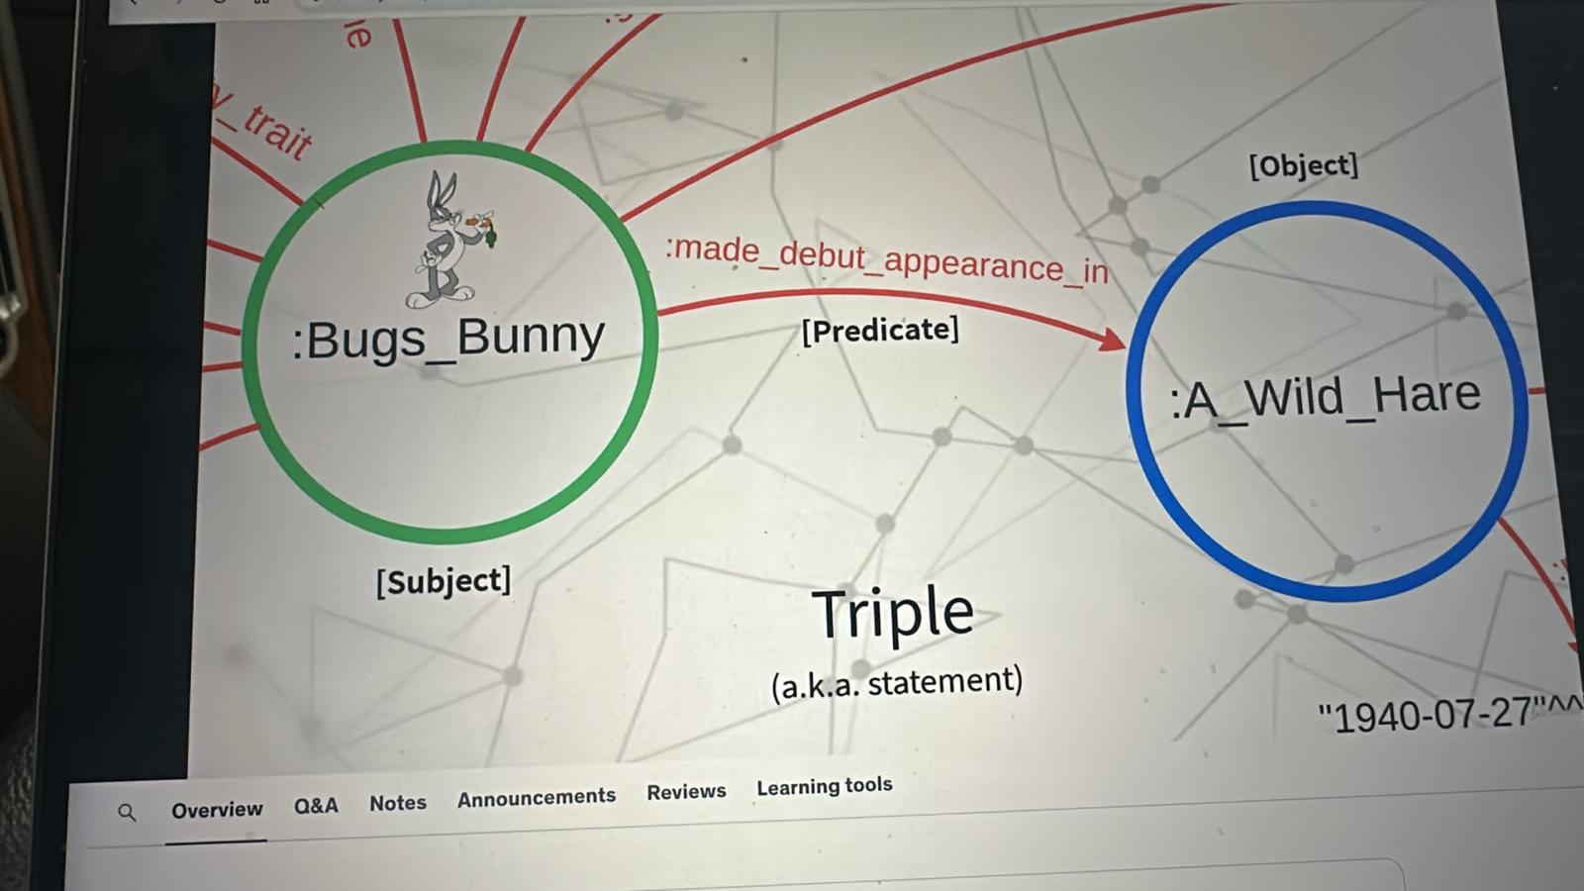

**Neo4j is *not* an RDF triple store.** Neo4j is a **Labeled Property Graph (LPG)** database. It stores **nodes/relationships with properties** and is queried with **Cypher** (not SPARQL). It doesn’t expose a native SPARQL endpoint or store data as RDF triples internally.

That said, Neo4j can interoperate with RDF:

* **Neosemantics (n10s) plugin** lets you **import/export RDF** (Turtle, N-Triples, etc.) into Neo4j by mapping triples into an LPG structure, and export LPG back to RDF. You still **query with Cypher**, not SPARQL.
* Some teams keep an RDF store (for SPARQL + reasoning) **and** Neo4j (for Cypher + graph algorithms) and sync between them.

### **Quick comparison**

| **Capability** | **RDF Triple Store (GraphDB, Stardog, AllegroGraph, RDF4J/Jena, etc.)** | **Neo4j** |
| --- | --- | --- |
| Data model | RDF triples (subject–predicate–object) | Labeled Property Graph (nodes/edges + properties) |
| Query | **SPARQL 1.1** | **Cypher** |
| Reasoning | RDFS/OWL (often built-in / configurable) | No native OWL reasoning (can emulate via rules/procs) |
| Shapes/constraints | SHACL common | Constraints/indexes; SHACL only via RDF tools or external validation |
| Best for | Linked Data, ontology-first, SPARQL apps, inference | Operational graph apps, path queries, graph algorithms (GDS), Cypher-driven apps |
| RDF I/O | Native | Via **n10s** plugin (import/export) |
| SPARQL endpoint | Yes | No |

### **If you need both worlds**

* **Single engine option:** **Amazon Neptune** supports **SPARQL (RDF)** and **openCypher/Gremlin (property graph)** in one managed service.
* **Two-engine pattern (common):**
  + RDF store (e.g., **GraphDB/Stardog**) = **system of record** for ontologies, SHACL, SPARQL, reasoning.
  + **Neo4j** = **application/analytics graph** (Cypher, Neo4j GDS, fast traversals).
  + Sync via RDF export → **n10s** import (and optionally back out as RDF if needed).

If you tell me your must-haves (SPARQL? OWL reasoning? GDS algorithms? managed service vs OSS?), I’ll recommend a concrete setup and give you the import/export scripts to glue them together.

Thought for 19s

Got it—here’s a straight-shooting, **GenAI-focused** and **company-level** guide for choosing **RDF (SPARQL)** vs **Neo4j (LPG/Cypher)**, plus hybrid patterns you can put in production.

# **TL;DR (choose by your primary goal)**

* **Ship GenAI features fast with sub-second latency** (RAG over docs + graph context, path-heavy questions, graph algorithms): **Neo4j**.
* **Share/merge knowledge across BUs & partners, publish open data, enforce semantic contracts & reasoning**: **RDF triple store**.
* **You need both** (publish as standards + fast app features): **Hybrid** (RDF as system-of-record, Neo4j as serving graph) or **Amazon Neptune** (SPARQL + openCypher in one managed cluster).

# **A) GenAI lens: what each does best**

| **GenAI capability** | **Best with Neo4j (LPG/Cypher)** | **Best with RDF (SPARQL)** |
| --- | --- | --- |
| **RAG latency (p95)** | Millisecond-level when combining **Cypher** + native **vector index** (facts + snippets) | Typically higher; vector is often external; SPARQL is great for exact facts, not kNN |
| **Graph-aware RAG** | Natural: facts via Cypher + **GDS** for ranking/paths + vectors for text | Possible, but graph algorithms & kNN usually sit outside the triple store |
| **Exact facts & enumerations** | Good (Cypher), but no native inference | Excellent via SPARQL with **RDFS/OWL reasoning** |
| **Schema/quality for LLM grounding** | DB constraints + Cypher checks | **SHACL** shapes (strong machine-checkable contracts) |
| **Linking to public knowledge** | Import/export via mapping; not native | **Native**: IRIs, JSON-LD, SPARQL federation |
| **Hallucination control** | Facts from Cypher + provenance nodes + snippet citations | Facts from SPARQL + SHACL-validated data + linked open data citations |

**Rule of thumb for RAG routers**

* **Fact-style** (counts, membership, relationships, strict filters) → KG path: **Cypher** (Neo4j) or **SPARQL** (RDF).
* **Open-ended** (why/how, summaries, definitions) → **vector search** over curated chunks; add KG context (entities, paths) for grounding.

# **B) Company lens: governance & sharing**

| **Company concern** | **Neo4j (LPG/Cypher)** | **RDF (SPARQL)** |
| --- | --- | --- |
| **Cross-BU & partner sharing** | Export RDF/JSON-LD; requires mapping | **Native**: IRIs, SPARQL, JSON-LD, **DCAT** catalogs |
| **Data contracts / compliance** | Custom checks; constraints | **SHACL shapes** (formal, versionable contracts) |
| **Interoperability & standards** | Via n10s/ETL | **First-class** (RDF vocabularies, Linked Data) |
| **Developer velocity** | Very high for app teams | Higher bar (semantics/ontologies skill set) |
| **Analytics & algorithms** | **Neo4j GDS** built-in | External libs or limited |
| **Operating model** | One “product graph” per BU easy to evolve | One “enterprise knowledge graph” shared across orgs |

# **C) Canonical architectures (text diagrams)**

## **1) Neo4j-first GenAI (fast app features)**

[Docs/PDFs/HTML] → chunk → embed → Neo4j(:Chunk {embedding})

[Entities/Facts] → Neo4j(:Entity/relations)

Query:

Router → (a) Cypher for facts/paths (b) Vector kNN for snippets

Answer composer → citations (nodes/edges + chunks)

## **2) RDF-first Knowledge Hub (sharing & governance)**

[Sources] → RDF/OWL + SHACL → RDF store (SPARQL)

Publish:

- SPARQL endpoint (internal/public)

- JSON-LD APIs

- DCAT dataset catalog

(Option) Stream app-needed slice → Neo4j for low-latency features

## **3) Hybrid (most enterprises)**

Authoritative knowledge → RDF store (SPARQL/SHACL/JSON-LD/DCAT)

Nightly/stream export → Neo4j (Cypher/GDS/Vector) → app APIs & RAG

# **D) Concrete use-cases (what wins where)**

* **Fraud/Risk, Supply-chain impact, Recommendations, Root-cause paths** → **Neo4j** *Why*: real-time multi-hop traversals + GDS algorithms + vector-grounded answers.
* **Enterprise glossary, Policy hub, Reference data shared with partners/public** → **RDF** *Why*: IRIs, SPARQL federation, SHACL validation, JSON-LD publishing.
* **Copilot for internal engineering/product docs** (answers with facts + snippets) → **Neo4j + vector** *Why*: combine Cypher facts with nearby chunk evidence for grounded LLM outputs.
* **Regulated ontology & shared semantics across BUs/vendors** → **RDF** *Why*: formal semantics/reasoning; stable, versioned contracts.

# **E) Pros & cons that matter for GenAI programs**

## **Neo4j**

**Pros**: Low latency; easy app integration; **GDS**; native vector index; flexible modeling.  
 **Cons**: No native OWL reasoning or SHACL; you’ll export RDF for open sharing.

## **RDF triple store**

**Pros**: **SPARQL + RDFS/OWL + SHACL**; JSON-LD/DCAT; perfect for interop & public data.  
 **Cons**: Traversal/algorithms and vector typically external; steeper skills; may feel slower for interactive apps.

# **F) How the retrieval chain differs (tiny examples)**

**Cypher + vector (Neo4j):**

// Fact slice

MATCH (:VehicleModel {code:$model})<-[:BELONGS_TO]-(t:Trim)

MATCH (t)-[:HAS_FEATURE]->(:Feature {code:$feature})

RETURN collect(t.code) AS trims;

// Vector slice

CALL db.index.vector.queryNodes('chunk_openai', 5, $queryEmbedding) YIELD node, score

RETURN node.text AS snippet, score, node.source AS src;

**SPARQL (RDF):**

PREFIX ex:<http://example.com/auto#>

SELECT ?trim WHERE {

?trim a ex:Trim ; ex:belongsTo ex:M1 ; ex:hasFeature ex:F_ACC .

}

Use SHACL before publishing to ensure shapes (e.g., each ex:Trim has exactly one ex:belongsTo).

# **G) What I’d pick for a large company (practical)**

1. **Public/partner sharing or cross-BU semantic alignment is a key goal** → Start **RDF first**.  
   * Publish **SPARQL**, **JSON-LD**, **DCAT**; enforce **SHACL**.
   * Mirror the high-value slices into **Neo4j** for app features with RAG.
2. **You’re product-feature-driven (internal apps) and need results fast** → Start **Neo4j first**.  
   * Add **vector RAG**; return citations and provenance.
   * When you’re ready to share outward, **export RDF/JSON-LD**.
3. **Team wants one managed service** → **Amazon Neptune** (SPARQL + openCypher).  
   * Model knowledge as RDF; implement app traversals via openCypher.

# **H) Success metrics (exec-level)**

* **Accuracy**: CQ pass rate, grounded citations present.
* **Latency**: p95 answer time (<1s for app features).
* **Coverage**: % of questions routed to graph facts vs vector.
* **Governance**: SHACL pass rate, schema drift incidents.
* **Adoption**: # of BUs publishing/consuming, # partner integrations.
* **Ops**: cost per 1k queries, index build SLA, data freshness.

# **I) 30-day pilot (actionable)**

* **Week 1**: Pick 5 competency questions. Draft minimal **ontology** (RDF) + minimal **LPG** (Neo4j).
* **Week 2**: Ingest one BU’s docs → **chunks + embeddings**; load **RDF store** and **Neo4j**; set **SHACL** & Neo4j constraints.
* **Week 3**: Build router: **SPARQL for facts**; **Neo4j + vector** for open questions. Ship an internal UI with citations.
* **Week 4**: Add **JSON-LD** & **DCAT** for publishing; measure accuracy/latency; decide scale path (RDF-first, Neo4j-first, or Neptune).

If you want, I can package this as a one-page **CEO brief (DOCX)** and a **technical addendum** (SPARQL/Cypher templates + a router sketch) so you can hand it to both execs and engineers.

##### **You said:**

Suppose that I have a data that I need to publish for world and public domain then which one to choose like Neo4j or RDF store

###### **ChatGPT said:**

Thought for 13s

If your goal is to **publish data to the world/public domain**, pick an **RDF triple store** as your primary publication layer. Keep **Neo4j** only as an optional, secondary “app graph” for demos, low-latency features, or graph algorithms.

# **Why RDF for public publishing**

* **Open standards & web-native**: IRIs (global IDs), RDF serializations (Turtle, N-Quads, JSON-LD), and **SPARQL** for queries.
* **Interoperability**: Others can link to your IRIs and federate queries across endpoints.
* **Contracts & quality**: **SHACL** shapes make your published data machine-checkable.
* **Discoverability**: **DCAT** catalogs advertise datasets, versions, and downloads.
* **Longevity**: RDF/JSON-LD and SPARQL are the lingua franca for public/open knowledge.

Neo4j is excellent for **internal product features** (fast traversals, GDS algorithms, vector RAG), but it’s **not** a native RDF/SPARQL store. Use it behind the scenes if you also need an interactive app.

# **Recommended patterns**

## **A) Public-first (RDF as system of record) — best for publishing**

[Curate/ETL] → RDF/OWL + SHACL → Triple store (GraphDB / Virtuoso / RDF4J/Jena / Neptune-RDF)

Publish:

/sparql (read-only, rate-limited)

/data (RDF dumps: TTL, N-Quads, HDT)

/id/{…} (persistent IRIs with content-negotiation to JSON-LD/HTML)

DCAT catalog (dataset metadata, versions, license)

(Optional) Stream a slice → Neo4j for low-latency demos or RAG

## **B) Hybrid (common in enterprises)**

* **RDF** for sharing/governance; **Neo4j** for app latency & graph algorithms.
* Sync via RDF export → **Neo4j n10s** import (and export back if needed).

## **C) One managed engine**

* **Amazon Neptune** gives you **SPARQL** (RDF) and **openCypher** (property graph) in one cluster.

# **“Publish to world” checklist (copy/paste)**

1. **Mint persistent IRIs** under your domain  
    e.g., https://data.example.com/id/vehicle/FALCON_X
2. **Model** with RDF/OWL (+ **SKOS** for labels/synonyms)
3. **Validate** with **SHACL** (CI gate before release)
4. **Host a triple store** & expose a **read-only SPARQL** endpoint  
    Set quotas/rate limits, caching, and CORS.
5. **Offer JSON-LD** and **HTML** via content negotiation  
    /id/... → 303 redirect → /doc/... (HTML) and /data/... (TTL/JSON-LD)
6. **Publish DCAT catalog** + **RDF dumps** (TTL / N-Quads / HDT)  
    Include dataset versioning, license, and provenance.
7. **Docs & examples** Provide 3–5 starter SPARQL queries and example JSON-LD responses.
8. *(Optional)* Mirror to **Neo4j** for interactive apps/RAG  
    Import with **n10s**, add **vector index** on text chunks, serve Cypher APIs.

# **Tiny examples**

**SPARQL (public facts):**

PREFIX ex: <https://data.example.com/auto#>

SELECT ?trim WHERE {

?trim a ex:Trim ;

ex:belongsTo ex:M1 ;

ex:hasFeature ex:F_ACC .

}

**JSON-LD (content-negotiated view of an entity):**

{

"@id": "https://data.example.com/id/vehicle/FALCON_X",

"@type": "ex:VehicleModel",

"ex:code": "FALCON_X",

"skos:prefLabel": "Falcon X"

}

**Neo4j (optional serving graph for apps/RAG):**

MATCH (:VehicleModel {code:'FALCON_X'})<-[:BELONGS_TO]-(t:Trim)-[:HAS_FEATURE]->(:Feature {code:'ACC'})

RETURN t.code;

## **Bottom line**

* **Publishing to the world / other companies** → **RDF triple store** (SPARQL, JSON-LD, DCAT, SHACL).
* **Building fast, graph-heavy product features** → **Neo4j** (optionally fed from your RDF layer).
* **Want both with fewer moving parts** → **Amazon Neptune** (RDF + openCypher).

If you want, I can generate a **one-page DOCX** “Public Data Publishing Plan” with the checklist, URL patterns, and a minimal SPARQL starter kit.

##### **You said:**

Make a one text Model How GEN AI Works like Chat GPT with RDF triple store, Neo4j and Verctor Database

###### **ChatGPT said:**

Thought for 9s

Here’s a single, self-contained **text model** of how a ChatGPT-style GenAI system can work **with all three stores together**: an **RDF triple store** (SPARQL), **Neo4j** (Labeled Property Graph, Cypher), and a **Vector Database** (dense embeddings).

# **One-Text Model — GenAI + RDF Triple Store + Neo4j + Vector DB**

┌────────────────────────────────────────────────────────────────┐

│ DATA (INGEST) │

│ Files • DB tables • APIs • Web pages • Partners’ RDF/SPARQL │

└──────────────┬───────────────────────────┬─────────────────────┘

│ │

┌──────────────▼──────────────┐ ┌────────▼─────────┐

│ Normalize & Chunk Text │ │ Extract Entities │

│ (clean, split, metadata) │ │ (NER, rules, KB) │

└──────────────┬──────────────┘ └────────┬─────────┘

│ │

┌────────────────────▼──────────────────┐ ┌────▼──────────────────┐

│ RDF Modeling (RDFS/OWL, IRIs, SKOS) │ │ LPG Modeling (Neo4j) │

│ + SHACL validation (contracts) │ │ labels/props/edges │

└──────────────┬────────────────────────┘ └──────────┬───────────┘

│ │

┌──────────────────▼──────────────┐ ┌───────────────▼──────────────┐

│ RDF Triple Store (SPARQL) │ │ Neo4j App Graph (Cypher + GDS)│

│ • publish /sparql, JSON-LD, DCAT│ │ • fast traversals, algorithms │

└─────────────────┬───────────────┘ └───────────────┬──────────────┘

│ │

│ ┌───────────────────────▼─────────────────────┐

│ │ Vector DB / Vector Index (chunks + embeddings)│

│ │ • kNN search for semantic similarity │

│ └───────────────────────┬─────────────────────┘

│ │

└──────────────────────────┬───────────────┘

│

┌──────────────────▼───────────────────┐

│ Query Orchestrator (Router + Tools) │

│ • Entity linker (uses SKOS/IRIs) │

│ • Route per question: │

│ - SPARQL (exact facts/inference) │

│ - Cypher (paths/algos, low-latency)│

│ - Vector (open-ended/snippets) │

└──────────────────┬───────────────────┘

│

┌───────────────▼────────────────────┐

│ LLM Answer Composer (prompting) │

│ • Merges results + citations │

│ • Factual guardrails (re-ask/store)│

└───────────────┬────────────────────┘

│

┌───────────────▼────────────────────┐

│ Final Answer │

│ • Facts (KG) + Evidence (snippets) │

│ • Links/IRIs + provenance │

└─────────────────────────────────────┘

## **Roles (what each store is responsible for)**

* **RDF Triple Store (SPARQL)** — *Publish & interoperate*
  + Uses **IRIs** for global IDs, **RDFS/OWL** for meaning, **SKOS** for labels/synonyms, **SHACL** for machine-checkable data contracts.
  + Exposes **/sparql**, **JSON-LD**, and **DCAT** catalogs so other BUs/partners/public can safely consume your data.
  + Best for **exact facts**, **federation** (link to public KGs), and **reasoning** (derived truths).
* **Neo4j (LPG/Cypher + GDS)** — *Serve app features fast*
  + Stores the **application graph** (nodes/relationships with properties) for **sub-second multi-hop traversals** and **graph algorithms** (centrality, communities, similarity, link prediction).
  + Great for production features and **graph-aware RAG** (combine facts + paths with snippets).
* **Vector DB / Index** — *Semantic recall of text*
  + Holds **chunk embeddings** (from your documents or web pages).
  + Answers **open-ended** or fuzzy questions by retrieving semantically similar passages.
  + Supplies **evidence snippets** the LLM can quote.

## **Query-time flow (how a single question is answered)**

1. **User question arrives** → Normalize (lowercase, remove boilerplate), detect language.
2. **Entity linking** → map terms to **IRIs** (from RDF/SKOS) and to **Neo4j nodes** (codes/keys).
3. **Router decides**:  
   * If **exact fact / policy / enumeration** → run **SPARQL** against the RDF store.
   * If **path-heavy / impact / recommendations / “what connects X to Y?”** → run **Cypher** on Neo4j (+ optional **GDS** algorithm).
   * If **open-ended / “explain/why/how”** → run **kNN** on the **Vector DB** to pull top-k chunks; optionally expand with **Neo4j paths** for context.
   * Mixed questions call **multiple paths**; the orchestrator merges results.
4. **LLM Answer Composer** → Templated prompt that:  
   * Inserts **facts** from SPARQL/Cypher, **snippets** from the vector path.
   * Cites **IRIs**, graph node IDs, and document sources.
   * Applies **guardrails** (e.g., “if no authoritative fact found, say ‘not found’”).
5. **Answer** → Structured facts + quoted evidence, with clickable identifiers/links.

## **Minimal examples (the three retrieval paths)**

**SPARQL (RDF) — exact fact**

PREFIX ex: <https://data.example.com/auto#>

SELECT ?trim WHERE {

?trim a ex:Trim ;

ex:belongsTo ex:M1 ;

ex:hasFeature ex:F_ACC .

}

**Cypher (Neo4j) — path/aggregation**

MATCH (:VehicleModel {code:$model})<-[:BELONGS_TO]-(t:Trim {modelYear:$year})

MATCH (t)-[:HAS_FEATURE]->(:Feature {code:$feature})

OPTIONAL MATCH (sr:SaleRecord)-[:FOR_TRIM]->(t)-[:SOLD_IN]->(:Region {code:$region})

RETURN t.code AS trim, sum(sr.quantity) AS units;

**Vector (kNN) — open-ended snippet retrieval**

query_embedding = embed("Explain ACC benefits on Falcon X in California")

topk = vector_index.query(k=5, embedding=query_embedding)

# returns chunks + scores (+ optional KG entity links for grounding)

The **LLM** prompt then merges: *“Using Facts: {table} and Evidence: {snippets}, answer concisely; include citations to IRIs and doc URLs.”*

## **How the three layers stay in sync**

* **RDF ↔ Neo4j**
  + Export RDF (Turtle/JSON-LD) from the triple store → **import into Neo4j** via **n10s** (neosemantics), mapping IRIs to node keys and predicates to relationship types.
  + Optional reverse export (Neo4j → RDF) for publication, if Neo4j is the first landing zone.
* **Text chunks ↔ both graphs**
  + Keep a **Chunk** node/table with metadata (source, section, seq).
  + Link **Chunk → Entity** (MENTIONS) in Neo4j; store **same links** as RDF triples for publication.

## **When each path is chosen (simple router rules)**

* **SPARQL first** if the question contains:  
  + explicit entities + filters (by code, date, region) and expects **authoritative facts**;
  + needs **inference** (e.g., subclass/part-of expands results) or **federation** (Wikidata/partner SPARQL).
* **Cypher first** if the question:  
  + requires **multi-hop** reasoning (impact, dependency, “find shortest connection”),
  + benefits from **GDS** ranking (top influencers, anomalies, communities),
  + needs **ms latency** in an interactive product.
* **Vector first** if the question:  
  + is **open-ended** (“why/how/explain/summarize”),
  + needs **passage-level** evidence (manuals, tickets, research).

Most production systems run **two or three paths** and let the composer merge answers with confidence scores and citations.

## **Governance & sharing (enterprise angle)**

* Treat the **RDF store as the “system of record”** for public/partner sharing:  
  + **IRIs**, **JSON-LD**, **/sparql**, **DCAT**, **SHACL** as data contracts.
* Treat **Neo4j as the “serving graph”** for app features:  
  + **GDS** for analytics, **vector index** near graph for RAG, **Cypher** APIs for products.
* Keep a **CI gate**:  
  + SHACL validation on RDF before publish; Cypher shape checks on Neo4j before release.
* **Observability**:  
  + Log router decisions, path timings, LLM citations; monitor p95 latency and CQ accuracy.

## **Why this hybrid works (like ChatGPT, but grounded)**

* The **Vector DB** gives broad semantic recall (what the LLM is good at).
* The **Graphs** (RDF + Neo4j) **ground and constrain** the answer with exact, explainable facts and traversals.
* The **RDF layer** lets you **share** knowledge externally with standards; the **Neo4j layer** lets you **serve** internal products with speed and algorithms.

If you want, I can turn this into a **one-page DOCX/PDF** with the same text diagram and copy-paste checklists for your team.

##### **You said:**

One-Text Model — GenAI + RDF Triple Store + Neo4j + Vector DB In this diagram I need a two text diagram 1. One for fill the Data Stracture with very simple GEN AI app how would that work 2. Fill the How does from Ask question reterive the Answer and Role of RDF Triple Store (SPARQL) , Neo4j App Graph (Cypher + GDS), Vector DB / Vector Index (chunks + embeddings) and finally Query Orchestrator (Router + Tools)

###### **ChatGPT said:**

Thought for 22s

Perfect—here are the **two text-only diagrams** you asked for. They’re copy-pasteable into a README or DOCX and stay completely editable.

# **1) Fill the Data Structure — simple GenAI app (build-time)**

[Sources]

PDFs | HTML | DB tables | CSV/JSON | Partner RDF/SPARQL

│

▼

[Normalize]

- extract text (Tika/PDFBox)

- clean (remove boilerplate)

- keep metadata: doc_id, title, url, date

│

▼

[Chunk Text]

- split into ~1–2k chars with overlap

- assign: chunk_id, section_id, seq_no

│

├───────────────────────────────┐

│ │

▼ ▼

[Entity & Term Extraction] [Embed Chunks]

- detect entities (NER/rules) - embedding := model(text)

- map to canonical IDs: - store 1536-D (or model-dim)

• RDF IRIs (SKOS labels) - keep vector with chunk_id

• Neo4j nodes (codes/keys) - add cosine index

│ │

├───────────────┬───────────────┘

│ │

▼ ▼

[RDF Modeling] [Neo4j Modeling]

- Classes: Document, Section, - Labels: :Document, :Section,

Chunk, Entity (+ domain) :Chunk, :Entity (+ domain)

- Properties: hasSection, - Rels: :HAS_SECTION,

hasChunk, next, mentions, :HAS_CHUNK, :NEXT, :MENTIONS,

RELATED_TO, … domain rels (e.g., :BELONGS_TO)

- Shapes: SHACL (contracts) - Constraints: uniqueness on keys

│ │

▼ ▼

[RDF Triple Store] [Neo4j App Graph]

- load triples - MERGE nodes/rels

- expose /sparql - create vector index on Chunk.embedding

│ │

└───────┬───────┘

▼

[Vector DB / Vector Index]

- (chunk_id, embedding, metadata: doc_id, section_id, entity_links)

- kNN ready for semantic retrieval

┌─────────────────────────────────────────────────────────────────────┐

│ Minimal data structures (examples) │

│ Chunk record: │

│ {chunk_id, doc_id, section_id, seq_no, text, │

│ embedding[], source_url, entity_ids[]} │

│ Neo4j nodes/rels: │

│ (:Document{docId,title,url})-[:HAS_SECTION]->(:Section{sectionId})│

│ (:Section)-[:HAS_CHUNK]->(:Chunk{chunkId,seq_no,text}) │

│ (:Chunk)-[:NEXT]->(:Chunk) ; (:Chunk)-[:MENTIONS]->(:Entity{uri}) │

│ RDF triples (Turtle): │

│ ex:doc1 ex:hasSection ex:s1 . ex:s1 ex:hasChunk ex:c1 . │

│ ex:c1 ex:mentions ex:ACC ; ex:next ex:c2 . │

└─────────────────────────────────────────────────────────────────────┘

# **2) Ask → Retrieve → Answer — roles of SPARQL, Cypher/GDS, Vector, Orchestrator (run-time)**

User Question

e.g., "Which 2023 Falcon X trims have ACC and how many sold in CA?"

│

▼

[Query Orchestrator (Router + Tools)]

- Normalize question (lang, stopwords)

- Entity linking via SKOS/IRIs + Neo4j keys (ACC → ex:F_ACC; Falcon X → ex:M1)

- Intent detection:

• Fact/filters/enumeration? → SPARQL path

• Path/impact/graph ranking? → Cypher (+ optional GDS)

• Open-ended/why/how? → Vector path

- May run 2–3 paths and merge

│ │ │

│ │ └───────────────► [Vector DB / Index]

│ │ kNN on chunk embeddings

│ │ RETURN top-k {text, score, doc_id}

│ │

│ └────────────────────────────► [Neo4j App Graph]

│ Cypher traversals/aggregations

│ (optionally GDS for ranking/paths)

│

└─────────────────────────────────────► [RDF Triple Store]

SPARQL for exact facts,

reasoning, federation

│

▼

[Result Aggregation]

- Join facts (SPARQL/Cypher rows) with evidence (vector snippets)

- De-duplicate; compute confidence; build provenance (IRIs, node IDs, URLs)

│

▼

[LLM Answer Composer]

- Prompt template:

"Using Facts: {tables} and Evidence: {snippets}, answer concisely,

include citations (IRIs, doc URLs), and say 'not found' if no facts."

│

▼

[Final Answer]

- Structured facts (models, trims, units) + quoted snippets

- Citations: SPARQL resources (IRIs), Neo4j nodes/paths, document URLs

### **Tiny, concrete examples for each path (same question, different roles)**

**SPARQL (RDF facts)** PREFIX ex:<http://example.com/auto#> PREFIX xsd:<http://www.w3.org/2001/XMLSchema#>

SELECT ?trim (SUM(?q) AS ?units) WHERE {

?trim a ex:Trim ; ex:belongsTo ex:M1 ;

ex:modelYear "2023"^^xsd:gYear ; ex:hasFeature ex:F_ACC .

?sr a ex:SaleRecord ; ex:forTrim ?trim ; ex:soldIn ex:CA ;

ex:saleDate "2023-03-15"^^xsd:date ; ex:quantity ?q .

} GROUP BY ?trim

**Cypher (Neo4j paths/aggregation, low latency)** MATCH (:VehicleModel {code:'FALCON_X'})<-[:BELONGS_TO]-(t:Trim {modelYear:2023})

MATCH (t)-[:HAS_FEATURE]->(:Feature {code:'ACC'})

MATCH (sr:SaleRecord)-[:FOR_TRIM]->(t)

MATCH (sr)-[:SOLD_IN]->(:Region {code:'CA'})

WHERE date(sr.saleDate)=date('2023-03-15')

RETURN t.code AS trim, sum(sr.quantity) AS units;

**Vector (open-ended explanation)** query = "Explain ACC benefits for Falcon X drivers in California"

top_k = vector_index.query(k=5, embedding=embed(query))

-> returns {chunk_id, text, score, doc_id, entity_links:[F_ACC,M1,CA]}

**Router tip:**

* If the question contains **hard filters** (brand, year, region, date) → prioritize **SPARQL or Cypher**.
* If it seeks an **explanation** or **background** → prioritize **Vector**, then enrich with KG entities/paths for grounding.
* If it asks **“impact/connection/shortest path”** → **Cypher (+ GDS)** first.

If you want these two diagrams dropped into a one-page DOCX (editable text, no images) with your colors/logo, I can generate it now.